Government Campaign Advertising |  | 2021
This document guides public sector agencies in the planning, development and ongoing management of government campaign advertising. | Guidelines

Date of Issue: July 2021
Contents
1. Introduction 1
2. Who it applies to 1
3. What is campaign advertising 1
4. Guiding principles 1
5. Requirements for applicants 1
6. When does an application need to be submitted to DPC? 2
7. Who reviews the applications? 2
8. Review process 3
9. Post review requirements 3
10. Media booking guidance 4
11. Accessibility 4
12. Requirements for WA Government Attribution 4
13. Third-party advertising on Government Websites 5
14. Use of the WA State Government Badge 5
15. Further Information 5
APPENDIX 1 6
Application to Undertake Campaign Advertising 6

1. Introduction

The Western Australian Government aims to ensure that campaign advertising across all Government agencies are effectively managed and responsive to the needs of the public.

The Government Campaign Advertising Guidelines (the Guidelines) aim to support government agencies in achieving efficiencies and value for money in the delivery of campaign advertising.

These Guidelines must be read in conjunction with the Premier’s Circular 2021/08 – Government Campaign Advertising, and the associated Government Campaign Advertising Policy (the Policy).

The Department of the Premier and Cabinet oversees the application of the Policy and Guidelines.

2. Who it applies to

These Guidelines apply to all public sector agencies other than those listed in Schedule 1 of the Public Sector Management Act 1994.

3. What is campaign advertising

Campaign advertising is promotional in nature and generally runs over a sustained period to encourage behaviour change, educate or promote ongoing activities of Government.

4. Guiding principles

In developing and managing campaign advertising, government agencies must ensure their campaign:
- Adheres to Category A2 of Media Booking, Buying and Planning Services for Advertising CUAMBBP2018;
- Objectives align with or support a priority of Government;
- Provides a clear benefit or important message to the public;
- Is apolitical in nature;
- Is supported by an assessment of the cost-effectiveness of the media strategy and selection that demonstrates value for money; and
- Includes the methodology for evaluating how effectively the campaign delivers on its objective(s).

5. Requirements for applicants

WA Government agencies are required to ensure their application:
- Complies with relevant Government policies, and
- Is submitted for review prior to undertaking any related procurement or media bookings, at least two weeks in advance of when the campaign is proposed to commence.

6. When does an Application to Undertake Campaign Advertising need to be submitted to DPC?

A WA Government agency should submit an Application to Undertake Campaign Advertising if any of the following apply:
- A campaign is valued at $10,000 or above (ex GST);
- Any element of the campaign is booked in interstate or international markets.

Campaigns that are valued below $10,000 (ex GST) do not have to be presented to DPC for review, however agencies must still adhere to Category A2 of Media Booking, Buying and Planning Services for Advertising CUAMBBP2018 when completing campaigns below this threshold.

7. Who reviews the applications?

7.1 Campaigns valued between $10,000 and $149,999 inclusive (ex GST)

DPC’s Communications and Media Unit (CMU) manages the review process for campaign applications that are valued between $10,000 and $149,999 inclusive (ex GST), and assesses each application for compliance with the guiding principles (refer to point 4 of the Guidelines).

The CMU also:
- Assists the Department of Finance with monitoring and reporting on media placement expenditure by government agencies through the Master Media Services Common Use Arrangement (CUA);
- Provides advice to agencies on the Policy and Guidelines, including for campaigns below $10,000 (ex GST);
- Provides secretariat support and refers applications valued at $150,000 and above (ex GST) to the Independent Communications Review Committee for consideration.

7.2 Campaigns valued at $150,000 or above (ex GST)

The Independent Communications Review Committee (ICRC) considers all applications valued at $150,000 or above (ex GST) for compliance with the guiding principles (refer to point 4 of the Guidelines). The ICRC also assess any applications under $150,000 (ex GST) that have been referred by the CMU.

The ICRC consists of senior representatives from DPC and other WA Government departments. Members are required to identify any potential or perceived conflict of interest regarding any submissions that are received. A decision on the member’s continued participation in the review of that submission will be determined by the ICRC Chair.

The ICRC also:
- May require departmental or agency staff to attend the meeting to present further information regarding an application
- Periodically reviews the Government Advertising Policy and Guidelines.

8. Review process
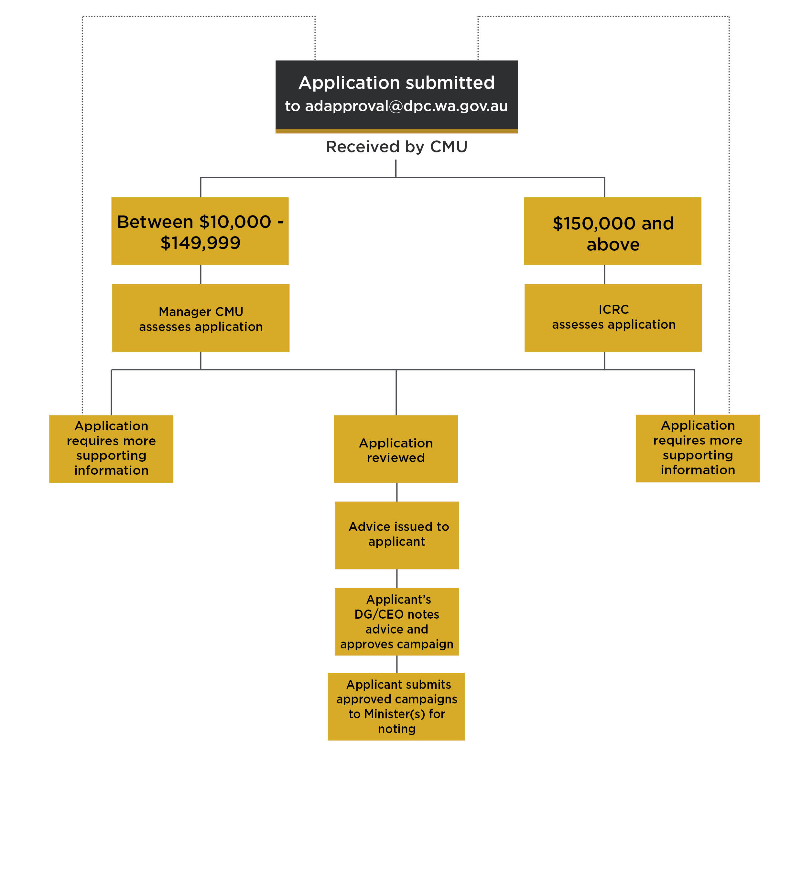

9. Post review requirements

9.1 Final approval and noting

As per the review process, once an applicant receives the outcome of the CMU or ICRC’s review, it is the applicant’s responsibility to seek final approval from their DG/CEO and their relevant Minister(s) before proceeding with the campaign. The CMU or ICRC advice should be included with the campaign documentation when seeking final approval.

9.2 Amendments or adjustments to expenditure

If the value of the campaign significantly changes post-application, it is the applicant’s responsibility to submit changes for consideration by the CMU/ICRC and re-approval by their DG/CEO.

10. Media booking guidance

All government advertising (media placement) must be booked through the mandatory CUA for Media Booking, Buying and Planning Services for Advertising CUAMBBP2018. Exceptions include if electing to buy outside of the CUA for overseas media placement or in social media and paid search directly from social media channels or search engine providers. Refer to the CUA for guidance.

11. Accessibility

All advertising and campaign communications should be designed for accessibility, which includes the requirement for ‘closed captions’ to be applied to television, cinema and social/digital media broadcasts.

12. Requirements for WA Government Attribution

Campaign advertising by Western Australian Government agencies in all broadcast mediums must include an attribution clearly indicating that the message is authorised by the Government of Western Australia. Broadcast mediums include, but are not limited to television, radio, cinema, online videos and digital or social communications.

This requirement is in addition to any applicable requirement under the Broadcasting Services Act 1992 (including live-reads).

12.1 Television, videos, digital and social media broadcasts

At the completion of the commercial/material there must be a full screen graphic displaying white type on a black background that reads:

- Authorised by the Government of Western Australia, Perth or where there are time constraints – Authorised by the State Government, Perth;
- No other words or graphic devices can be included on this final screen.

The following spoken announcement should also be made:
- ‘Authorised by the Government of Western Australia, Perth’, or where there are time constraints – ‘Authorised by the State Government, Perth’;
- The spoken announcement must not precede the final graphic with the written authorization;
- In digital or social mediums where spoken announcements are not practicable due to size or time limitations, then the final graphic that displays the written authorisation is sufficient; and
- Any additional requirements during a Caretaker Convention Period.

12.2 Radio

There should be a spoken announcement immediately following the commercial which states:

- ‘Authorised by the Government of Western Australia, Perth’ or where there are time constraints – ‘Authorised by the State Government, Perth’. (No music or sound effects may accompany the voice over); and
- Any additional requirements during a Caretaker Convention Period.

13. Third-party advertising on Government Websites

Government agencies should note that review or approval of third party paid advertising on Government websites is not within the scope of the Government Campaign Advertising and Policy and Guidelines.

14. Use of the WA State Government Badge

Advertisements produced for and on behalf of the Western Australian Government should be clearly identifiable in accordance with Common Badging requirements.

Please refer to the Common Badging webpage for further information.

15. Further Information

Communications and Media Unit
Department of the Premier and Cabinet
Level 6, Dumas House
2 Havelock Street
WEST PERTH WA 6005

For all enquiries:
Email: AdApplications@dpc.wa.gov.au
Phone: 6552 6666

APPENDIX 1

Government of Western Australia
Department of the Premier and Cabinet
DPC Use Only

Date Received:____________
CMU No:

Application to Undertake Government Campaign Advertising

This application is required for campaign advertising.

Agency name
Agency contact | Name:  Work phone and/or mobile:  Email:
Campaign title
Duration | Proposed Start Date:  Proposed End Date:
Objective(s) | Highlight alignment with a Government priority
Target audience (including location) | Provide detail on the intended audience
Benefit(s) and/or key message(s) | Outline benefit or important message for public
Proposed media selection (indicate any regional component) | Provide rationale for media selection and how it will best reach the target audience, including assessment for the cost-effectiveness of the media strategy and media selection that demonstrates value for money
Evaluation of campaign effectiveness | State the proposed evaluation methodology and who will undertake it
Sponsorship and/or industry contributions | Provide details of any cost offsets
Proposed Campaign budget breakdown (ex GST) | Media placement expenditure | $
Proposed Campaign budget breakdown (ex GST) | Creative costs | $
Proposed Campaign budget breakdown (ex GST) | Production costs | $
Proposed Campaign budget breakdown (ex GST) | Other costs (e.g. market research, events; itemise and attach) | $
Proposed Campaign budget breakdown (ex GST) | Total Campaign Budget | $

Contracted creative production agency
Nominated media planner
Nominated CUA media booking agency

All applications must be pre-endorsed by the applicant’s manager and relevant Tier 2
Manager’s Name
Manager’s Signature
Date
Tier 2’s Name
Tier 2’s Signature
Date

Email completed applications to AdApplications@dpc.wa.gov.au

