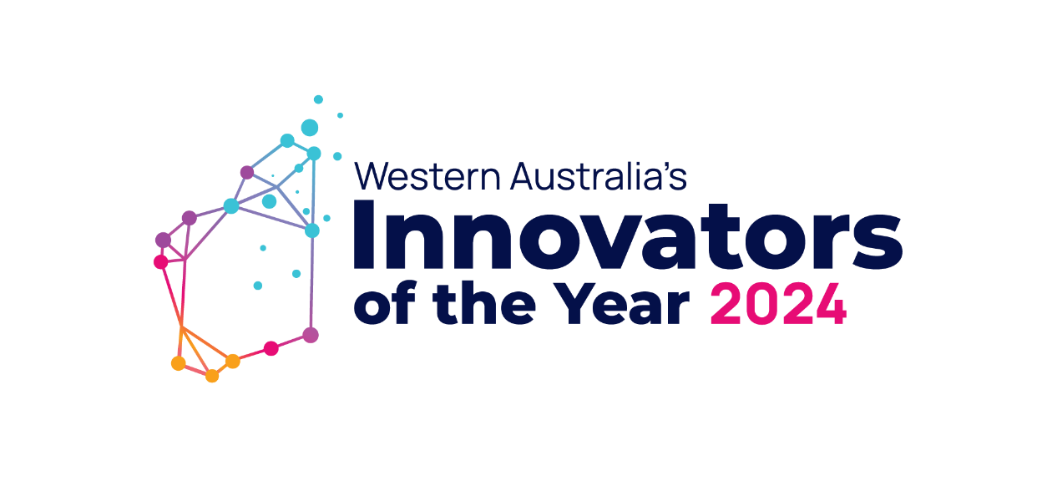
Key Messages for the Government Innovators of the Year Award
- Expressions of Interest for the Government Innovators of the Year Award open Thursday 30 May 2024 and close at 11:00AM (AWST) Wednesday 31 July 2024.
- The Government Innovators of the Year Award has been introduced to acknowledge state government employees who are innovating, creating novel IP and adding value to public service delivery.
- The new award category was announced by the Minister for Innovation and the Digital Economy Stephen Dawson on Wednesday 24 April at the WAIOTY 2024 awards program launch, hosted at Perth Morning Startup.
- To be considered for this award, applications are completed via and online expressions of interest form.
- The WAIOTY awards are in their 18th year, showcasing Western Australian innovative and entrepreneurial individuals, businesses, and creative minds since 2006.
- The awards program is an initiative of the New Industries Fund. The fund aims to support an accelerate new and emerging businesses in WA.
- The innovations must demonstrate an economic, social, and/or environmental benefit to WA.
- The 2024 program recognises Western Australian innovators through 8 awards across 6 categories.
- Find more information on eligibility and how to apply for the Government Innovators of the year award on the application guidelines page.
Agency social post Suggestion | Calling all creative minds in Western Australia’s public sector!  Expressions of interest for the first ever Government Innovators of the Year Award is open through the @Department of Jobs, Tourism, Science and Innovation.  Finalists will be invited to the Western Australia's Innovators of the Year 2024 awards night!  Winners will receive a place on the @Australian Innovation Management Institute’s (AIMI) Certified Innovation Catalyst Program, courtesy of the award’s sponsor, AIMI.  The program is open to all WA Government employees.  Applications close at 11:00am (AWST) Wednesday 31 July 2024.  To learn more or to apply, visit: WAIOTY 2024: Government Innovators of the Year award (www.wa.gov.au)
Tags | @LikeNoOtherWA  @Department-of-Jobs-Tourism-Science-and-Innovation  @StephenDawson @RogerCookMLA @RioTintoAustralia @BusinessNews @Wesfarmers @WoodsideEnergy @GriffithHack @NexiaPerth @Wrays @CSIRO @MooreAustralia @Betterlabs @AIMI @CERI @BiodesignAustralia
Hashtags | #WAIOTY24 #IOTY #WAIOTY #NewIndustriesFund #Innovation #WesternAustralia #LikeNoOtherWA
Agency internal e-news article suggestions | Expressions of interest are open for the first ever Government Innovators of the Year Award.  WA Government employees who develop novel products, services and technologies that enhance government operations and add value to the public service delivery are encouraged to apply.  Finalists will be invited to the Western Australia’s Innovators of the Year 2024 awards night in October.  Winners will receive a place on the Australian Innovation Management Institute’s (AIMI) Certified Innovation Catalyst Program, courtesy of the award’s sponsor, AIMI.  The newly added category in Western Australia's Innovators of the Year 2024 awards program is an initiative of the New Industries Fund under The Department of Jobs, Tourism, Science and Innovation.  Applications close 11:00am Wednesday 31 July 2024.  To learn more and apply for the award, visit the application page.  Learn more about the awards program on the New Industries Fund: Western Australia’s Innovators of the Year homepage.

