Western Australian Public Sector Quarterly Workforce Report –
March 2022

About this information
This page presents a snapshot of the public sector workforce based on the most recent data available. More detailed workforce information (including information on other government entities) is available in the State of the WA Government Sector Workforce 2020-21.

Please see the Commission’s About our workforce data page for additional contextual information.

Overview of the public sector as at March 2022
Headcount |  | 159,839
Full-time equivalent (FTE) |  | 125,623
General government salaries expenses  (March quarter) |  | $3,476 M
Public sector median age |  | 45
Top 3 occupation groups (FTE) | Teachers | 18.7%
 | Clerical workers | 16.8%
 | Nurses and midwives | 11.3%

Diversity groups | March 2022 |  | Aspirational target
Women in the SES | Representation | 43.8% | 50.0%
 | Headcount | 162
Aboriginal and Torres Strait Islander people | Representation | 2.8% | 3.7%
 | Headcount | 3,363
People with disability | Representation | 1.5% | 5.0%
 | Headcount | 1,867
Culturally and linguistically diverse people | Representation | 15.7% | 15.5%
 | Headcount | 17,839
Youth  (aged 24 and under) | Representation | 5.3% | 5.8%
 | Headcount | 8,446
Mature  (aged 45 and over) | Representation | 50.6% | n.a.
 | Headcount | 80,871

Sector profile

Employment trends
In March 2022 the WA public sector employed 159,839 people, equating to 125,623 full time equivalent (FTE) employees.

In headcount terms, this reflected a quarterly increase of 3,876 (+2.5%) since December 2021, and an annual increase of 8,086 (+5.3%) since March 2021.

In FTE terms, this reflects a quarterly increase of 3,262 (+2.7%) since December 2021 and an annual increase of 5,266 (+4.4%) since March 2021.

Over the quarter, the Department of Education increased by 523 headcount (+0.9%) and 1,020 FTE (+2.4%), in line with the start of the new school term. The increase related to growth in student enrolments and opening of new schools, implementing commitments to employ more education assistants especially for students in need of additional support, and continuing to respond to the COVID-19 pandemic.

The WA Health portfolio has increased by 3,148 headcount (+5.8%) and 2,257 FTE (+5.5%) over the quarter. Over 12 months, this represented an increase of 5,986 headcount (+11.5%) and 3,968 FTE (10.1%), accounting for approximately 75% of net growth in the public sector. Increases occurred across the Department of Health and all Health Service Providers, led by South Metropolitan Health Service (+1,224 FTE), East Metropolitan Health Service (+705 FTE), Child and Adolescent Health Service (+684 FTE) and WA Country Health Service (+647 FTE).

The majority (52.2%) of the increase in WA Health related to patient care including an increase of 1,124 registered nurses and midwives, 360 allied health professionals, 313 nursing support and personal care workers, and 273 medical practitioners. Administrative staff comprised an additional 22.7% of the increase (899 additional FTE), with the remainder distributed across other roles.

Overall, WA Health has reported increases related to the management of COVID-19 and extension of the vaccination and booster program, along with increased mental health services and operational demands.

All other agencies remained relatively stable over the quarter.

Salaries expenditure
General government salaries for the first nine months of 2021-22 grew by 6% to total $10,562 million. Salaries represent the single largest component of general government sector expenses (41.5% for the nine months to 31 March 2022, or 45.8% if concurrent superannuation costs are also included). For more information on salaries expenditure, please refer to Department of Treasury’s Quarterly Financial Results Report.

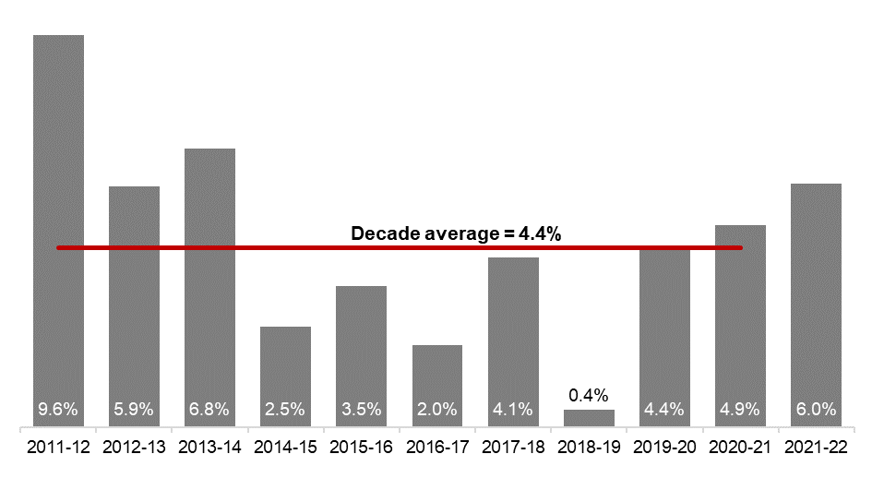
[ALT text - Salaries growth for the March quarter of 2021-22 was 6.0%, compared to a ten-year average of 4.4%.]

Source: Department of Treasury

Historical headcount, FTE and salaries expenditure
Quarter | Headcount | FTE | Quarterly salaries  expenditure ($M)
September 2015 | 139,277 | 109,919 | 2,837
December 2015 | 137,520 | 108,325 | 2,888
March 2016 | 137,371 | 108,722 | 2,801
June 2016 | 135,770 | 107,809 | 2,857
September 2016 | 137,746 | 109,295 | 2,887
December 2016 | 135,936 | 106,830 | 2,931
March 2017 | 139,144 | 109,895 | 2,880
June 2017 | 140,403 | 110,662 | 2,912
September 2017 | 141,609 | 111,472 | 2,980
December 2017 | 137,878 | 108,371 | 3,029
March 2018 | 140,799 | 110,404 | 3,049
June 2018 | 139,812 | 110,373 | 3,135
September 2018 | 141,744 | 111,255 | 3,023
December 2018 | 138,678 | 108,601 | 3,091
March 2019 | 142,278 | 112,099 | 2,982
June 2019 | 142,735 | 111,932 | 3,172
September 2019 | 143,775 | 113,367 | 3,140
December 2019 | 143,586 | 113,143 | 3,212
March 2020 | 146,343 | 115,548 | 3,147
June 2020 | 146,562 | 116,878 | 3,366
September 2020 | 148,408 | 117,773 | 3,319
December 2020 | 148,532 | 117,664 | 3,350
March 2021 | 151,753 | 120,357 | 3,298
June 2021 | 153,396 | 121,298 | 3,502
September 2021 | 155,931 | 123,034 | 3,512
December 2021 | 155,963 | 122,361 | 3,574
March 2022 | 159,839 | 125,623 | 3,476

WA public sector agencies’ staffing levels
Agency | Mar-22  Headcount | Mar-22  FTE | FTE change from  Dec-21 | FTE change from  Mar-21
WA public sector | 159,839 | 125,623 | 3,262 | 5,266
Department of Education | 57,806 | 43,714 | 1,020 | 1,271
WA Health | 57,855 | 43,392 | 2,257 | 3,968
WA Health (North Metropolitan Health Service) | 12,410 | 9,276 | 434 | 459
WA Health (South Metropolitan Health Service) | 11,563 | 8,658 | 516 | 1,224
WA Health (WA Country Health Service) | 11,464 | 8,610 | 459 | 647
WA Health (East Metropolitan Health Service) | 9,750 | 7,509 | 466 | 705
WA Health (Child and Adolescent Health Service) | 6,521 | 4,488 | 224 | 684
WA Health (PathWest) | 2,555 | 2,016 | 130 | 198
WA Health (Health Support Services) | 2,293 | 1,714 | 13 | -7
WA Health (Department of Health) | 1,299 | 1,121 | 14 | 57
Department of Justice | 7,432 | 6,760 | -161 | -193
Department of Communities | 5,852 | 5,113 | 12 | -21
Western Australia Police | 2,894 | 2,128 | -14 | -65
Department of Biodiversity, Conservation and Attractions | 2,408 | 2,046 | 25 | 67
Public Transport Authority | 2,279 | 2,174 | 6 | 51
Department of Primary Industries and Regional Development | 1,916 | 1,728 | 0 | 68
Department of Fire and Emergency Services | 1,828 | 1,673 | -19 | -1
Department of Mines, Industry Regulation and Safety | 1,728 | 1,614 | 1 | -33
Department of Transport | 1,631 | 1,464 | 6 | 47
North Metropolitan TAFE | 1,494 | 1,201 | 21 | -29
South Metropolitan TAFE | 1,418 | 1,189 | 55 | -32
Main Roads Western Australia | 1,234 | 1,158 | 7 | -10
Department of Local Government, Sport and Cultural Industries | 1,190 | 943 | 21 | 11
Department of Finance | 1,101 | 1,013 | -2 | -10
Department of Water and Environmental Regulation | 968 | 860 | 7 | 16
Department of Planning, Lands and Heritage | 918 | 815 | 21 | 27
Department of the Premier and Cabinet | 673 | 602 | 8 | 73
South Regional TAFE | 582 | 415 | 12 | -30
VenuesWest | 510 | 258 | -2 | -6
Department of Training and Workforce Development | 493 | 435 | 2 | 5
Landgate | 483 | 432 | -11 | -35
Insurance Commission of Western Australia | 435 | 384 | 1 | -4
Mental Health Commission | 429 | 348 | -5 | 54
Central Regional TAFE | 415 | 331 | -2 | -33
Legal Aid Commission of Western Australia | 408 | 354 | 7 | 36
Department of Jobs, Tourism, Science and Innovation | 383 | 343 | 11 | 31
North Regional TAFE | 326 | 301 | -2 | 7
Office of the Director of Public Prosecutions | 321 | 283 | 0 | -1
Lotterywest | 291 | 274 | 0 | 31
Department of Treasury | 278 | 250 | 10 | -1
Office of the Auditor General | 210 | 188 | 10 | 5
Public Sector Commission | 204 | 130 | 0 | 4
Forest Products Commission | 167 | 157 | -21 | -5
ChemCentre | 153 | 140 | 0 | 6
Metropolitan Cemeteries Board | 152 | 141 | -2 | -5
WorkCover Western Australia | 142 | 128 | 0 | -1
Corruption and Crime Commission | 120 | 115 | -2 | -7
Ombudsman Western Australia | 77 | 66 | -2 | 0
Small Business Development Corporation | 67 | 59 | 2 | 2
Economic Regulation Authority | 66 | 60 | -4 | -8
GESB | 65 | 61 | 2 | 5
Animal Resources Centre | 65 | 61 | -2 | -1
Western Australian Electoral Commission | 46 | 45 | -3 | -3
Legal Practice Board | 37 | 34 | -5 | -5
Department of the Registrar, Western Australian Industrial Relations Commission | 37 | 35 | -1 | 1
Construction Training Fund | 36 | 30 | 1 | 9
Western Australian Meat Industry Authority | 32 | 20 | 0 | 4
National Trust of Australia (W.A.) | 27 | 21 | -1 | -5
MyLeave | 24 | 23 | 0 | 23
Health and Disability Services Complaints Office | 20 | 17 | 3 | 2
Office of the Inspector of Custodial Services | 18 | 15 | 0 | 0
Metropolitan Redevelopment Authority | 16 | 13 | -3 | -10
Commissioner for Children and Young People | 15 | 12 | -2 | -6
Infrastructure WA | 14 | 13 | 0 | -2
Office of the Information Commissioner | 14 | 12 | 0 | 1
Burswood Park Board | 9 | 8 | 1 | 1
Keep Australia Beautiful WA | 8 | 7 | 0 | -1
Minerals Research Institute of Western Australia (MRIWA) | 6 | 6 | 1 | 2
Veterinary Surgeons' Board | 6 | 5 | 0 | 0
Salaries and Allowances Tribunal | 4 | 4 | 1 | 2
Architects Board of Western Australia | 3 | 3 | 0 | 1

Data quality statement
Information is based on an aggregate of agency supplied data, collected quarterly through the Human Resource Minimum Obligatory Information Requirements (HR MOIR). Data is supplied by agencies according to the guidelines set out in HR MOIR Data Definitions 1.5.1.
The information provided reflects the Commission’s holdings at the date of release. Workforce data is occasionally revised for quality, and corrections applied may result in figures being adjusted over time. This information relates only to public sector (Department, SES and non-SES agencies), and excludes sworn officers of the WA Police Force, public universities, local governments, government trading enterprises and other authorities.
All data is accurate as reported to us by contributing agencies.
As some figures have been rounded, discrepancies may occur between sums of the component items and totals. Salaries expenditure data and information is provided by the Department of Treasury.

Contact
All enquiries about the Public Sector Commission’s data should be directed to stateadministrator@psc.wa.gov.au.

