Western Australian Public Sector Quarterly Workforce Report – March 2021

About this information
This page presents a snapshot of the public sector workforce based on the most recent data available. More detailed workforce information (including information on other government entities) is available in the State of the WA Government Sector Workforce 2019-20.

Please see the Commission’s About our workforce data page for additional contextual information.

Overview of the public sector as of March 2021
Headcount |  | 151,753
Full-time equivalent (FTE) |  | 120,357
General government expenses (March quarter) |  | $3,298m
Senior Executive Service (SES) |  | 400
Public sector median age |  | 45
Top 3 occupation groups (FTE) | Teachers | 19.1%
 | Clerical workers | 16.5%
 | Nurses and midwives | 10.9%

Diversity groups | March 2021 |  | Aspirational target
Women in SES | Representation | 43.5% | 50.0%
 | Headcount | 174
Aboriginal and Torres Strait Islander people | Representation | 2.7% | 3.7%
 | Headcount | 3,115
People with disability | Representation | 1.5% | 5.0%
 | Headcount | 1,734
Culturally and linguistically diverse people | Representation | 14.6% | 15.5%
 | Headcount | 15,382
Youth  (aged 24 and under) | Representation | 4.3% | 5.8%
 | Headcount | 6,529
Mature  (aged 45 and over) | Representation | 52.0% | n.a.
 | Headcount | 78,866

Sector profile

Employment trends
In March 2021 the WA public sector employed 151,753 people, equating to 120,357 full-time equivalent (FTE) employees.

In headcount terms, this reflected a quarterly increase of 3,221 (+2.2%) since December 2020, and an annual increase of 5,410 (+3.7%) since March 2020.

In FTE terms, this reflects a quarterly increase of 2,693 (+2.3%) since December 2020 and an annual increase of 4,809 (+4.2%) since March 2020.

WA Health continues to drive growth in staffing levels, accounting for over just over half (50.5%) of the total increase in headcount this quarter. Between December 2020 and March 2021, WA Health’s headcount increased by 1,625 (+3.2%) while FTE increased by 1,122 (+2.9%). WA Health reported that these increases were related to system-wide activities associated with COVID-19 response including, but not limited to, resourcing for contact tracing and vaccination programs.

The Department of Education’s headcount increased by 1,048 (+1.9%) and FTE by 1,228 (+3.0%) between December 2020 and March 2021. This reflects schools reopening from February 2021, and is similar to the increase in the March 2020 quarter.

Staffing at the 5 TAFE colleges increased by 517 headcount (+13.5%) and 371 FTE (+11.7%) with the recommencement of the semester. Two of the colleges reported increased demand for lecturers, with Central Regional TAFE employing more lecturers due to the uptake of free and half price TAFE courses.

WA Police continued its expansion, increasing by 137 headcount in the March 2021 quarter.

A small number of agencies saw decreases in headcount and FTE, with the most notable being the Department of Communities decreasing by 315 headcount (-5.2%) or 207 FTE (-3.9%). This included cessation of fixed term contracts, severances, secondments and retirements.

Salaries expenditure
Salaries represent the single largest component of general government sector expenses (41% for March 2021, or 45% if concurrent superannuation costs are also included).

General government salaries for the first nine months of 2020–21 grew by 4.9% to total $9,967 million.
Figure 1. Salaries growth for the first nine months of each financial year (to the March quarter), since 2010–11 (general government)
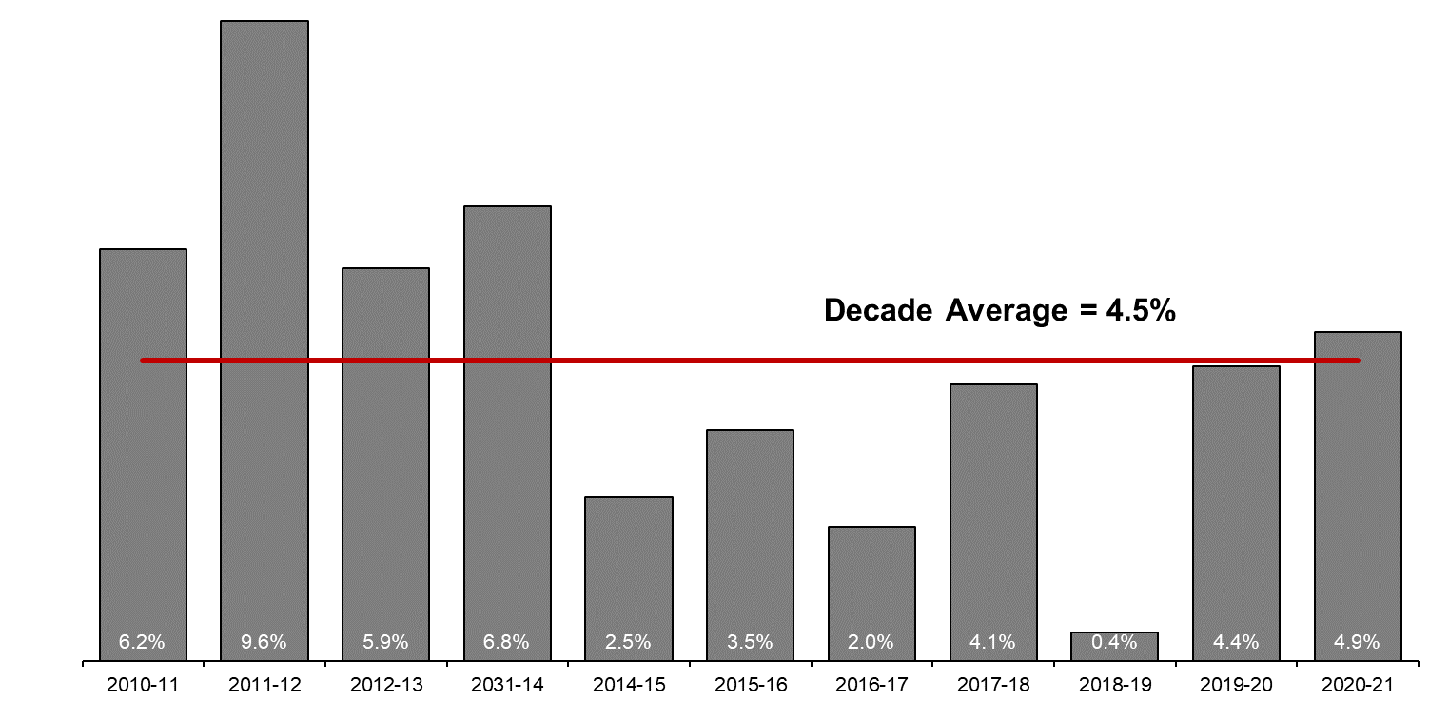 [ALT text - Salaries growth for the first nine months of 2020–21 was 4.9%, compared to a ten-year average of 4.5%.]
Source: Department of Treasury

Historical headcount, FTE and salaries expenditure
Quarter | Headcount | FTE | Quarterly salaries  expenditure ($m)
September 2015 | 139,277 | 109,919 | 2,837
December 2015 | 137,520 | 108,325 | 2,888
March 2016 | 137,371 | 108,722 | 2,801
June 2016 | 135,770 | 107,809 | 2,857
September 2016 | 137,746 | 109,295 | 2,887
December 2016 | 135,936 | 106,830 | 2,931
March 2017 | 139,144 | 109,895 | 2,880
June 2017 | 140,403 | 110,662 | 2,912
September 2017 | 141,609 | 111,472 | 2,980
December 2017 | 137,878 | 108,371 | 3,029
March 2018 | 140,799 | 110,404 | 3,049
June 2018 | 139,812 | 110,373 | 3,135
September 2018 | 141,744 | 111,255 | 3,023
December 2018 | 138,678 | 108,601 | 3,091
March 2019 | 142,278 | 112,099 | 2,982
June 2019 | 142,735 | 111,932 | 3,172
September 2019 | 143,775 | 113,367 | 3,140
December 2019 | 143,586 | 113,143 | 3,212
March 2020 | 146,343 | 115,548 | 3,147
June 2020 | 146,562 | 116,878 | 3,366
September 2020 | 148,408 | 117,793 | 3,319
December 2020 | 148,532 | 117,664 | 3,350
March 2021 | 151,753 | 120,357 | 3,298

WA Public Sector agencies’ staffing levels
Agency | Mar-21  Headcount | Mar-21  FTE | FTE change from  Dec-20 | FTE change from Mar-20
Western Australian Public Sector | 151,753 | 120,357 | +2,693 | +4,809
Department of Education | 56,248 | 42,443 | +1,228 | +1,872
WA Health | 51,869 | 39,424 | +1,121 | +2,149
North Metropolitan Health Service | 11,724 | 8,816 | +150 | +237
WA Country Health Service | 10,499 | 7,963 | +151 | +251
South Metropolitan Health Service | 9,782 | 7,434 | +265 | +495
East Metropolitan Health Service | 8,747 | 6,803 | +221 | +414
Child and Adolescent Health Service | 5,284 | 3,804 | +147 | +188
Health Support Services | 2,309 | 1,721 | +124 | +255
PathWest | 2,287 | 1,818 | +10 | +90
Department of Health | 1,237 | 1,065 | +53 | +220
Department of Justice | 7,448 | 6,953 | +55 | +480
Department of Communities | 5,750 | 5,134 | -207 | -523
Western Australia Police | 2,964 | 2,193 | +28 | +67
Department of Biodiversity, Conservation and Attractions | 2,345 | 1,979 | -1 | +46
Public Transport Authority | 2,226 | 2,123 | +5 | +99
Department of Primary Industries and Regional Development | 1,836 | 1,660 | +33 | +100
Department of Fire and Emergency Services | 1,791 | 1,674 | -7 | +36
Department of Mines, Industry Regulation and Safety | 1,768 | 1,647 | +21 | +68
Department of Transport | 1,552 | 1,417 | 0 | +63
North Metropolitan TAFE | 1,513 | 1,230 | +133 | +60
South Metropolitan TAFE | 1,450 | 1,221 | +113 | -9
Main Roads Western Australia | 1,231 | 1,168 | +30 | +73
Department of Local Government, Sport and Cultural Industries | 1,215 | 932 | +15 | +14
Department of Finance | 1,089 | 1,023 | +24 | +92
Department of Water and Environmental Regulation | 940 | 845 | -7 | -6
Department of Planning, Lands and Heritage | 872 | 788 | -2 | +41
South Regional TAFE | 623 | 445 | +72 | +24
Department of the Premier and Cabinet | 593 | 528 | -28 | 0
Landgate | 504 | 467 | +6 | -16
VenuesWest | 502 | 264 | -13 | +22
Department of Training and Workforce Development | 483 | 430 | -1 | +13
Central Regional TAFE | 440 | 364 | +37 | +20
Insurance Commission of Western Australia | 424 | 388 | +12 | +4
Mental Health Commission | 364 | 294 | +1 | +19
Legal Aid Commission of Western Australia | 361 | 318 | -1 | +14
Department of Jobs, Tourism, Science and Innovation | 347 | 313 | +22 | +27
North Regional TAFE | 323 | 294 | +16 | +5
Office of the Director of Public Prosecutions | 314 | 283 | +6 | +16
Department of Treasury | 274 | 251 | -4 | +1
Lotterywest | 257 | 243 | +2 | -8
Office of the Auditor General | 194 | 183 | +19 | +33
Public Sector Commission | 181 | 127 | +5 | -2
Forest Products Commission | 173 | 163 | -23 | -12
Metropolitan Cemeteries Board | 160 | 146 | -3 | -6
ChemCentre | 147 | 134 | 0 | -3
WorkCover Western Australia | 145 | 129 | -4 | +4
Corruption and Crime Commission | 127 | 122 | -5 | -6
Ombudsman Western Australia | 80 | 66 | +1 | +1
Economic Regulation Authority | 74 | 67 | +4 | +5
Animal Resources Centre | 66 | 62 | +3 | -2
Small Business Development Corporation | 64 | 57 | +3 | +2
GESB | 61 | 56 | +3 | +6
Western Australian Electoral Commission | 51 | 48 | +3 | +7
Legal Practice Board | 41 | 39 | -3 | -2
National Trust of Australia (W.A.) | 37 | 26 | +1 | -4
Department of the Registrar, Western Australian Industrial Relations Commission | 35 | 34 | -5 | 0
Metropolitan Redevelopment Authority | 28 | 23 | -18 | -68
Western Australian Meat Industry Authority | 27 | 16 | -2 | -3
Construction Training Fund | 25 | 21 | +1 | +1
Health and Disability Services Complaints Office | 21 | 15 | +1 | -2
Commissioner for Children and Young People | 20 | 18 | +4 | +3
Office of the Inspector of Custodial Services | 18 | 15 | 0 | +3
Infrastructure WA | 16 | 15 | 0 | +13
Office of the Information Commissioner | 13 | 12 | 0 | +2
Keep Australia Beautiful WA | 10 | 8 | -3 | -1
Burswood Park Board | 8 | 6 | 0 | +1
Veterinary Surgeons' Board | 6 | 4 | 0 | 0
Minerals Research Institute of Western Australia (MRIWA) | 5 | 5 | -1 | -1
Architects Board of Western Australia | 2 | 2 | 0 | -1
Salaries and Allowances Tribunal | 2 | 2 | 0 | 0

Data quality statement
Information is based on an aggregate of agency supplied data, collected quarterly through the Human Resource Minimum Obligatory Information Requirement (HR MOIR). Data is supplied by agencies according to the guidelines set out in HR MOIR Data Definitions 1.5.1.
The information provided reflects the Commission’s holdings at the date of release. Workforce data is occasionally revised for quality, and corrections applied may result in figures being adjusted over time. This information relates only to public sector (Department, SES and non-SES agencies), and excludes sworn officers of the WA Police Force, public universities, local governments, government trading enterprises and other authorities.
All data is accurate as reported to us by contributing agencies.
As some figures have been rounded, discrepancies may occur between sums of the component items and totals. Salaries expenditure data and information is provided by the Department of Treasury.

Contact
All enquiries about the Public Sector Commission’s data should be directed to stateadministrator@psc.wa.gov.au.

