Western Australian Public Sector Quarterly Workforce Report – March 2020

About this information

This page presents a snapshot of the Public Sector workforce based on the most recent data available. More detailed workforce information (including information on other government entities) is available in the State of the Western Australian Government Sector Workforce 2018/19.

Please see the Commission’s About our workforce data page for additional contextual information.

Overview of the Public Sector as of 31 March 2020
Headcount |  | 146 343
Full-time equivalent (FTE) |  | 115 548
General government expenses (March quarter) |  | $3 147M
Senior Executive Service (SES) |  | 412
Women in SES |  | 175
Aboriginal and Torres Strait Islander |  | 2.7%
People with disability |  | 1.5%
Culturally and linguistically diverse |  | 13.9%
Aged 34 and under |  | 23.6%
Aged 55 and over |  | 26.9%
Median age |  | 46
Top 3 occupation groups (FTE) | Teachers | 19.3%
 | Clerical workers | 16.6%
 | Nurses and midwives | 10.9%

Sector profile
Employment trends
In March 2020, the WA public sector employed 146 343 people (headcount), an increase of 2757 from December 2019. The number of full-time equivalent (FTE) showed a similar increase of 2406 to 115 548.
The majority of the increase relates to additional employees to support WA Health respond to COVID-19 and seasonal variation with the recommencement of the academic year.
The March quarter usually sees a quarterly increase in WA Health agencies, as fixed term contracts are renewed and new intakes of graduate medical officers are conducted. March 2020, however, had a quarterly increase of 3.2 per cent
(+1166 FTE) compared to only 2.4 per cent for the same period in 2017-18 and 2018-19. The greater increase this year accompanied COVID-19 coronavirus clinics being established, increased COVID-19 testing, and other efforts to help combat the pandemic. Approximately three quarters of the increase in the Health portfolio was accounted for by nursing, medical and health professionals and support staff in those areas.
The other main component of increase in headcount and FTE is associated with the education sector. These increases follow the usual seasonal cycle and relate to the commencement of the 2020 academic semester.
Salaries expenditure
Relative to the same period in 2018-19, general government salaries grew by $402 million (or 4.4 per cent) over the first three quarters of 2019-20, to total $9499 million. Salaries in the health, education, law and order, and community services sectors account for over 83 per cent of general government salaries costs in the March outcome. Higher salary costs included increases under the Government’s Wages Policy and other prevailing industrial agreements, the impact of the Government’s commitment to convert eligible casual and fixed-term contract staff to permanent employees across the sector, and other movements in the sector’s workforce.
Figure 1. Salaries growth for the nine months to 31 March (general government)
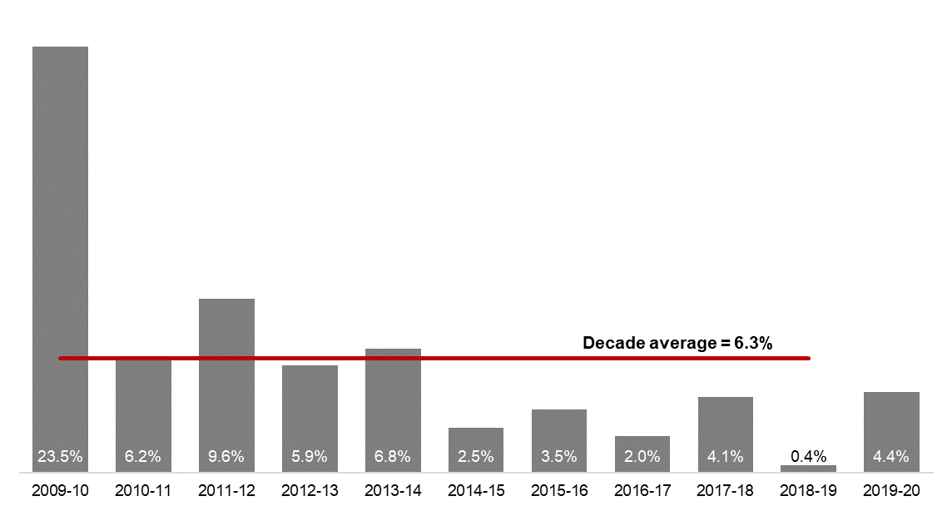
[ALT text - Salaries growth for the nine months to 31 March (general government) was 4.4 per cent in 2019-20, compared to a ten-year average of 6.3 percent.]
Source: Department of Treasury

Historical headcount, FTE and salaries expenditure
Quarter | Headcount | FTE | Salaries  expenditure ($M)
September 2015 | 139 277 | 109 919 | 2 837
December 2015 | 137 520 | 108 325 | 2 888
March 2016 | 137 371 | 108 722 | 2 801
June 2016 | 135 770 | 107 809 | 2 857
September 2016 | 137 746 | 109 295 | 2 887
December 2016 | 135 936 | 106 830 | 2 931
March 2017 | 139 144 | 109 895 | 2 880
June 2017 | 140 403 | 110 662 | 2 912
September 2017 | 141 609 | 111 472 | 2 980
December 2017 | 137 878 | 108 371 | 3 029
March 2018 | 140 799 | 110 404 | 3 049
June 2018 | 139 812 | 110 373 | 3 135
September 2018 | 141 744 | 111 255 | 3 023
December 2018 | 138 678 | 108 601 | 3 091
March 2019 | 142 278 | 112 099 | 2 982
June 2019 | 142 735 | 111 932 | 3 172
September 2019 | 143 775 | 113 367 | 3 140
December 2019 | 143 586 | 113 143 | 3 212
March 2020 | 146 343 | 115 548 | 3 147

WA public sector entities staffing levels
Agency | Mar-20 Headcount | Mar-20 FTE | FTE change from Dec-19 | FTE change from Mar-19
Western Australian Public Sector | 146 343 | 115 548 | 2 406 | 3 449
Department of Education | 54 281 | 40 571 | 555 | 938
WA Health (North Metropolitan Health Service) | 11 381 | 8 580 | -212 | -468
WA Health (WA Country Health Service) | 10 179 | 7 713 | 274 | 212
WA Health (South Metropolitan Health Service) | 9 157 | 6 939 | 173 | 84
WA Health (East Metropolitan Health Service) | 8 122 | 6 390 | 192 | 120
Department of Justice | 6 984 | 6 473 | 83 | 589
Department of Communities | 6 497 | 5 657 | 40 | 270
WA Health (Child and Adolescent Health Service) ^{i} | 5 005 | 3 616 | 499 | 471
Western Australia Police | 2 899 | 2 126 | -6 | 49
WA Health (PathWest) | 2 121 | 1 728 | 33 | 139
WA Health (Health Support Services) | 2 120 | 1 465 | 169 | 100
Public Transport Authority | 2 108 | 2 024 | 55 | 92
Department of Biodiversity, Conservation and Attractions | 2 283 | 1 933 | 1 | 77
Department of Fire and Emergency Services | 1 762 | 1 638 | -11 | 15
Department of Primary Industries and Regional Development | 1 735 | 1 560 | 8 | -10
Department of Mines, Industry Regulation and Safety | 1 698 | 1 579 | 37 | 176
Department of Transport | 1 460 | 1 354 | -6 | 25
North Metropolitan TAFE | 1 458 | 1 170 | 81 | -60
South Metropolitan TAFE | 1 442 | 1 230 | 169 | 72
Department of Local Government, Sport and Cultural Industries | 1 174 | 919 | 50 | 57
Main Roads Western Australia | 1 142 | 1 095 | 41 | 71
Department of Health | 1 006 | 845 | 39 | 131
Department of Finance | 993 | 931 | 35 | 11
Department of Water and Environmental Regulation | 980 | 851 | -6 | 55
Department of Planning, Lands and Heritage | 841 | 747 | -36 | 70
Department of the Premier and Cabinet | 603 | 529 | 1 | 36
South Regional TAFE | 587 | 422 | 71 | 0
Landgate | 511 | 483 | 9 | 17
VenuesWest | 473 | 242 | -20 | -28
Department of Training and Workforce Development | 470 | 417 | 0 | 15
Insurance Commission of Western Australia | 419 | 383 | -2 | 26
Central Regional TAFE | 418 | 344 | 34 | -6
Legal Aid Commission of Western Australia | 348 | 304 | 0 | 6
Mental Health Commission | 336 | 275 | -4 | -14
Department of Jobs, Tourism, Science and Innovation | 319 | 286 | 7 | 31
North Regional TAFE | 314 | 289 | 6 | 5
Office of the Director of Public Prosecutions | 297 | 267 | 7 | 19
Department of Treasury | 270 | 251 | 8 | -32
Lotterywest | 262 | 251 | 4 | 16
Forest Products Commission | 187 | 175 | -8 | 4
Public Sector Commission | 177 | 129 | 14 | 28
Metropolitan Cemeteries Board | 169 | 152 | 3 | 6
Office of the Auditor General | 168 | 150 | 0 | -7
ChemCentre | 147 | 137 | -1 | 2
Corruption and Crime Commission | 135 | 128 | 6 | 8
WorkCover Western Australia | 133 | 125 | 2 | 6
Metropolitan Redevelopment Authority | 99 | 91 | -4 | -7
Ombudsman Western Australia | 75 | 65 | 1 | 7
Animal Resources Centre | 68 | 63 | 3 | 4
Economic Regulation Authority | 67 | 63 | 1 | 5
Small Business Development Corporation | 62 | 55 | 0 | 7
GESB | 57 | 50 | 0 | 5
Legal Practice Board | 46 | 41 | 0 | -1
Western Australian Electoral Commission | 44 | 41 | 2 | 0
National Trust of Australia (W.A.) | 41 | 30 | 4 | 2
Department of the Registrar, Western Australian Industrial Relations Commission | 37 | 34 | -2 | 0
Western Australian Meat Industry Authority | 33 | 19 | 4 | 3
Construction Training Fund | 21 | 20 | 0 | -1
Equal Opportunity Commission | 21 | 20 | 1 | 0
Health and Disability Services Complaints Office | 21 | 17 | 2 | 3
Commissioner for Children and Young People | 19 | 15 | 2 | 0
Office of the Inspector of Custodial Services | 17 | 13 | -2 | -7
Office of the Information Commissioner | 10 | 9 | 0 | -2
Keep Australia Beautiful WA | 10 | 9 | 0 | -2
Burswood Park Board | 6 | 5 | 0 | 1
Veterinary Surgeons' Board | 6 | 5 | 0 | 0
Minerals Research Institute of Western Australia (MRIWA) | 5 | 5 | 0 | 1
Architects Board of Western Australia | 3 | 3 | 1 | 1
Infrastructure WA | 2 | 2 | 1 | n.a.
Salaries and Allowances Tribunal | 2 | 2 | 0 | -1

Disclaimer
The Western Australian Government is committed to quality service to its customers and makes every attempt to ensure accuracy, currency and reliability of the information contained on the Public Sector Commission’s website or in its publications. However, changes in circumstances over time may impact on the veracity of this information.

Contact
All enquiries about the Public Sector Commission’s data should be directed to: stateadministrator@psc.wa.gov.au.

The North Metropolitan Health Service transferred the neonatal care function to Child and Adolescent Health Service in January 2020. This affected approximately 377 FTE.
The Department of Communities supports the Disability Services Commission (Headcount: 1248; FTE: 1030) and Housing Authority (Headcount: 2052; FTE: 1866) which remain statutory authorities.
Sworn officers are employed by the Police Force (a non-public sector entity as defined in the Public Sector Management Act 1994), separated from the Police Service.
The Department of Biodiversity, Conservation and Attractions includes the Botanic Gardens and Parks Authority (Headcount: 143; FTE: 103), Rottnest Island Authority (Headcount: 156; FTE: 131), and Zoological Parks Authority (Headcount: 196; FTE: 149) as part of administrative arrangements. However, these statutory authorities remain as separate entities and continue to employ their own staff.
While staff of regional development commissions are part of the Department of Primary Industries and Regional Development, regional development commissions and their respective chief executives and boards remain as separate entities under legislation. For the purposes of this report, the nine regional development commissions are included in the Department of Primary Industries and Regional Development.
Energy Policy WA was established on 5 September 2019 as a new sub-department within the Department of Mines, Industry Regulation and Safety (DMIRS) and employee numbers are included within DMIRS for the purposes of this report.
Infrastructure WA was established in July 2019 so no comparison exists with March 2019.

