Western Australian Public Sector Quarterly Workforce Report – June 2020

About this information

This page presents a snapshot of the public sector workforce based on the most recent data available. More detailed workforce information (including information on other government entities) is available in the State of the Western Australian Government Sector Workforce 2018/19.

Please see the Commission’s About our workforce data page for additional contextual information.

Overview of the public sector as of 30 June 2020
Headcount |  | 146,562
Full-time equivalent (FTE) |  | 116,878
General government expenses (June quarter) |  | $3,366M
Senior Executive Service (SES) |  | 413
Women in SES |  | 173
Aboriginal and Torres Strait Islander people |  | 2.7%
People with disability |  | 1.5%
Culturally and linguistically diverse people |  | 14.1%
Youth (aged 24 and under) |  | 3.9%
Mature (aged 45 and over) |  | 52.6%
Median age |  | 46
Top 3 occupation groups (FTE) | Teachers | 19.1%
 | Clerical workers | 16.5%
 | Nurses and midwives | 10.8%

Sector profile
Employment trends
In June 2020, the WA public sector employed 146,562 people (headcount), an increase of 219 from March 2020. The number of full-time equivalent (FTE) employees increased by 1,330 to 116,878.
In the January to March period, WA Health had a larger than usual quarterly increase associated with COVID-19 coronavirus clinics being established, increased COVID-19 testing, and other efforts to help combat the pandemic. In the June quarter, WA Health’s staffing levels remained relatively steady maintaining preparedness to respond to the pandemic.
The Department of Education had an increase of 1,138 FTE this quarter. Approximately 850 of these were cleaners, in line with the additional health and safety measures brought in to schools during the COVID-19 pandemic.
The Department of Justice also saw a significant increase of 292 FTE. The reasons for this include the Government’s decision to transition the Melaleuca Remand and Reintegration Facility into the public sector, as well as the commencement of 86 trainee prison officers and 31 trainee youth custodial officers.
Other changes in FTE over the quarter were due to seasonal factors including:
- a decrease in FTE at the Department of Biodiversity, Conservation and Attractions due to the end of the summer bushfire season
- a decrease in FTE at TAFE Colleges collectively as a result of the end of the first semester.

Salaries expenditure
Salaries are the single largest component of general government expenses (42% in in 2019–20, or 46% if concurrent superannuation costs are also included).
In 2019–20, general government salaries expenditure grew by 4.9% to total $12,865 million. This includes increases in workforce numbers particularly in health, education, law and order as well as community services, as well as increases in wage rates consistent with the Government’s $1,000 per year wages policy.
Figure 1. Salaries growth for the 2019–20 financial year (general government)
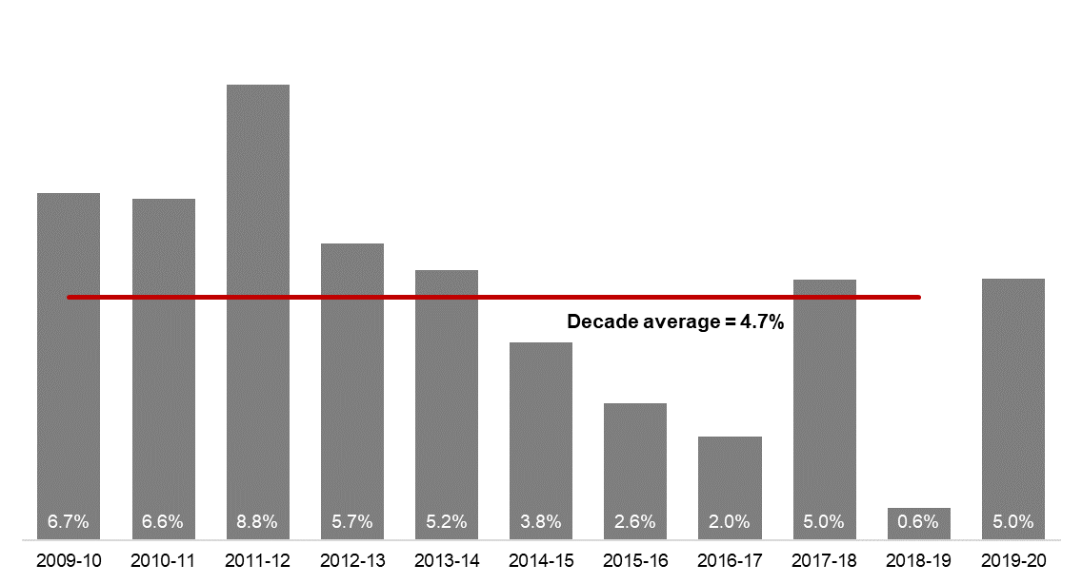
[ALT text - Salaries growth for the 2019–20 financial year was 5.0 per cent, compared to a ten-year average of 4.7 percent.]
Source: Department of Treasury

Historical headcount, FTE and salaries expenditure
Quarter | Headcount | FTE | Salaries  expenditure ($M)
September 2015 | 139,277 | 109,919 | 2,837
December 2015 | 137,520 | 108,325 | 2,888
March 2016 | 137,371 | 108,722 | 2,801
June 2016 | 135,770 | 107,809 | 2,857
September 2016 | 137,746 | 109,295 | 2,887
December 2016 | 135,936 | 106,830 | 2,931
March 2017 | 139,144 | 109,895 | 2,880
June 2017 | 140,403 | 110,662 | 2,912
September 2017 | 141,609 | 111,472 | 2,980
December 2017 | 137,878 | 108,371 | 3,029
March 2018 | 140,799 | 110,404 | 3,049
June 2018 | 139,812 | 110,373 | 3,135
September 2018 | 141,744 | 111,255 | 3,023
December 2018 | 138,678 | 108,601 | 3,091
March 2019 | 142,278 | 112,099 | 2,982
June 2019 | 142,735 | 111,932 | 3,172
September 2019 | 143,775 | 113,367 | 3,140
December 2019 | 143,586 | 113,143 | 3,212
March 2020 | 146,343 | 115,548 | 3,147
June 2020 | 146,562 | 116,878 | 3,366

WA public sector entities staffing levels
Agency | Jun-20 Headcount | Jun-20 FTE | FTE change from Mar-20 | FTE change from Jun-19
Western Australian Public Sector | 146,562 | 116,878 | 1,330 | 4,946
Department of Education | 55,062 | 41,710 | 1,138 | 1,597
WA Health | 48,835 | 37,432 | 157 | 1,810
North Metropolitan Health Service | 11,272 | 8,576 | -3 | -157
WA Country Health Service | 10,023 | 7,659 | -53 | 456
South Metropolitan Health Service | 9,111 | 6,957 | 18 | 284
East Metropolitan Health Service | 8,118 | 6,399 | 9 | 327
Child and Adolescent Health Service | 5,007 | 3,627 | 10 | 423
PathWest | 2,135 | 1,738 | 11 | 122
Health Support Services | 2,115 | 1,562 | 97 | 188
Department of Health | 1,054 | 914 | 68 | 167
Department of Justice | 7,255 | 6,766 | 292 | 731
Department of Communities | 6,233 | 5,497 | -160 | -26
Western Australia Police | 2,927 | 2,163 | 37 | 74
Department of Biodiversity, Conservation and Attractions | 2,201 | 1,836 | -96 | 49
Public Transport Authority | 2,131 | 2,074 | 49 | 123
Department of Fire and Emergency Services | 1,773 | 1,644 | 6 | 20
Department of Mines, Industry Regulation and Safety | 1,754 | 1,599 | 20 | 192
Department of Primary Industries and Regional Development | 1,749 | 1,584 | 24 | 4
Department of Transport | 1,506 | 1,387 | 32 | 45
North Metropolitan TAFE | 1,384 | 1,126 | -44 | -66
South Metropolitan TAFE | 1,361 | 1,134 | -96 | 57
Main Roads Western Australia | 1,141 | 1,099 | 4 | 74
Department of Local Government, Sport and Cultural Industries | 1,083 | 900 | -19 | 14
Department of Finance | 988 | 928 | -4 | 22
Department of Water and Environmental Regulation | 972 | 868 | 17 | 56
Department of Planning, Lands and Heritage | 874 | 782 | 35 | 26
Department of the Premier and Cabinet | 629 | 553 | 25 | 59
South Regional TAFE | 536 | 377 | -45 | 7
Landgate | 508 | 473 | -9 | 3
Department of Training and Workforce Development | 468 | 420 | 3 | 16
Insurance Commission of Western Australia | 421 | 384 | 1 | 12
Central Regional TAFE | 399 | 321 | -22 | -11
Legal Aid Commission of Western Australia | 356 | 307 | 4 | 19
Mental Health Commission | 346 | 284 | 9 | 5
Department of Jobs, Tourism, Science and Innovation | 321 | 284 | -2 | 21
Office of the Director of Public Prosecutions | 299 | 270 | 3 | 14
North Regional TAFE | 299 | 270 | -19 | -20
VenuesWest | 292 | 196 | -46 | -32
Department of Treasury | 278 | 255 | 5 | -30
Lotterywest | 269 | 257 | 6 | 20
Forest Products Commission | 222 | 192 | 17 | -1
Metropolitan Cemeteries Board | 169 | 154 | 2 | 5
Office of the Auditor General | 165 | 152 | 2 | -6
Public Sector Commission | 157 | 121 | -8 | 22
ChemCentre | 151 | 137 | 0 | 4
Corruption and Crime Commission | 133 | 125 | -3 | 6
WorkCover Western Australia | 131 | 124 | -2 | 1
Metropolitan Redevelopment Authority | 91 | 83 | -8 | -15
Ombudsman Western Australia | 75 | 64 | -1 | 3
Economic Regulation Authority | 70 | 65 | 2 | 6
Animal Resources Centre | 66 | 62 | -2 | 2
Small Business Development Corporation | 65 | 57 | 2 | 6
GESB | 58 | 51 | 1 | 5
Legal Practice Board | 49 | 44 | 3 | 4
Western Australian Electoral Commission | 43 | 41 | 0 | 0
National Trust of Australia (W.A.) | 40 | 30 | 0 | 1
Department of the Registrar, Western Australian Industrial Relations Commission | 35 | 33 | -1 | -1
Western Australian Meat Industry Authority | 31 | 17 | -1 | -1
Health and Disability Services Complaints Office | 23 | 21 | 4 | 5
Construction Training Fund | 23 | 22 | 2 | 0
Equal Opportunity Commission | 21 | 20 | 0 | 2
Commissioner for Children and Young People | 19 | 15 | 0 | 0
Office of the Inspector of Custodial Services | 19 | 15 | 3 | -4
Infrastructure WA | 13 | 13 | 11 | n.a.
Office of the Information Commissioner | 11 | 10 | 1 | -1
Keep Australia Beautiful WA | 10 | 9 | 0 | 1
Burswood Park Board | 7 | 5 | 0 | 0
Veterinary Surgeons' Board | 6 | 5 | 0 | 0
Minerals Research Institute of Western Australia (MRIWA) | 5 | 5 | 0 | 2
Architects Board of Western Australia | 2 | 2 | -1 | 0
Salaries and Allowances Tribunal | 2 | 2 | 0 | -1

Data quality statement
Information in this report is based on workforce data collected from agencies as at the end of each respective quarter. Data is supplied by agencies according to the guidelines set out in the HR MOIR Data Definitions 1.5.1. Workforce data is occasionally revised (e.g. discrepancies in agency data identified) and this may result in figures being adjusted.
Data covers only public sector agencies and does not include the WA Police Force (sworn officers), parliamentary electorate offices, local governments, government trading enterprises or public universities.
All data is accurate as reported to us by contributing agencies.
Totals may be affected by rounding.
Salaries expenditure data and information is provided by the Department of Treasury.
Changes since last report
The names of the diversity groups have been updated to match the Workforce Diversification and Inclusion Strategy 2020-2025 and data is now presented on people aged 24 and under to match the definition of Youth.
Data on people aged 55 and over has been replaced with data on Mature (aged 45 and over) to match reporting in the Director of Equal Opportunity in Public Employment annual report.

Contact
All enquiries about the Public Sector Commission’s data should be directed to stateadministrator@psc.wa.gov.au.

The Department of Communities supports the Disability Services Commission (Headcount: 1,150; FTE: 973) and Housing Authority (Headcount: 1,944; FTE: 1,799) which remain statutory authorities.
Sworn officers are employed by the Police Force (a non-public sector entity as defined in the Public Sector Management Act 1994), separated from the Police Service.
The Department of Biodiversity, Conservation and Attractions includes the Botanic Gardens and Parks Authority (Headcount: 141; FTE: 101), Rottnest Island Authority (Headcount: 146; FTE: 122), and Zoological Parks Authority (Headcount: 190; FTE: 148) as part of administrative arrangements. However, these statutory authorities remain as separate entities and continue to employ their own staff.
Energy Policy WA was established on 5 September 2019 as a new sub-department within the Department of Mines, Industry Regulation and Safety (DMIRS) and employee numbers are included within DMIRS for the purposes of this report.
While staff of regional development commissions are part of the Department of Primary Industries and Regional Development, regional development commissions and their respective chief executives and boards remain as separate entities under legislation. For the purposes of this report, the nine regional development commissions are included in the Department of Primary Industries and Regional Development.
Infrastructure WA was established in July 2019 so no comparison exists with June 2019.

