Western Australian Public Sector Quarterly Workforce Report – December 2021

About this information
This page presents a snapshot of the public sector workforce based on the most recent data available. More detailed workforce information (including information on other government entities) is available in the State of the WA Government Sector Workforce 2020-21.

Please see the Commission’s About our workforce data page for additional contextual information.

Overview of the public sector as at December 2021
Headcount |  | 155,963
Full-time equivalent (FTE) |  | 122,361
General government salaries expenses  (December quarter) |  | $3,574 M
Public sector median age |  | 45
Top 3 occupation groups (FTE) | Teachers | 18.8%
 | Clerical workers | 16.9%
 | Nurses and midwives | 11.0%

Diversity groups | December 2021 |  | Aspirational target
Women in the SES | Representation | 44.5% | 50.0%
 | Headcount | 165
Aboriginal and Torres Strait Islander people | Representation | 2.7% | 3.7%
 | Headcount | 3281
People with disability | Representation | 1.5% | 5.0%
 | Headcount | 1,836
Culturally and linguistically diverse people | Representation | 15.3% | 15.5%
 | Headcount | 17,121
Youth  (aged 24 and under) | Representation | 4.7% | 5.8%
 | Headcount | 7,357
Mature  (aged 45 and over) | Representation | 51.4% | n.a.
 | Headcount | 80,179

Sector profile

Employment trends
In December 2021 the WA public sector employed 155,963 people, equating to 122,361 full-time equivalent (FTE) employees.

In headcount terms, this reflected a quarterly increase of 32 (+0.0%) since September 2021, and an annual increase of 7,431 (+5.0%) since December 2020.

In FTE terms, this reflects a quarterly decrease of 673 (-0.5%) since September 2021 and an annual increase of 4,697 (+4.0%) since December 2020.

The Department of Education decreased by 432 headcount (-0.7%) and 926 FTE (-2.1%), in line with the end of year holiday period.

The WA Health portfolio saw total headcount and FTE stable between quarters, after several quarters of sustained increase. Where growth occurred for Health Service Providers this quarter, this related largely to COVID-19 vaccination response, including expanded capacity, vaccination, analysis and recruitment to allow existing staff to clear leave liability.

Salaries expenditure
General government salaries totalled $7,086 million in the first six months of 2021-22 (an increase of $417m or 6.3% compared to the same period in the prior year). Salaries represent the single largest component of general government sector expenses (41.5% for December 2021, or 45.8% if concurrent superannuation costs are also included). For more information on salaries expenditure, please refer to Department of Treasury’s Quarterly Financial Results Report.

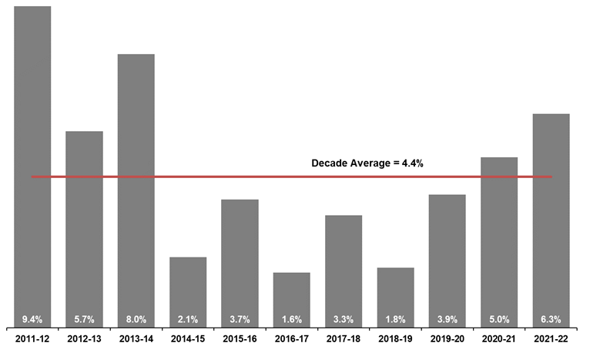
[ALT text - Salaries growth for the December quarter of 2021-22 was 6.3%, compared to a ten-year average of 4.4%.]

Source: Department of Treasury

Historical headcount, FTE and salaries expenditure
Quarter | Headcount | FTE | Quarterly salaries  expenditure ($M)
September 2015 | 139,277 | 109,919 | 2,837
December 2015 | 137,520 | 108,325 | 2,888
March 2016 | 137,371 | 108,722 | 2,801
June 2016 | 135,770 | 107,809 | 2,857
September 2016 | 137,746 | 109,295 | 2,887
December 2016 | 135,936 | 106,830 | 2,931
March 2017 | 139,144 | 109,895 | 2,880
June 2017 | 140,403 | 110,662 | 2,912
September 2017 | 141,609 | 111,472 | 2,980
December 2017 | 137,878 | 108,371 | 3,029
March 2018 | 140,799 | 110,404 | 3,049
June 2018 | 139,812 | 110,373 | 3,135
September 2018 | 141,744 | 111,255 | 3,023
December 2018 | 138,678 | 108,601 | 3,091
March 2019 | 142,278 | 112,099 | 2,982
June 2019 | 142,735 | 111,932 | 3,172
September 2019 | 143,775 | 113,367 | 3,140
December 2019 | 143,586 | 113,143 | 3,212
March 2020 | 146,343 | 115,548 | 3,147
June 2020 | 146,562 | 116,878 | 3,366
September 2020 | 148,408 | 117,773 | 3,319
December 2020 | 148,532 | 117,664 | 3,350
March 2021 | 151,753 | 120,357 | 3,298
June 2021 | 153,396 | 121,298 | 3,502
September 2021 | 155,931 | 123,034 | 3,512
December 2021 | 155,963 | 122,361 | 3,574

WA public sector agencies’ staffing levels
Agency | Dec-21  Headcount | Dec-21  FTE | FTE change from  Sep-21 | FTE change from  Dec-20
WA public sector | 155,963 | 122,361 | -673 | 4,697
Department of Education | 57,283 | 42,693 | -926 | 1,478
WA Health | 54,707 | 41,135 | -13 | 2,833
WA Health (North Metropolitan Health Service) | 11,836 | 8,842 | -96 | 175
WA Health (South Metropolitan Health Service) | 10,818 | 8,142 | -34 | 972
WA Health (WA Country Health Service) | 10,759 | 8,151 | -173 | 339
WA Health (East Metropolitan Health Service) | 9,178 | 7,042 | 125 | 460
WA Health (Child and Adolescent Health Service) | 6,149 | 4,264 | 41 | 607
WA Health (PathWest) | 2,388 | 1,886 | 28 | 79
WA Health (Health Support Services) | 2,313 | 1,701 | 103 | 104
WA Health (Department of Health) | 1,266 | 1,107 | -8 | 96
Department of Justice | 7,527 | 6,921 | 0 | 23
Department of Communities¹ | 5,798 | 5,101 | 174 | -240
Western Australia Police | 2,914 | 2,141 | -24 | -23
Department of Biodiversity, Conservation and Attractions | 2,394 | 2,020 | 70 | 40
Public Transport Authority | 2,264 | 2,167 | 5 | 49
Department of Primary Industries and Regional Development | 1,932 | 1,729 | 28 | 101
Department of Mines, Industry Regulation and Safety | 1,861 | 1,613 | -13 | -13
Department of Fire and Emergency Services | 1,807 | 1,691 | 20 | 10
Department of Transport | 1,620 | 1,458 | -15 | 41
North Metropolitan TAFE | 1,427 | 1,180 | -11 | 83
South Metropolitan TAFE | 1,341 | 1,134 | -26 | 26
Main Roads Western Australia | 1,219 | 1,150 | -17 | 12
Department of Local Government, Sport and Cultural Industries | 1,171 | 922 | -15 | 5
Department of Finance | 1,083 | 1,016 | -3 | 17
Department of Water and Environmental Regulation | 956 | 854 | 10 | 1
Department of Planning, Lands and Heritage | 886 | 794 | 11 | 4
Department of the Premier and Cabinet | 657 | 593 | 11 | 37
South Regional TAFE | 543 | 403 | -6 | 29
Department of Training and Workforce Development | 488 | 433 | 0 | 2
Landgate | 486 | 443 | -7 | -18
VenuesWest | 475 | 260 | 10 | -17
Insurance Commission of Western Australia | 430 | 383 | 2 | 7
Mental Health Commission | 425 | 352 | 22 | 60
Central Regional TAFE | 398 | 333 | -8 | 7
Legal Aid Commission of Western Australia | 395 | 347 | 12 | 28
Department of Jobs, Tourism, Science and Innovation | 392 | 333 | 4 | 42
North Regional TAFE | 326 | 303 | -12 | 26
Office of the Director of Public Prosecutions | 318 | 283 | 6 | 6
Lotterywest | 297 | 274 | 17 | 32
Department of Treasury | 273 | 241 | -3 | -15
Office of the Auditor General | 204 | 179 | -9 | 15
Forest Products Commission | 192 | 178 | 20 | -7
Public Sector Commission | 165 | 131 | 5 | 8
ChemCentre | 157 | 140 | 3 | 7
Metropolitan Cemeteries Board | 154 | 143 | -3 | -6
WorkCover Western Australia | 142 | 128 | 1 | -4
Corruption and Crime Commission | 122 | 117 | 3 | -10
Ombudsman Western Australia | 80 | 68 | 0 | 2
Economic Regulation Authority | 69 | 64 | 1 | 1
Small Business Development Corporation | 67 | 57 | -1 | 3
GESB | 64 | 59 | 0 | 6
Animal Resources Centre | 64 | 63 | 4 | 4
Western Australian Electoral Commission | 51 | 48 | -3 | 3
Legal Practice Board | 43 | 40 | -1 | -2
Department of the Registrar, Western Australian Industrial Relations Commission | 39 | 36 | 1 | -3
Construction Training Fund | 35 | 29 | 2 | 9
Western Australian Meat Industry Authority | 32 | 20 | 3 | 2
National Trust of Australia (W.A.) | 29 | 22 | -1 | -3
MyLeave | 24 | 23 | 1 | 23
Health and Disability Services Complaints Office | 19 | 14 | -5 | 0
Metropolitan Redevelopment Authority | 19 | 16 | -1 | -25
Commissioner for Children and Young People | 18 | 14 | -1 | 0
Office of the Inspector of Custodial Services | 18 | 16 | 0 | 0
Office of the Information Commissioner | 14 | 13 | 1 | 1
Infrastructure WA | 14 | 14 | 0 | -2
Burswood Park Board | 8 | 7 | 0 | 0
Keep Australia Beautiful WA | 8 | 7 | -1 | -4
Minerals Research Institute of Western Australia (MRIWA) | 7 | 5 | 0 | 0
Veterinary Surgeons' Board | 6 | 5 | 0 | 0
Architects Board of Western Australia | 3 | 3 | 1 | 1
Salaries and Allowances Tribunal | 3 | 3 | 0 | 1
¹A change to the reporting method has resulted in a one-off apparent increase of 125 FTE since September 2021.

Data quality statement
Information is based on an aggregate of agency supplied data, collected quarterly through the Human Resource Minimum Obligatory Information Requirements (HR MOIR). Data is supplied by agencies according to the guidelines set out in HR MOIR Data Definitions 1.5.1.
The information provided reflects the Commission’s holdings at the date of release. Workforce data is occasionally revised for quality, and corrections applied may result in figures being adjusted over time. This information relates only to public sector (Department, SES and non-SES agencies), and excludes sworn officers of the WA Police Force, public universities, local governments, government trading enterprises and other authorities.
All data is accurate as reported to us by contributing agencies.
As some figures have been rounded, discrepancies may occur between sums of the component items and totals. Salaries expenditure data and information is provided by the Department of Treasury.

Contact
All enquiries about the Public Sector Commission’s data should be directed to stateadministrator@psc.wa.gov.au.

