Western Australian Public Sector Quarterly Workforce Report – December 2020

About this information
This page presents a snapshot of the public sector workforce based on the most recent data available. More detailed workforce information (including information on other government entities) is available in the State of the WA Government Sector Workforce 2019-20.
Please see the Commission’s About our workforce data page for additional contextual information.

Overview of the public sector as of December 2020
Headcount |  | 148,532
Full-time equivalent (FTE) |  | 117,664
General government expenses (December quarter) |  | $3,350M
Senior Executive Service (SES) |  | 406
Public sector median age |  | 45
Top 3 occupation groups (FTE) | Teachers | 18.7%
 | Clerical workers | 16.7%
 | Nurses and midwives | 10.8%

Diversity groups | Dec 2020 |  | Aspirational target
Women in SES | Representation | 43.1% | 50.0%
 | Headcount | 175
Aboriginal and Torres Strait Islander people | Representation | 2.7% | 3.7%
 | Headcount | 3,042
People with disability | Representation | 1.5% | 5.0%
 | Headcount | 1,685
Culturally and linguistically diverse people | Representation | 14.4% | 15.5%
 | Headcount | 14,984
Youth  (aged 24 and under) | Representation | 4.1% | 5.8%
 | Headcount | 6,053
Mature  (aged 45 and over) | Representation | 52.4% | n/a
 | Headcount | 77,826

Sector profile

Employment trends
In December 2020 the WA public sector employed 148,532 people, equating to 117,664 full-time equivalent (FTE) employees.
In headcount terms, this reflected a quarterly increase of 124 (+0.1%) since September 2020, and an annual increase of 4,946 (+3.4%) since December 2019. In FTE terms, this reflects a quarterly decrease of 109 (-0.1%) since September 2020 and an annual increase of 4,521 (+4.0%) since December 2019.
The end of the academic year resulted in decreases in both headcount and FTE in the education sector:
- Department of Education’s headcount and FTE decreased by 330 (-0.6%) and 533 (-1.3%) respectively over the quarter. Similar to 2019, the school term ended later than usual, resulting in a greater number of Department of Education employees appearing in the data (approximately 1700 FTE more than usual).
- The 5 TAFE colleges collectively decreased by 352 headcount (-7.5%) and 258 FTE
(-8.4%) with fewer casual staff required outside of TAFE semesters.
Sectorwide, the decreases in the education sector were partially offset by growth at other agencies:
- WA Health had a small quarterly increase of 271 headcount (+0.5%) and 217 FTE (+0.6%) compared to last quarter
- Department of Biodiversity, Conservation and Attractions recorded seasonally-related increases of 115 headcount (+5.2%) and 127 FTE (+6.9%) reflecting increased capacity to respond to the summer bushfire season and increases in casual nursery staff
- Following a period of reduced staffing levels due to the COVID-19 pandemic, VenuesWest increased its workforce to 517 headcount (277 FTE), similar to its size in December 2020.

Salaries expenditure
Salaries represent the single largest component of general government expenses (41% for December 2020, or 45% if concurrent superannuation costs are also included).
General government salaries for the first six months of 2020–21 grew by 5% to total $6,669 million (Figure 1).
Figure 1. Salaries growth for the September quarter since 2010–11 (general government)
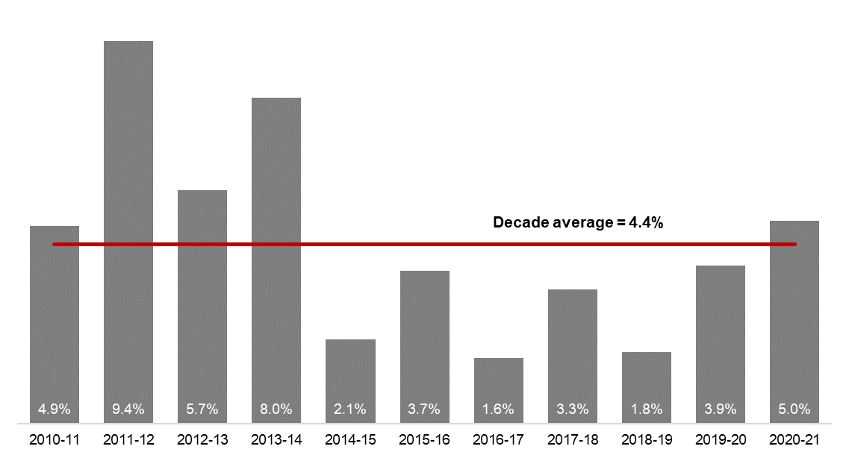
[ALT text - Salaries growth for the December quarter was 5.0%, compared to a ten-year average of 4.4%.]
Source: Department of Treasury

Historical headcount, FTE and salaries expenditure
Quarter | Headcount | FTE | Salaries  expenditure ($M)
September 2015 | 139,277 | 109,919 | 2,837
December 2015 | 137,520 | 108,325 | 2,888
March 2016 | 137,371 | 108,722 | 2,801
June 2016 | 135,770 | 107,809 | 2,857
September 2016 | 137,746 | 109,295 | 2,887
December 2016 | 135,936 | 106,830 | 2,931
March 2017 | 139,144 | 109,895 | 2,880
June 2017 | 140,403 | 110,662 | 2,912
September 2017 | 141,609 | 111,472 | 2,980
December 2017 | 137,878 | 108,371 | 3,029
March 2018 | 140,799 | 110,404 | 3,049
June 2018 | 139,812 | 110,373 | 3,135
September 2018 | 141,744 | 111,255 | 3,023
December 2018 | 138,678 | 108,601 | 3,091
March 2019 | 142,278 | 112,099 | 2,982
June 2019 | 142,735 | 111,932 | 3,172
September 2019 | 143,775 | 113,367 | 3,140
December 2019 | 143,586 | 113,143 | 3,212
March 2020 | 146,343 | 115,548 | 3,147
June 2020 | 146,562 | 116,878 | 3,366
September 2020 | 148,408 | 117,773 | 3,319
December 2020 | 148,532 | 117,664 | 3,350

WA public sector entities staffing levels
Agency | Dec-20 Headcount | Dec-20 FTE | FTE change from  Sep-20 | FTE change from Dec-19
Western Australian Public Sector | 148,532 | 117,664 | -109 | +4,521
Department of Education | 55,200 | 41,215 | -533 | +1,198
WA Health | 50,244 | 38,302 | +217 | +2,193
North Metropolitan Health Service | 11,537 | 8,667 | -73 | -125
WA Country Health Service | 10,231 | 7,812 | -70 | +374
South Metropolitan Health Service | 9,409 | 7,170 | +99 | +403
East Metropolitan Health Service | 8,435 | 6,582 | +127 | +384
Child and Adolescent Health Service | 5,059 | 3,657 | -1 | +539
PathWest | 2,227 | 1,807 | +64 | +112
Health Support Services | 2,205 | 1,596 | +7 | +300
Department of Health | 1,141 | 1,011 | +63 | +205
Department of Justice | 7,408 | 6,899 | +65 | +509
Department of Communities | 6,065 | 5,341 | -16 | -277
Western Australia Police | 2,908 | 2,164 | -11 | +33
Department of Biodiversity, Conservation and Attractions | 2,328 | 1,980 | +127 | +48
Public Transport Authority | 2,198 | 2,119 | +15 | +150
Department of Primary Industries and Regional Development | 1,788 | 1,627 | +16 | +75
Department of Fire and Emergency Services | 1,769 | 1,681 | +19 | +32
Department of Mines, Industry Regulation and Safety | 1,747 | 1,627 | +1 | +84
Department of Transport | 1,543 | 1,417 | +2 | +56
North Metropolitan TAFE | 1,329 | 1,097 | -85 | +9
South Metropolitan TAFE | 1,308 | 1,108 | -87 | +47
Department of Local Government, Sport and Cultural Industries | 1,187 | 917 | -18 | +48
Main Roads Western Australia | 1,181 | 1,138 | +15 | +85
Department of Finance | 1,067 | 999 | +52 | +102
Department of Water and Environmental Regulation | 954 | 852 | -16 | -5
Department of Planning, Lands and Heritage | 868 | 790 | +11 | +7
Department of the Premier and Cabinet | 630 | 556 | +9 | +28
VenuesWest | 517 | 277 | +170 | +15
South Regional TAFE | 506 | 373 | -55 | +22
Landgate | 502 | 462 | -1 | -13
Department of Training and Workforce Development | 484 | 430 | +12 | +14
Insurance Commission of Western Australia | 415 | 376 | -3 | -9
Central Regional TAFE | 389 | 327 | -28 | +17
Legal Aid Commission of Western Australia | 362 | 319 | +10 | +15
Mental Health Commission | 352 | 293 | +4 | +14
Department of Jobs, Tourism, Science and Innovation | 324 | 290 | -1 | +11
Office of the Director of Public Prosecutions | 308 | 277 | +10 | +17
North Regional TAFE | 300 | 277 | -3 | -6
Department of Treasury | 277 | 255 | -2 | +12
Lotterywest | 259 | 241 | -5 | -6
Forest Products Commission | 197 | 185 | +16 | +2
Office of the Auditor General | 175 | 164 | +5 | +14
Metropolitan Cemeteries Board | 163 | 149 | -3 | 0
Public Sector Commission | 151 | 122 | +5 | +6
ChemCentre | 143 | 133 | -3 | -4
WorkCover Western Australia | 142 | 133 | +7 | +10
Corruption and Crime Commission | 135 | 126 | 0 | +5
Ombudsman Western Australia | 77 | 65 | +1 | +1
Economic Regulation Authority | 70 | 63 | -1 | +1
Animal Resources Centre | 63 | 59 | +3 | -2
Small Business Development Corporation | 62 | 54 | -1 | -1
GESB | 59 | 53 | 0 | +3
Metropolitan Redevelopment Authority | 47 | 41 | -8 | -54
Western Australian Electoral Commission | 46 | 45 | 0 | +6
Legal Practice Board | 45 | 42 | -2 | +1
Department of the Registrar, Western Australian Industrial Relations Commission | 40 | 39 | +3 | +3
National Trust of Australia (W.A.) | 35 | 25 | -4 | -1
Western Australian Meat Industry Authority | 28 | 18 | +1 | +3
Construction Training Fund | 22 | 20 | -1 | 0
Office of the Inspector of Custodial Services | 18 | 15 | +1 | +1
Health and Disability Services Complaints Office | 17 | 14 | -5 | -1
Infrastructure WA | 16 | 16 | +3 | +15
Commissioner for Children and Young People | 16 | 15 | 0 | +1
Office of the Information Commissioner | 13 | 12 | 0 | +2
Keep Australia Beautiful WA | 12 | 11 | +1 | +2
Burswood Park Board | 8 | 6 | +1 | +1
Veterinary Surgeons' Board | 6 | 5 | +1 | 0
Minerals Research Institute of Western Australia (MRIWA) | 5 | 5 | 0 | 0
Architects Board of Western Australia | 2 | 2 | 0 | 0
Salaries and Allowances Tribunal | 2 | 2 | 0 | 0

Data quality statement
Information is based on an aggregate of agency supplied data, collected quarterly through the Human Resource Minimum Obligatory Information Requirement (HR MOIR). Data is supplied by agencies according to the guidelines set out in HR MOIR Data Definitions 1.5.1.
The information provided reflects the Commission’s holdings at the date of release. Workforce data is occasionally revised for quality, and corrections applied may result in figures being adjusted over time. This information relates only to Public Sector (Department, SES and non-SES agencies), and excludes sworn officers of the WA Police Force, public universities, local governments, government trading enterprises and other authorities.
All data is accurate as reported to us by contributing agencies.
As some figures have been rounded, discrepancies may occur between sums of the component items and totals. Salaries expenditure data and information is provided by the Department of Treasury.

Contact
All enquiries about the Public Sector Commission’s data should be directed to stateadministrator@psc.wa.gov.au.

As of 1 December, staff of the Equal Opportunity Commission (EOC) were transitioned to the Department of Justice (except for the Commissioner). For the purposes of this report, the Commissioner is included in the Department of Justice.
Staffing numbers for the Department of Communities includes the Disability Services Commission and Housing Authority.
Sworn officers are employed by the Police Force (a non-public sector entity as defined in the Public Sector Management Act 1994), separate from the Police Service.
Staffing numbers for the Department of Biodiversity, Conservation and Attractions includes the Botanic Gardens and Parks Authority, Rottnest Island Authority, and Zoological Parks Authority.
Staffing numbers for the Department of Primary Industries and Regional Development, includes the nine regional development commissions.

