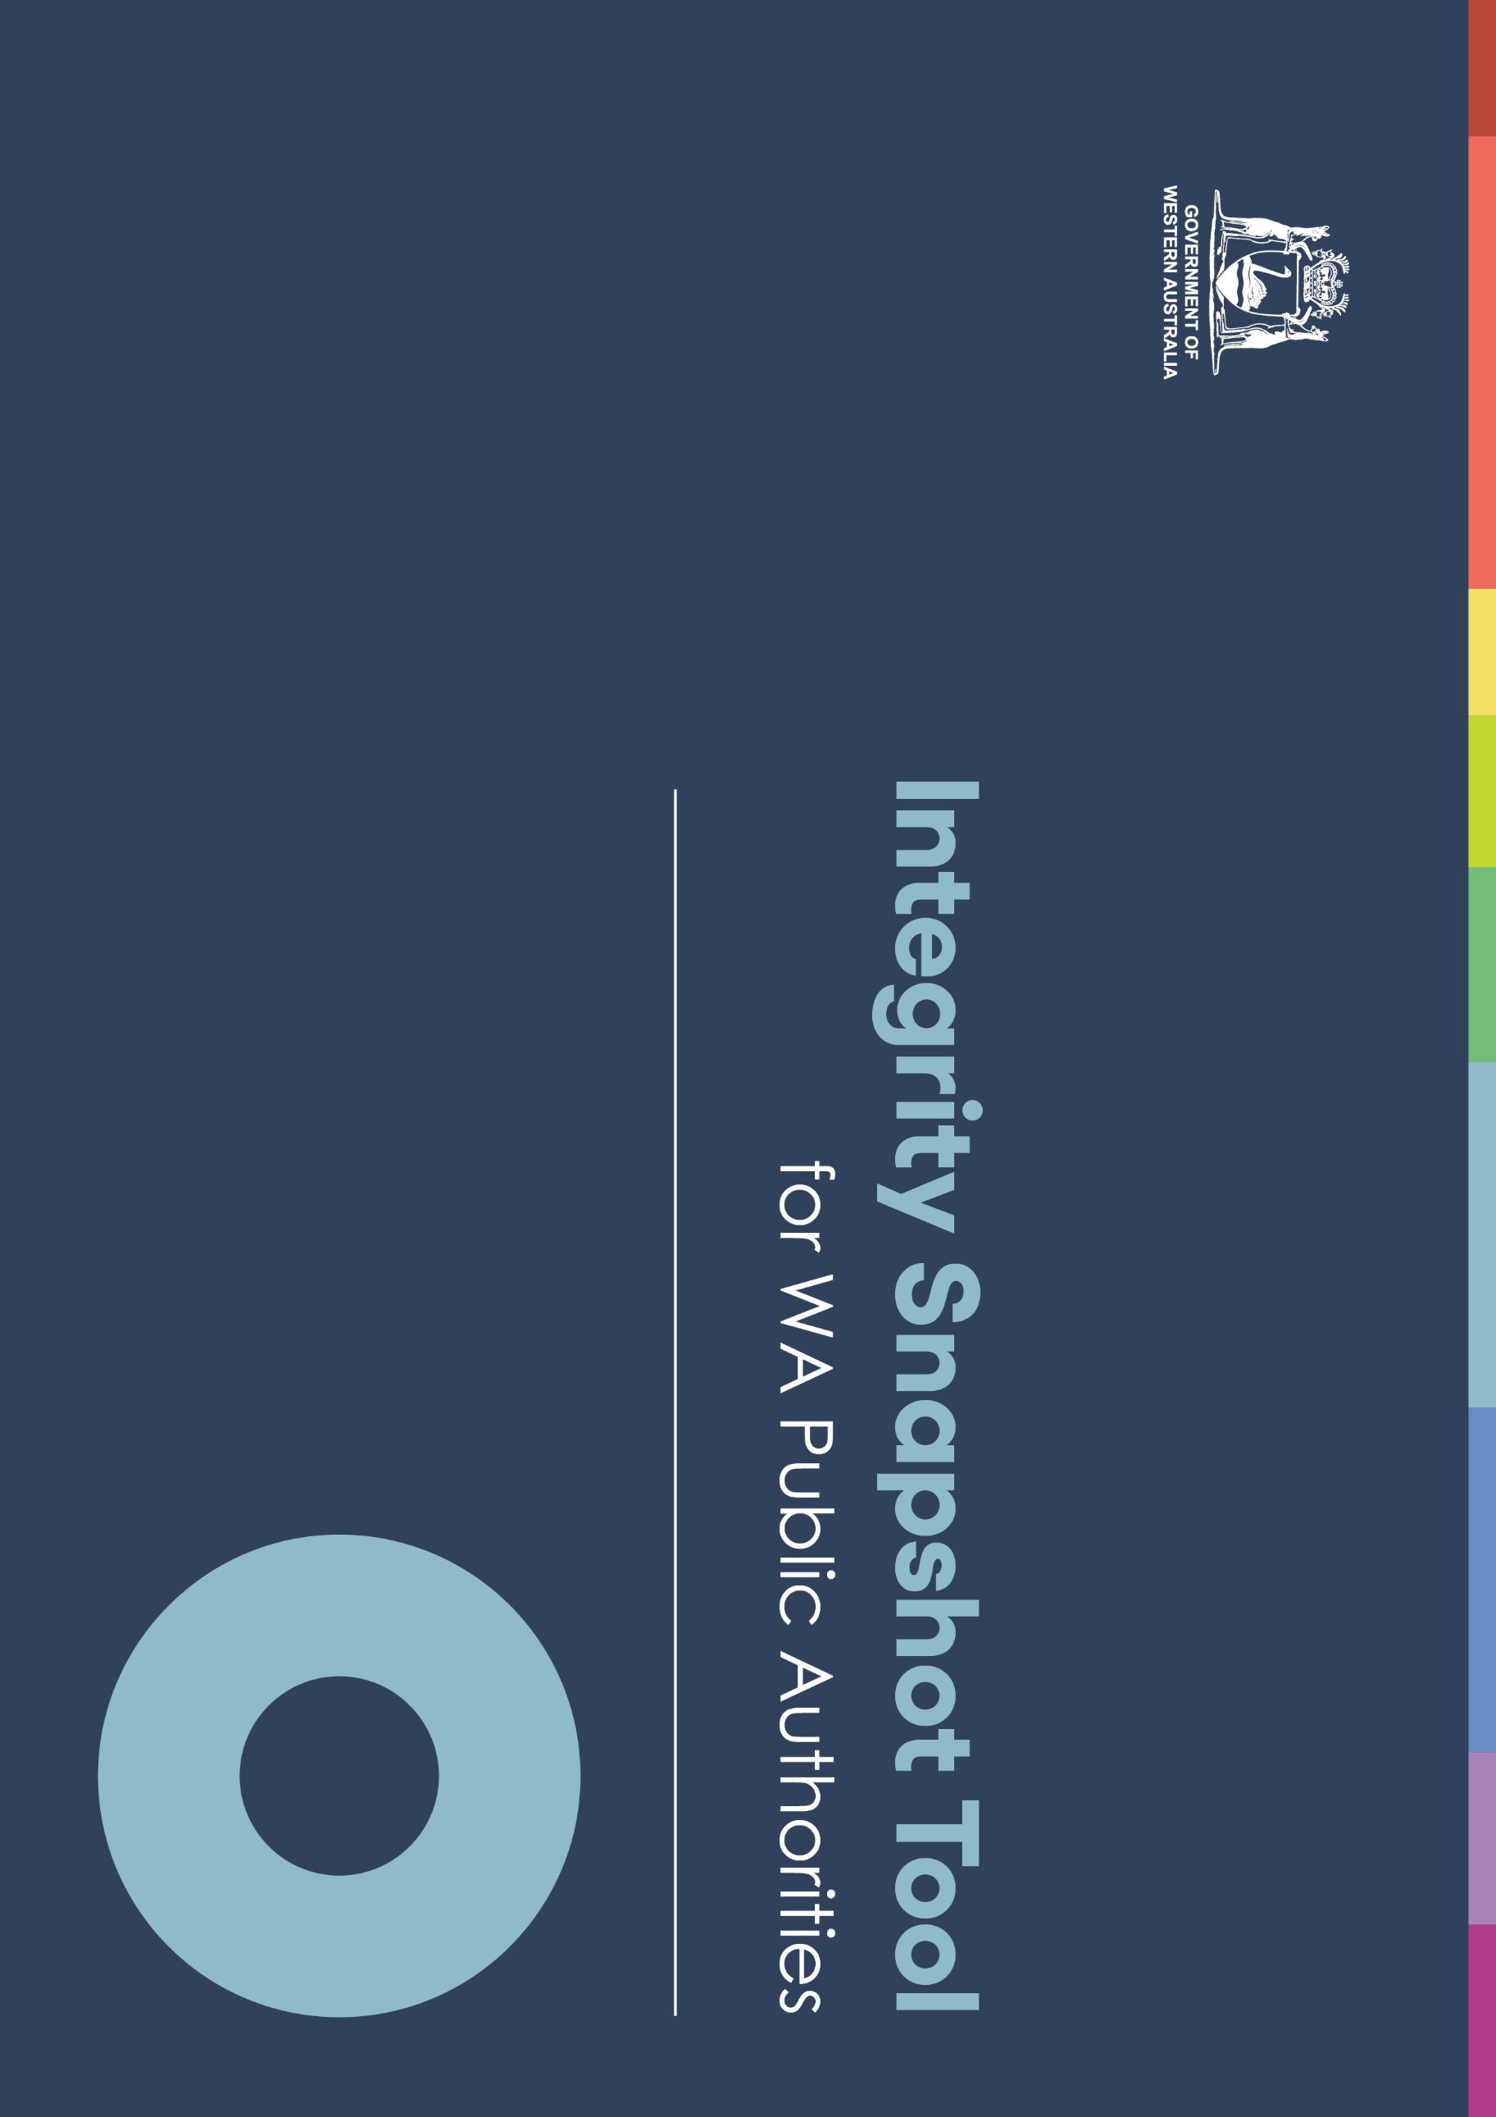

Integrity Snapshot Tool
The snapshot tool supports the Integrity Strategy for WA Public Authorities 2020-23. It gives public authorities a clear view of what they have in place to support integrity, and can help them identify areas for development or more focus that should feature in their planning. The snapshot tool is not meant to be an exhaustive list of things to consider and should be used by public authorities in a manner that best suits their contexts. It is not intended to replace more detailed or specific risk management activities.
The tool can:
- help public authorities evaluate their approaches to promoting integrity and reducing misconduct risks
- identify any gaps in the current approaches to integrity by public authorities that could be actioned.

How to use the snapshot tool
As this is a self-assessment tool, public authorities can benefit by using it to review the status of their approach to integrity and make decisions about where further or additional work is needed.
Public authorities are encouraged to update their assessments as they progress with actioning items. In this way they capture their assessments on an ongoing basis. It is acknowledged that each public authority has a different risk profile and operating context, and is at varying points of progress in managing integrity risks.

Assessment guide
Activity | Description
In place | Suggested activity has been addressed or is subject to review.
In progress | Steps are in place to address suggested activity.
Not in place | Steps may be required to address suggested activity.

PSC1956726

01 Plan and act to improve integrity

Effective governance systems and frameworks are established.
 | In place | In progress |  | Not in place |  | Proposed actions  and comments
Assess if your authority:
has developed and implemented a Code of Conduct that sets out its standards of conduct and integrity, and incorporates code requirements into policies and procedures to reinforce conduct expectations
For public sector agencies, the Code of conduct should comply with Commissioner's Instruction 40: Ethical Foundations.
has identified its integrity risks considering its work and operating context, and records those risks (e.g. in a risk register, fraud and corruption control plan)
enacts controls to address identified risks
identifies and links policies that relate to risks to ensure they have consistent principles and objectives, and are clear and easy to follow (e.g. fraud and corruption, use of public resources, record keeping and use of information, conflicts of interest, gifts and benefits)
has an organisation structure that provides clear lines of accountability and responsibility for integrity and misconduct functions (including the role of leaders and managers)
has documented delegation schedules in place that align to organisation structure and legislative obligations
reviews delegation schedules regularly to ensure they remain current and operate with appropriate levels of authority

01 Plan and act to improve integrity (continued)
 | In place | In progress | Not in place | Proposed actions  and comments
Assess if your authority:
has a position, team or committee with documented responsibility to consider findings and recommendations from integrity audits, assessments, reviews and investigations
assigns accountability and responsibility for monitoring and oversighting risks and controls (e.g. in authority’s structure, job descriptions)
has an internal audit committee with an independent chair
uses tools and templates provided by the Commission or other sources to support its approach to managing integrity risks
has a process to review regularly its integrity risk profile to ensure it is responsive to emerging risks and recommendations made by integrity bodies (e.g. policy and practice review, process improvements)
evaluates and refines any processes, systems and controls that are in place or may be introduced to inform its detection and prevention of irregularities and corrupt practice (e.g. detection software, data analytics)
conducts regular assessments of business areas and functions that are, or may be, vulnerable to integrity risks (e.g. procurement and contracting; use of and access to confidential information; recruitment)
connects and collaborates with other authorities to seek or share expertise and advice on integrity matters (e.g. conducting investigations, policy development and process improvements)

02 Model and embody a culture of integrity

A culture of integrity exists, and is reinforced and communicated by leaders.
 | In place | In progress | Not in place | Proposed actions  and comments
Assess if your authority:
has values that include integrity integrated into all aspects of its business (e.g. in policies, processes and systems)
promotes integrity in and outside the authority (e.g. website, publications, staff newsletters, division meetings, annual reports and everyday practices)
has leaders who role model integrity and demonstrate zero tolerance for breaches of ethical codes and misconduct
has a consultation mechanism to engage with and involve staff when reviewing integrity policies, procedures and information to gain shared commitment and understanding
has human resource policies and practices that reflect a commitment to recruiting staff who demonstrate a strong alignment to its values
ensures recruitment materials include information on values and conduct expectations
conducts integrity checking, including qualification and employment history checks, as a normal part of selection and recruitment practices, particularly for positions of trust (e.g. integrity officers, finance and procurement staff)
uses staff performance processes to discuss and reinforce its values and conduct expectations
measures staff confidence and attitudes about its integrity, including confidence in speaking up about misconduct and integrity matters (e.g. through staff perception surveys) and identifies steps to address any findings

Model and embody a culture of integrity (continued)
 | In place | In progress | Not in place | Proposed actions  and comments
Assess if your authority:
has staff formally acknowledge that they have read its code of conduct at appointment/induction
encourages staff to report misconduct (e.g. in policies, codes of conduct, staff communication)
makes information available about public interest disclosure processes and other reporting mechanisms to staff and stakeholders
has reporting policies or codes in place that includes a statement that reprisal action is not tolerated against those who speak up about misconduct and integrity matters

03 Learn and develop integrity knowledge and skills

Individual and authority integrity knowledge, skills and competence are grown.
 | In place | In progress | Not in place |  | Proposed actions  and comments
Assess if your authority:
ensures integrity training programs are up to date (e.g. reflects its code, legislative and policy requirements)
maintains records of staff who attend induction and integrity training
follows up with staff where necessary to ensure learnings from integrity training are embedded
has a process for communicating with staff about integrity matters including updating them about changes to policies, processes and systems (e.g. through newsletters, emails, meetings)
has a formal induction process in place for all new staff and contractors that includes a clear focus on integrity
delivers training on the Code of conduct and refresher training to staff that:
- is aligned to its Code of Conduct
- is customised to its context and business, and covers its specific integrity risks
- is up to date and reflects changes to systems and processes
- includes information on its integrity framework, policies, processes and systems
- includes information on how to recognise, respond to and report misconduct
- records attendance and completion rates which can be provided to the Commission and other integrity bodies as required

03 Learn and develop integrity knowledge and skills (continued)
 | In place | In progress | Not in place | Proposed actions  and comments
Assess if your authority:
provides specific integrity training to staff working in high risk roles (e.g. finance, procurement, integrity) in relation to fraud and corruption, accountability requirements and reporting suspected misconduct
evaluates staff awareness of its integrity requirements (e.g. through staff perception surveys) and acts on any knowledge deficits
encourages, supports and provides a mechanism for staff to seek advice on integrity matters when they are unsure
makes staff aware of the process of identifying integrity risks and contributing to the risk register
ensures staff who respond to and investigate integrity matters are suitably skilled (e.g. have Certificate IV in Government Investigations or higher qualification and/or relevant experience)
exercises due diligence when engaging contractors to deal with integrity matters to ensure they have the necessary qualifications, skills and/or experience (e.g. through reference and qualification checks)
seeks opportunities for further learning about integrity matters by identifying key staff to attend events and forums provided by the Commission and other bodies
establishes networks with other integrity practitioners

04 Be accountable for integrity

Prevention, detection and response to integrity matters are everyone’s personal and professional responsibilities.
 | In place | In progress | Not in place | Proposed actions  and comments
Assess if your authority:
has a clear and documented process to assess potential misconduct that guides decision making about when to notify the Public Sector Commission and Corruption and Crime Commission of minor misconduct and serious misconduct (respectively), using their online reporting tools
articulates the roles and responsibilities of the leadership team in overseeing integrity
has a documented and active process to review and learn from internal and external reports, including focusing on individual conduct as well as system, cultural and capability weaknesses that may have provided the opportunity for misconduct to occur
monitors, reviews and addresses its approach to changing and emerging risks (e.g. due to restructure, introduction of technology and legislative change) and ensures:
- a new integrity risk assessment is completed
- its risk register is updated
- internal policies, processes and systems are updated to reflect the new operating context
collected data is analysed and reported to the leadership team (e.g. reports of integrity breaches, complaints, grievances, staff survey results, training records, conflicts of interest, gifts and benefits register)
has integrity as a standing agenda item for its leadership team to provide a forum to interrogate data, and identify and respond to emerging trends (e.g. data about breaches of Code of Conduct or policy, allegations of misconduct, complaints received, and recommendations from self-assessments and audits)

