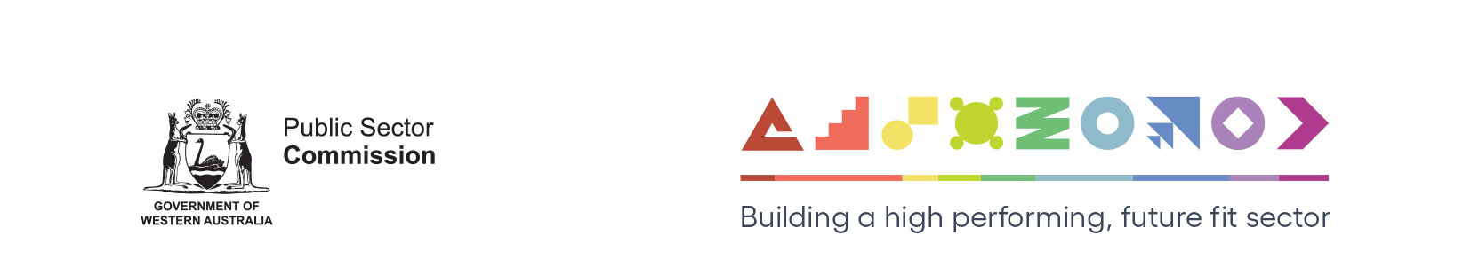
Code of Conduct checklist
This checklist helps an agency confirm that key activities associated with developing and implementing a code have been considered.
Stage 1: Source information
Where to source information for the code |  | Comments
Input from:
 | senior leadership team
 | subject matters experts (audit, standards and conduct, governance, risk, finance, human resources and legal)
 | selected parts of the workforce (if relevant)
Relevant requirements identified in:
 | legislation
 | Commissioner’s Instruction 40: Ethical Foundations
 | sector policies
 | agency policies and procedures that support the code
 | reports and resources of external integrity bodies
 | other data and research
 | Relevant risks and corresponding management strategies identified, for example by reviewing risk registers
Stage 2: Construct
What the code says (content) |  | Comments
 | Clear expectations of the leader including why the code is important and what it intends to achieve
 | Glossary of terms and acronyms (where necessary)
 | Consistent with mission, vision and values
 | Who the code applies to and when
 | Relevant integrity risks and the behaviours expected to manage these risks
 | Relevant policies and procedures to be complied with
 | Actions that may be taken if non-compliance with the code is suspected and examples of possible actions
 | Internal and external pathways to report suspected non-compliance with the code
 | Contacts for advice about the code
How content is presented |  | Comments
 | Language reflects corporate voice, is plain English and has a positive tone
 | Language and information are consistent with other relevant documents such as values and policies
 | Length has been considered and is fit for purpose
 | Design reflects corporate style, is contemporary and accessible
 | Content is logically presented for readability (for example, headings)
 | Engagement and interactivity are incorporated where relevant (for example, using links, decision making tools, mnemonics)
 | References and supplementary materials are current and relevant
Stage 3: Consult
How development of the code is progressing |  | Comments
 | Feedback from those who contributed at stage 1
 | Consultation with relevant areas of the workforce as necessary (hold focus groups)
 | Consultation with relevant stakeholders as necessary
 | Necessary changes incorporated to improve the draft
Stage 4: Approve
Who approves the code |  | Comments
 | Leader or senior leadership team through established processes
 | Approval date and version documented as part of good governance
 | Commitment to an implementation plan

Stage 5: Implement and promote
How the code is rolled out and embedded |  | Comments
 | Communicate what changes have been made, why and impact on staff
 | Staff read and acknowledge the code through new or existing processes
 | Code is easy for staff to find and access
 | All references to the code are updated (in policies and procedures, strategic documents, and recruitment materials)
 | Clients, suppliers and stakeholders informed of the code and its relevance
 | Tools for leaders and managers to promote the code
 | Plan for how minor changes and updates to the code are implemented and communicated
Stage 6: Training
How the code applies in practice |  | Comments
 | Training (and refresher training) on the code for new and existing staff (refer to Developing Code of Conduct Training and Training on your Code)
 | How code of conduct training fits into broader integrity education
 | Completion rates for training and refresher training recorded and can be reported
Stage 7: Monitor and review
How the code is working and improvement |  | Comments
 | Position or team responsible for regular/periodical review of the code, with review dates recorded and adhered to
 | How the code is monitored
 | How lessons learned in the agency and from external integrity agencies are captured and considered for improving the code

