Western Australian Public Sector Quarterly Workforce Report – December 2019

About this information

This page presents a snapshot of the Public Sector workforce based on the most recent data available. More detailed workforce information (including information on other government entities) is available in the State of the Western Australian Government Sector Workforce 2018/19.

Please see the Commission’s About our workforce data page for additional contextual information.

Overview of the Public Sector as at December 2019
Headcount |  | 143 586
Full-time equivalent (FTE) |  | 113 143
General government expenses (December quarter) |  | $3 212M
Senior Executive Service (SES) |  | 405
Women in SES |  | 168
Aboriginal and Torres Strait Islander |  | 2.7%
People with disability |  | 1.6%
Culturally and linguistically diverse |  | 13.7%
Aged 34 and under |  | 23.4%
Aged 55 and over |  | 27.0%
Median age |  | 46
Top 3 occupation groups (FTE) | Teachers | 19.1%
 | Clerical workers | 16.7%
 | Nurses and midwives | 10.7%

Sector profile
Employment trends
In December 2019, the WA public sector employed 143 586 people (headcount), a decrease of 189 employees from September 2019. The number of full-time equivalent (FTE) also decreased over the same period, falling by 224 (-0.2 per cent) to 113 143 FTE.
The December quarter usually shows a more pronounced decline in both headcount and FTE due to the conclusion of the academic semester and release of academic employees. In 2019, the school term ended later than usual, resulting in a greater number of Department of Education employees appearing in the data (approximately 1700 FTE more than usual). This last occurred in 2014, and will happen again in December 2020.
Other key changes include increases in the number of employees this quarter in:
- Department of Biodiversity, Conservation and Attractions, up 7.6%
(+136 FTE) due to increased firefighting efforts during the summer fire season, which is consistent with seasonal requirements
- Department of Communities (+221 FTE), driven by increased casual welfare support workers (+90 FTE)
- Department of Justice (+153 FTE), driven mostly by recruitment of prison officers (+76 FTE).
Salaries expenditure
General government salaries for the first six months of the 2019/20 financial year grew by 3.9 per cent to total $6 352 million. This growth included increases under the wages policy and other prevailing industrial agreements, as well as the impact of the Government’s commitment to convert casual and fixed term contract staff to permanent employees across the sector, and other movements in the sector’s workforce. Salaries in the health, education, law and order, and community services sectors account for over 83 per cent of the general government salaries costs in the December outcome, and account for most of the $238 million net movement during the period.

Figure 1. Salaries growth for the three months to 31 December (general government)
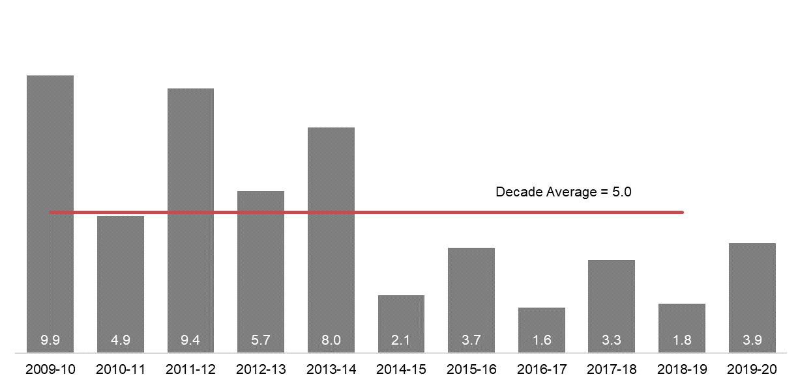
[ALT text - Salaries growth for the three months to 31 December (general government) was 3.9 per cent in 2019-20, compared to a ten-year average of 5.0 percent.]
Source: Department of Treasury

Historical headcount, FTE and salaries expenditure
Quarter | Headcount | FTE | Salaries  expenditure ($M)
September 2015 | 139 277 | 109 919 | 2 837
December 2015 | 137 520 | 108 325 | 2 888
March 2016 | 137 371 | 108 722 | 2 801
June 2016 | 135 770 | 107 809 | 2 857
September 2016 | 137 746 | 109 295 | 2 887
December 2016 | 135 936 | 106 830 | 2 931
March 2017 | 139 144 | 109 895 | 2 880
June 2017 | 140 403 | 110 662 | 2 912
September 2017 | 141 609 | 111 472 | 2 980
December 2017 | 137 878 | 108 371 | 3 029
March 2018 | 140 799 | 110 404 | 3 049
June 2018 | 139 812 | 110 373 | 3 135
September 2018 | 141 744 | 111 255 | 3 023
December 2018 | 138 678 | 108 601 | 3 091
March 2019 | 142 278 | 112 099 | 2 982
June 2019 | 142 735 | 111 932 | 3 172
September 2019 | 143 775 | 113 367 | 3 140
December 2019 | 143 586 | 113 143 | 3 212

WA public sector entities staffing levels

Agency | Dec-19 Headcount | Dec-19 FTE | FTE change from  Sep-19 | FTE change from  Dec-18
Western Australian Public Sector | 143 586 | 113 143 | -224 | 4542
Department of Education | 54 088 | 40 017 | -532 | 2212
WA Health (North Metropolitan Health Service) | 11 620 | 8792 | -24 | 16
WA Health (WA Country Health Service) | 9760 | 7438 | -127 | 32
WA Health (South Metropolitan Health Service) | 8859 | 6766 | -7 | -4
Department of Justice | 6838 | 6390 | 153 | 566
WA Health (East Metropolitan Health Service) | 7887 | 6198 | 18 | 136
Department of Communities | 6556 | 5617 | 221 | 202
WA Health (Child and Adolescent Health Service) | 4390 | 3118 | 36 | 78
Western Australia Police | 2883 | 2131 | 18 | 66
Public Transport Authority | 2032 | 1969 | 30 | 85
Department of Biodiversity, Conservation and Attractions | 2289 | 1932 | 136 | 76
WA Health (PathWest) | 2076 | 1695 | 67 | 111
Department of Fire and Emergency Services | 1731 | 1649 | 29 | 50
Department of Primary Industries and Regional Development | 1709 | 1552 | 7 | 12
Department of Mines, Industry Regulation and Safety | 1663 | 1543 | 99 | 180
Department of Transport | 1476 | 1361 | 31 | 54
WA Health (Health Support Services) | 1963 | 1296 | -96 | -3
North Metropolitan TAFE | 1305 | 1088 | -135 | -37
South Metropolitan TAFE | 1268 | 1061 | -114 | 135
Main Roads Western Australia | 1105 | 1054 | 26 | 34
Department of Finance | 973 | 897 | -10 | -24
Department of Local Government, Sport and Cultural Industries | 1041 | 869 | -12 | 52
Department of Water and Environmental Regulation | 985 | 858 | 13 | 94
Department of Health | 935 | 806 | 14 | 127
Department of Planning, Lands and Heritage | 872 | 783 | 15 | 86
Department of the Premier and Cabinet | 600 | 528 | 14 | 51
Landgate | 503 | 474 | -1 | 20
Department of Training and Workforce Development | 465 | 416 | 5 | -10
Insurance Commission of Western Australia | 418 | 385 | 19 | 33
South Regional TAFE | 455 | 351 | -60 | 14
Central Regional TAFE | 365 | 310 | -47 | 4
Legal Aid Commission of Western Australia | 349 | 304 | 0 | 9
North Regional TAFE | 303 | 283 | -12 | 11
Department of Jobs, Tourism, Science and Innovation | 309 | 279 | 8 | 28
Mental Health Commission | 347 | 279 | 1 | 3
VenuesWest | 524 | 262 | 0 | 13
Office of the Director of Public Prosecutions | 292 | 260 | 7 | 18
Lotterywest | 264 | 247 | 3 | 34
Department of Treasuryv | 258 | 243 | -41 | -23
Forest Products Commission | 206 | 183 | 15 | -10
Office of the Auditor General | 166 | 150 | -7 | 13
Metropolitan Cemeteries Board | 168 | 149 | 2 | 2
ChemCentre | 145 | 138 | 3 | -2
WorkCover Western Australia | 132 | 123 | -3 | 6
Corruption and Crime Commission | 130 | 121 | 2 | 6
Public Sector Commission | 126 | 116 | 13 | 17
Metropolitan Redevelopment Authority | 103 | 95 | -6 | -7
Ombudsman Western Australia | 75 | 64 | 0 | 1
Economic Regulation Authority | 66 | 62 | 3 | 4
Animal Resources Centre | 65 | 60 | -1 | 1
Small Business Development Corporation | 62 | 55 | 2 | 7
GESB | 56 | 50 | 2 | 6
Legal Practice Board | 44 | 41 | -1 | 0
Western Australian Electoral Commission | 41 | 39 | -1 | -1
Department of the Registrar, Western Australian Industrial Relations Commission | 39 | 36 | 5 | 2
National Trust of Australia (W.A.) | 36 | 27 | -1 | -1
Construction Training Fund | 21 | 20 | 0 | -2
Equal Opportunity Commission | 21 | 19 | 0 | 0
Health and Disability Services Complaints Office | 17 | 15 | -1 | 0
Western Australian Meat Industry Authority | 33 | 15 | -3 | 0
Office of the Inspector of Custodial Services | 17 | 14 | -2 | -2
Commissioner for Children and Young People | 17 | 13 | 1 | 1
Office of the Information Commissioner | 11 | 10 | -1 | 1
Keep Australia Beautiful WA | 11 | 9 | 0 | 4
Burswood Park Board | 6 | 5 | 0 | 1
Minerals Research Institute of Western Australia (MRIWA) | 5 | 5 | 1 | 1
Veterinary Surgeons' Board | 6 | 4 | 0 | 0
Architects Board of Western Australia | 2 | 2 | 0 | 0
Salaries and Allowances Tribunal | 2 | 2 | -1 | -1
Infrastructure WA | 1 | 1 | 1 | 1

Disclaimer
The Western Australian Government is committed to quality service to its customers and makes every attempt to ensure accuracy, currency and reliability of the information contained on the Public Sector Commission’s website or in its publications. However, changes in circumstances over time may impact on the veracity of this information.

Contact
All enquiries about the Public Sector Commission’s data should be directed to: stateadministrator@psc.wa.gov.au.

The Department of Communities supports the Disability Services Commission (Headcount: 1303; FTE: 1062) and Housing Authority (Headcount: 2013; FTE: 1825) which remain statutory authorities.
Sworn officers are employed by the Police Force (a non-public sector entity as defined in the Public Sector Management Act 1994), separated from the Police Service.
The Department of Biodiversity, Conservation and Attractions includes the Botanic Gardens and Parks Authority (Headcount: 137; FTE: 99), Rottnest Island Authority (Headcount: 147; FTE: 127), and Zoological Parks Authority (Headcount: 203; FTE: 152) as part of administrative arrangements. However, these statutory authorities remain as separate entities and continue to employ their own staff.
While staff of regional development commissions are part of the Department of Primary Industries and Regional Development, regional development commissions and their respective chief executives and boards remain as separate entities under legislation. For the purposes of this report, the nine regional development commissions are included in the Department of Primary Industries and Regional Development.
Energy Policy WA was established on 5 September 2019 as a new sub-department within the Department of Mines, Industry Regulation and Safety (DMIRS) and employee numbers are included within DMIRS for the purposes of this report. Part of the increase in headcount and FTE in DMIRS and the decrease in Department of Treasury is a result of this change.
In January 2019, employees of Healthway were transferred to Lotterywest as part of the amalgamation of the two organisations.

