Get involved!

Youth Participation Kit: Young people

Resource 1

This publication is designed to give you an idea about how, as a young person, you can get involved and participate in your community. It includes a guide to getting started, details on the different kinds of things you can try, and useful tips along the way.

Why participate?
Being involved in your community gives you the opportunity to shape your world, now and for the future. You can contribute your ideas, perspective, and creativity to make a difference for everyone, including other young people, organisations and the community at large.

What can you get out of participating?
- a sense of satisfaction and achievement
- new friends and valuable contacts
- greater your confidence and self esteem
- try new things to discover what you’re good at and what you enjoy
- great experience that will be useful throughout your career
- have your voice heard and provide advice to organisations
- make a valuable contribution to an organisation’s decision-making processes
- learn about organisations and how they work
- feel like you’re making a difference in your community.

What your participation can do for the community:
- increase understanding of young people’s interests, needs and concerns
- encourage other young people to participate
- demonstrate that young people are important and valuable contributors
- stimulate innovation, change and new ideas
- enable an ‘all hands-on deck’ approach with community projects, tasks and initiatives
- develop awareness of a particular issue.

Case Study: Bellamore Ndayikeze
Bellamore is the Founder of BN Collective, a projects-based initiative in collaboration with young people for young people. She is the Training and Development Coordinator for the Edmund Rice Centre WA, where she regularly supports young people to thrive to be the best they can be in the world.
Bellamore has been involved in Youth Week activities as a volunteer since 2017 and is an ardent advocate for young people. She was the Youth Week WA Ambassador in 2019 and has been on the Ministerial Youth Advisory Council since 2017 and is currently serving as its Chair.
Bellamore is currently a mentor for One Young World on the Connects program and is involved in various boards and committees including the Gender Diversity Advisory Group for the Department of Sport and Recreation.

“I believe that as a young person when you can commit yourself to serve others and being involved in as many things as you can, opportunities and connections usually happen. Naturally, you might not know what you want to do with your future, and that's ok, volunteer your time to a cause or maybe put your hands up to help at an event. Take a leap of faith, try and be as present as possible when you get out into the world. It's also crucial to make sure you do your best when you are involved. Doing your best also means looking after your wellbeing, being mindful and having fun. You have so much potential, be involved meaningfully and everything will fall in place.” – Bellamore Ndayikeze
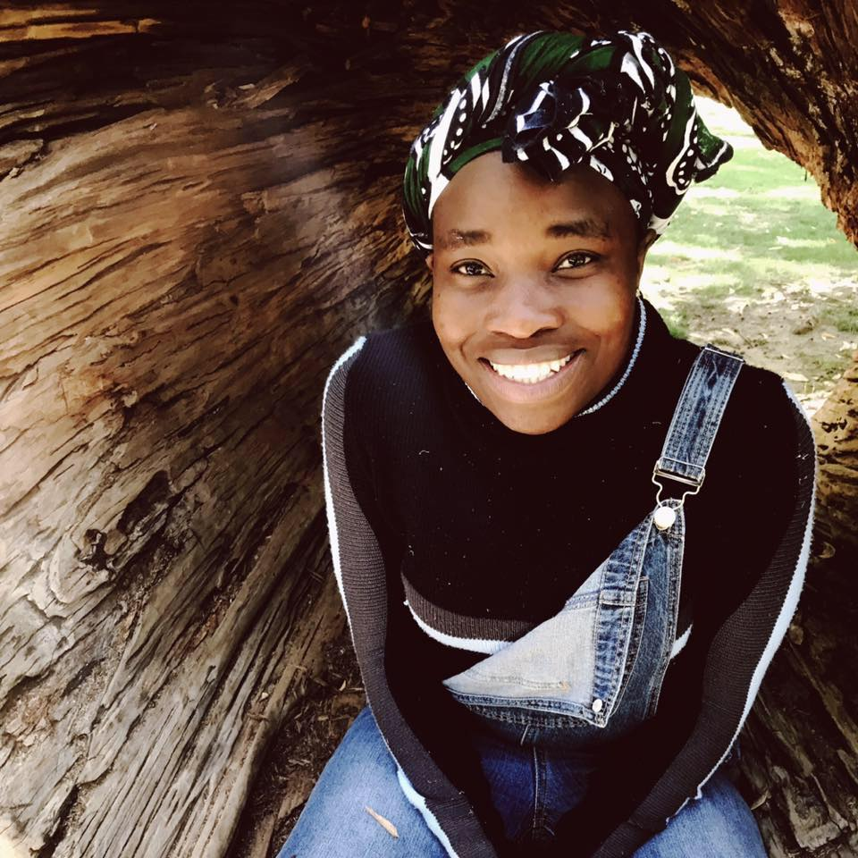

How do you do it?
Step-by-step guide to getting involved
Step 1 | Think about why you want to get involved, and what kinds of things you’re interested in doing | See Resource Sheet 2
Step 2 | Create a shortlist of the kinds of opportunities you’re interested in | See Resource Sheets 2, 3 and 4
Step 3 | Search for opportunities | See Resource Sheet 2
Step 4 | Evaluate the opportunities available and make initial contact  OR if you’re going to start something yourself, make your plan | See Resource Sheet 3  See Resource Sheets 4 and 5
Step 5 | Start doing it! | See Resource Sheets 5, 6 and 7
Step 6 | Check in with how you’re going | See Resource Sheet 9
Step 7 | Think about other opportunities | See Resource Sheet 9
Step 8 | If you ran a project or started something new, wrap it up and evaluate | See Resource Sheet 8

