Ageing with Choice:

Future directions for seniors housing
2019-2024

Contents

Message from the Ministers 1
The challenge 2
A new direction 3
What we know about seniors’ housing needs 4
What we heard 6
Introducing Ageing with Choice 7
Our goals 8
Partnerships and innovations 9
Priority 1: Age-friendly communities 10
Priority 2: Homes that support ageing in place 11

Priority 3: Affordable housing innovations and alternatives to home ownership 12
Priority 4: Better options for renters 14
Priority 5: A more age-responsive social housing system 15
Priority 6: Assistance for those experiencing housing crisis 16
Priority 7: Informed decision-making 17
Actions 18
Glossary 24
References 24

Message from the Ministers
Western Australians are living longer and our expectations of ageing are changing. This means we need to rethink the way we approach wellbeing in older age. As a community, we need to become more responsive to the needs of people, based on their circumstances, not their age alone.
In 2017, Western Australia (WA) was awarded affiliate membership of the World Health Organisation’s Global Network for Age-Friendly Cities and Communities. This recognises our nation-leading work to create communities that are inclusive for all ages.
Housing is an important part of building rich, diverse, age-friendly communities. Manageable, affordable and secure homes provide more than just shelter. They provide a foundation for good health, independence, social participation and quality of life.
Ageing with Choice is an initiative under the Affordable Housing Action Plan 2017-18 to 2019-20 and complements the development of the State’s 10-year Strategy on Homelessness.
Ageing with Choice sets the direction for government, industry and the community sector to respond to the changing housing needs of older Western Australians. It provides a framework for working collaboratively across sectors to improve housing outcomes for older Western Australians, emphasising the importance of:
- information, education, advocacy and awareness for consumers, industry and local decision makers to improve housing choices for older people
- demonstrating and trialling innovative housing options to expand the supply of affordable homes that can support ageing in place
- streamlining government efforts and leveraging government programs and investment to achieve better outcomes for older people.
A range of actions have been identified to address the diverse needs of older people, from those at risk of homelessness, those in social housing, private renters, retirement village residents and people who want to rightsize to a more appropriate home.
Ageing with Choice acknowledges that the majority of older Western Australians want to grow old in the communities they know, with the support of friends and family. It also recognises that communities are strengthened by the contribution of older people, as neighbours, family members, carers, volunteers, consumers and in the workforce.
Through this, and other initiatives, the State Government is working to enable older Western Australians to age well in their community of choice.
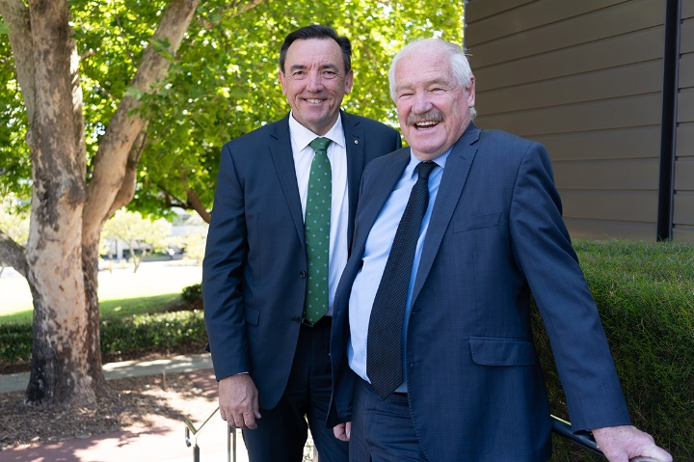
Hon Peter Tinley AM MLA
Minister for Housing; Veterans Issues; Youth; Asian Engagement
Hon Mick Murray MLA
Minister for Seniors and Ageing; Sport and Recreation; Volunteering

The challenge

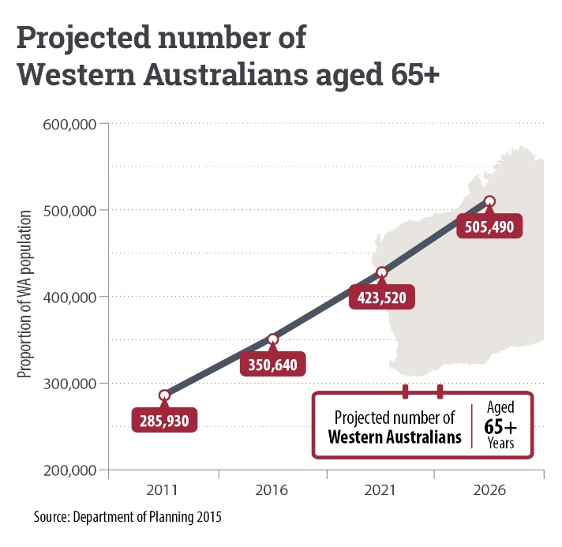
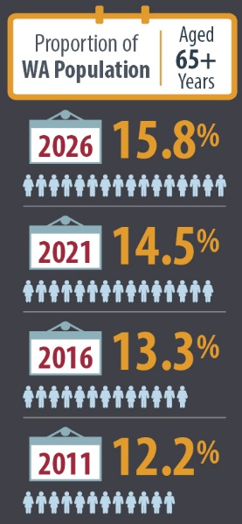
Like most developed countries, Australia has an ageing population. The number of people in WA aged 65 or over is projected to grow by 40 per cent to more than 500,000 by 2026.
With more people living longer, many will experience higher rates of chronic conditions and will require a greater level of care and support. At the same time, a growing number of older people do not own their own home or are reaching retirement age with a mortgage.
Australia’s Age Pension settings assume most people will own their own home after retirement. With pension rates not keeping pace with rising housing costs, the private market is struggling to respond. This is creating increased demand for affordable homes that can support ageing in place.
People’s housing needs change with age. While housing affordability affects everyone, older people are especially impacted because of their reduced earning and borrowing capacity and their specific housing needs.
Without appropriately-designed homes connected to transport, services and community, older people’s capacity to remain living independently is reduced. The risk of hospitalisation increases, as well as early entry into aged care.
Without access to suitable, affordable homes, more older people will struggle to balance housing and living costs or will be living in homes they cannot manage or maintain. This places them at increased risk of housing crisis, negatively impacts health and wellbeing, and places added pressure on government funded housing, health and aged care services.
Responding to these challenges is vital.

A new direction

Ageing with Choice provides direction over the next five years to improve housing choice and outcomes for older Western Australians.
Ageing with Choice recognises that everyone ages differently. Housing needs in older age are driven by changes in health, financial or family circumstances, rather than numerical age.
Working together across all sectors, we can create vibrant, inclusive communities with a range of housing and living options that meet people’s needs as they age. By acting now, we can position WA for the future.
Led by the Department of Communities and backed by cross-government action, Ageing with Choice identifies seven priorities and directions for reform.

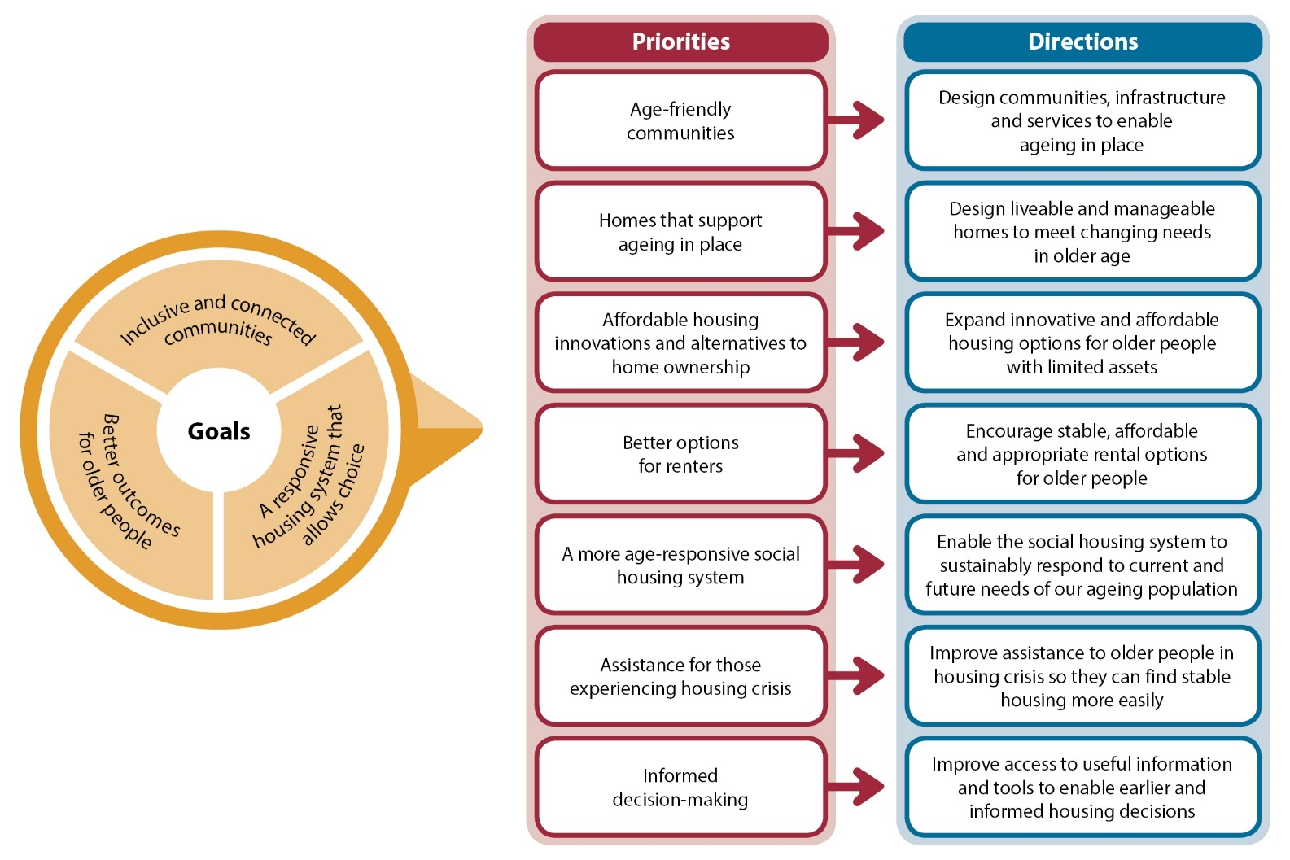

What we know about seniors’ housing needs

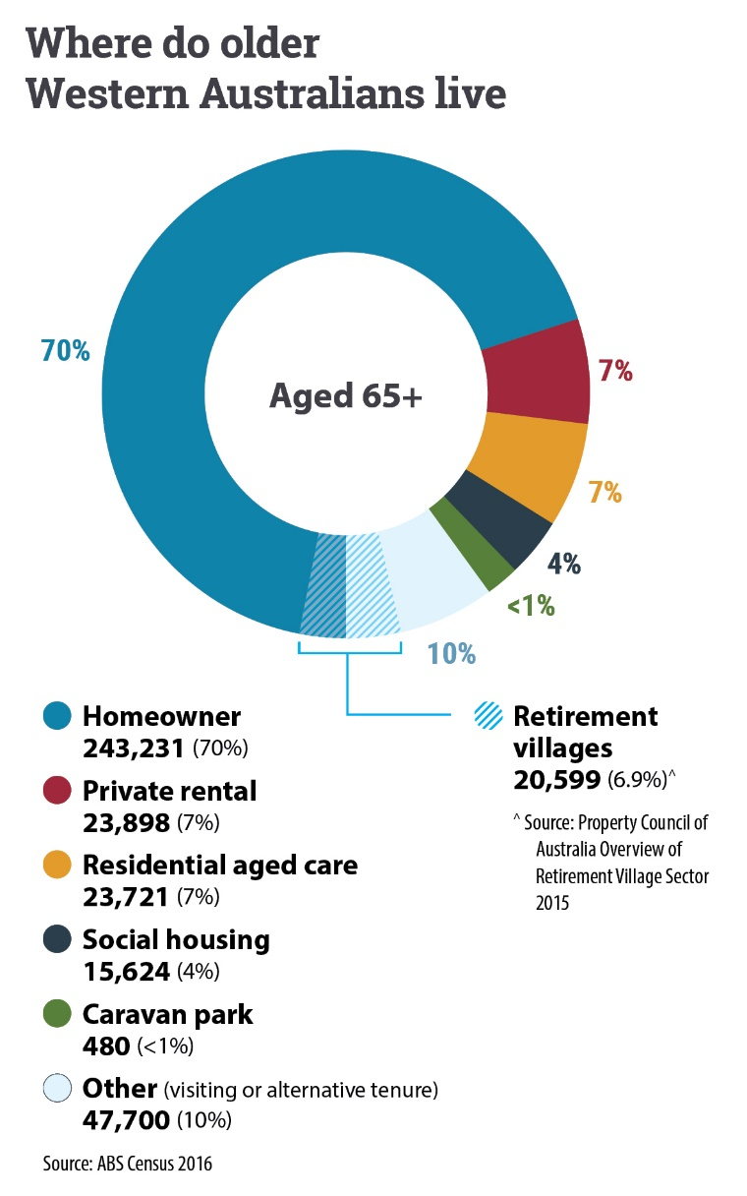

- While many older people have done well after decades of strong economic conditions, not everyone has benefited.
- More older people do not own their own home and are approaching retirement age with a mortgage. Between 2006 and 2016, the number of people aged 55 to 64 with a mortgage increased nearly 80 per cent to over 95,000.
- Many older people have insufficient superannuation and housing assets to meet their housing needs. A 2016 WA household survey* found nearly half of older households could not afford an entry level apartment ($345,000).
- People who fall out of home ownership after the age of 50 are more likely to require housing assistance.
- More older people are living in insecure private rental. Despite lower rental prices, median rent for a one-bedroom unit in Perth takes up 44 per cent of the single age pension (including Commonwealth Rent Assistance).
- In 2016, 45 per cent of private renters aged 65 or over were experiencing housing stress.
- The number of homeless older people aged 55 to 74 is increasing. Between 2011 and 2016, the number of homeless women aged 65 to 74 increased nearly 27 per cent (more than any other age group).
- Cost of living pressures are hitting low income households the hardest. Since 2012, the cost of living for pensioners has increased by 12 per cent.
- Older people aged 65 or over make up 34 per cent of main tenants in public housing. With the ageing population, demand will continue to outstrip supply. Social housing alone is not a sustainable response.

Some groups of older people experience greater housing need
- Older single women are more likely to be renting than couples or men and generally have lower levels of savings and superannuation.
- Indigenous people are less likely to own their own home. More than half of those 50 or over are renting. Many who want to remain on country struggle due to limited housing and support.
- Many older people in regional communities find it hard to age in place due to a lack of appropriate homes and services. Lower house prices in some regions mean that people who need to relocate from their community may not be able to afford to do so, even if they own their home outright.
- Older people who are dependent on others are more vulnerable to financial abuse and homelessness, especially those who have transferred assets to family in return for care. Vulnerability may be heightened among people from culturally and linguistically diverse backgrounds due to cultural expectations, social isolation, language barriers and lack of understanding of their legal rights.

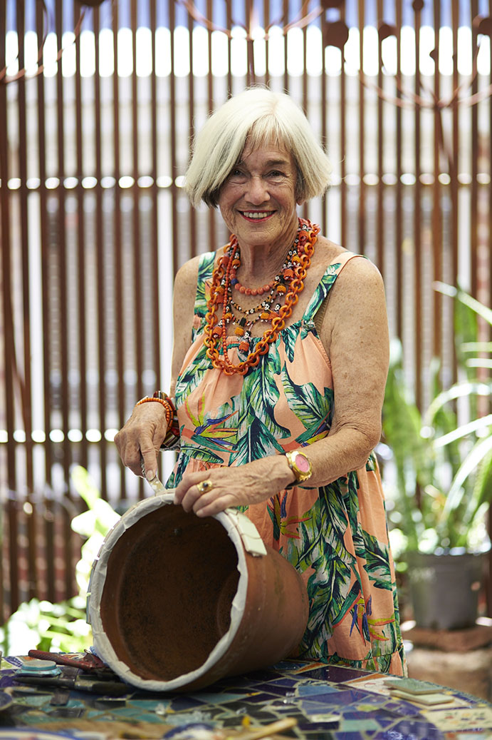

What we heard

We spoke with older Western Australians, industry, the community sector and people from all levels of government and this is what we learnt:
Older people want to age in place
- Most want to access support services in their home to avoid or delay moving into residential aged care.
- Most want to remain in communities they know but struggle to find affordable homes that suit their needs as they age.
- Moving to a new house and navigating a new neighbourhood is more difficult as people age, especially for those with poor health and mobility, or limited financial resources.
Community connection is important
- Many older people are looking for homes that are well-located near friends, family, amenities and transport.
- Social isolation is a big issue for those who live alone.
- Many older single women are concerned about security and some feel safer living with, or near, other women of the same age.
Lack of housing diversity is an issue
- Not all older people are looking for retirement housing and for some it is unaffordable, or simply unavailable.
- Older people want manageable homes, not necessarily smaller ones. Even people on low incomes want extra bedrooms for hobbies, grandchildren, or live-in care.
- Few homes are designed to support ageing in place, making it more difficult to live independently.
Affordability is a critical issue
- Most older people are on low fixed incomes and need a home they can afford.
- Those renting privately struggle to find affordable homes on the age pension and fear becoming homeless.
- Many older homeowners, wanting to reduce housing debt or release equity, face difficulties downpricing to a more affordable home in their community.
- People’s borrowing capacity reduces in older age. This, combined with a lack of affordable homes and high transaction costs, prevents many older homeowners from moving.
More people are facing housing crisis
- There is a high rate of invisible homelessness among older people. For example, older women often house-sit or stay with family or friends.
- Older people on low incomes face difficulties accessing support before they hit crisis.
Many face information challenges
- Few people plan ahead for their housing needs, which can lead to poor housing outcomes, particularly when decisions are made under stress.
- Some older people enter into housing contracts without fully understanding the arrangements and may face substantial costs when trying to exit.

Introducing Ageing with Choice

Aim
Ageing with Choice aims to enable older Western Australians, particularly those on low to moderate incomes, to access affordable, manageable and stable homes so they can age in their community of choice.
Ageing with Choice will benefit:
- older people and their families, who are trying to make decisions about housing
- people who want to rightsize but cannot find a more suitable home
- income-poor older homeowners, struggling with the costs and maintenance of their homes
- older people with mortgages who do not have enough equity to purchase a more affordable or appropriate property
- older people paying unaffordable rents in the private market or living in marginal or inappropriate housing
- residents of retirement villages and residential parks.

Scope
Ageing with Choice focuses primarily on independent living options, not residential aged care, which is a Commonwealth Government responsibility. It recognises, however, the State Government’s election commitment to fast track land identification and planning approvals for aged care facilities. It also recognises the need to work with aged care providers and the Commonwealth to facilitate in-home support, so people can live independently as long as they choose.
In addition, the State Government will continue to work with the Commonwealth to influence policy in areas related to home modifications, superannuation, taxation and Age Pension settings and Commonwealth Rent Assistance to achieve better outcomes for older Western Australians.

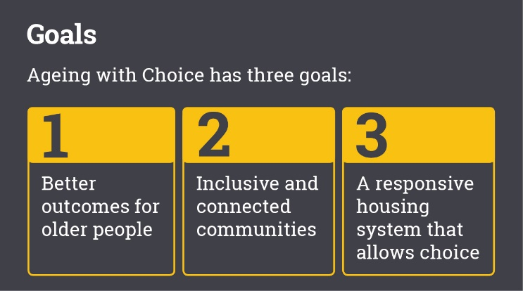
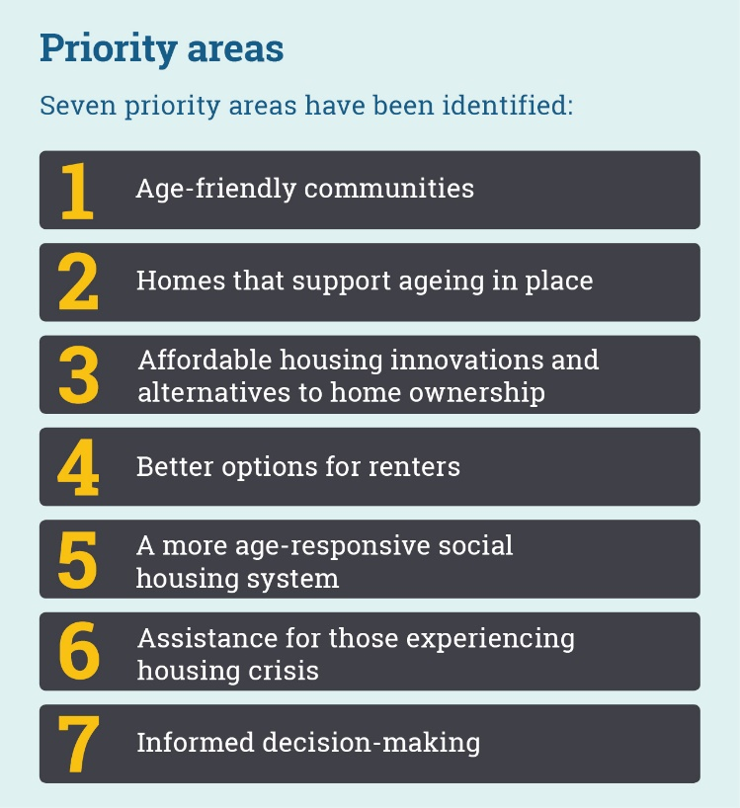

Our goals

Better outcomes for older people
All people deserve a place to call home. Affordable homes provide financial security and enable older people to participate socially and economically in our community. Stable homes support social connection and reduce the burden of housing transition in older age. Manageable homes, that are designed to age in place and can support in-home services, enable older people to live independently for longer. Access to information and support provides choice and can improve housing outcomes.

Inclusive and connected communities
Housing plays a critical role in creating inclusive and connected communities. By encouraging diversity of housing, we can give older people more opportunity to age in their community of choice. Homes that are well-located to services, transport and amenity make it easier for older people to remain living independently in their community. Designing homes and communities that are accessible and support connections with friends and neighbours can reduce social isolation and improve wellbeing in older age.

A responsive housing system that allows choice
A more responsive housing system means better outcomes for older people, their families and the community. A focus will be on making the rental market more age-friendly and expanding the range of long-term housing options for older people with limited assets. This requires partnerships with the private and community sectors to deliver affordable homes. Planning is a key enabler which can stimulate a greater diversity of housing options for older people. Reorienting housing assistance and information services can make it easier for older people to access appropriate housing options.
.

Partnerships and innovations
Partnerships and innovations that increase the choice of affordable, manageable and stable homes will be important to cater for the diverse needs of older people across our State. We will continue to work across sectors to explore new options and build on what we’ve already learned. Recent examples include:

The social housing investment package
A $560 million direct investment into social housing. The initiative halved the priority waiting list for older people (aged 55 or over) and families with children.
By working with the not-for-profit and private sectors, we fast-tracked construction timeframes and delivered 1,000 new social homes between 2015 and 2017.

Bethanie Peel Community Housing, Coodanup
This is an award-winning purpose-built complex for older people. All units are universally designed, with ground floor units incorporating enhanced adaptable design along with energy and water efficiency features to support ongoing affordability. The development is located within a larger retirement village that includes a range of different housing and care options and maximises social connection.

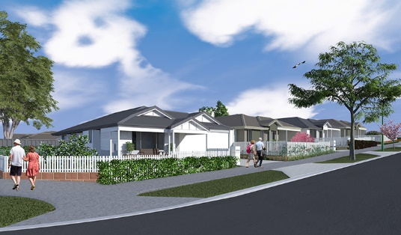

Cherry Glades Estate, Manjimup
Cherry Glades Estate is a collaboration between the Department of Communities, the Shire of Manjimup and Royalties for Regions.
Located in the South West, up to 60 affordable, age-friendly units close to services and amenity are planned for delivery. A range of tenure types will enable locals to age in their community. Construction of Stage 1 will commence in 2019.
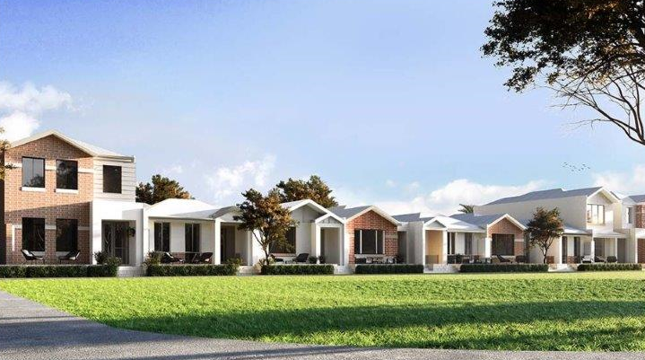

Haven Ridgewood, Ridgewood
In 2017/18 the Department of Communities partnered with Southern Cross Care (WA) Inc, a not-for-profit aged care provider, to develop an innovative and affordable over-55s residential estate. Integrated services will be provided to enable residents to live independently and age in place.

Priority 1: Age-friendly communities

Direction
Design communities, infrastructure and services to enable ageing in place

Current issue
- Without suitable housing and care options, people need to leave their communities, taking them away from their support networks.
- Lack of appropriately-sized land parcels and inconsistent planning requirements across local government are barriers to industry responding.
- Access to transport, services and amenity is important in older age.
- There is unmet demand for age appropriate homes located near services, particularly in regional areas. This is compounded when the cost of construction is greater than the market value of the completed home.
- Almost 25 per cent of people aged 65 or over live alone which increases the risk of social isolation.
- Many people require higher care as their physical or cognitive health declines.

Why this matters
- Enabling older people to remain in their community can improve wellbeing and reduce reliance on government services.
- Housing that is well-located and connected to services is vital to enabling older people to remain healthy, independent and participate in community life.
- Communities are more vibrant when there is greater connection and interaction among all ages.

Response
Responding to this challenge requires:
- engaging older people in the design and planning of communities
- rethinking how we plan and design communities to create places that are safe, accessible and inviting
- intentionally designing communities to deter crime and encourage incidental interactions between people
- locating liveable design homes near public transport, services and amenity
- encouraging affordable, diverse and adaptable housing through the planning system
- encouraging age-specific and multi-generational living options
- working across sectors to facilitate a continuum of care for older people
- encouraging innovation and technology that supports ageing in place, particularly in regional areas
- incorporating accessibility principles and investigating dementia-friendly design where practical.
LandCorp’s Claremont on the Park
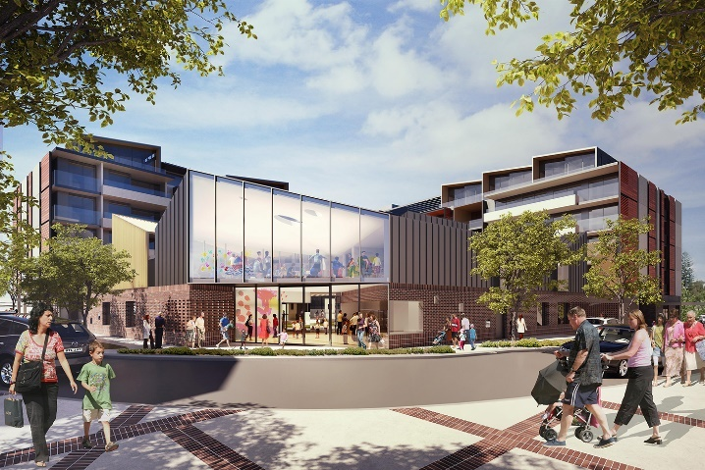
WA’s first multi-age precinct features a mix of housing and care options for older Western Australians, and an innovative childcare service.

Priority 2: Homes that support ageing in place

Direction
Design liveable and manageable homes to meet changing needs in older age

Current issue
- Older Australians on average can expect to live with a disability for around 18 to 20 years.
- Most homes have non-level entrances, steps in showers and narrow doors and passages which restrict mobility and equipment access.
- Lack of housing diversity in many established suburbs and in regional communities prevents older people from accessing more manageable and suitable homes.
- Larger** family homes make up nearly 80 per cent of WA’s housing stock, while larger households comprise only 24 per cent of the population.
- Despite the State Government’s focus on infill, there is limited community acceptance of higher-density housing and a need for quality medium-density housing.
- Many older people are on low incomes and struggle with living costs.

Why this matters
- Falls are the leading cause of death and hospitalisation for people aged 65 or over.
- Between 2000 and 2008, falls among older Western Australians aged 65 or over resulted in 439,831 days in hospital and cost taxpayers over $50 million.
- Retrofitting homes to support ageing is more expensive than building in age-friendly features during construction.
- Well-designed homes that are more affordable and liveable positively impact wellbeing. Design is also a key enabler to remaining independent and supporting delivery of in-home care, including extra space for carers.

Response
Responding to this challenge requires:
- working across-sectors to encourage improved design and housing density, particularly in established suburbs
- raising awareness among industry and consumers about liveable design
- building a higher proportion of homes to liveable design standards and encouraging construction methods which allow homes to be easily adapted
- exploring new technologies that support ageing in place, particularly in regional areas
- more supply of diverse and flexible housing options including dual-key and ancillary dwellings
- promoting sustainability initiatives to reduce transport and living costs.
- 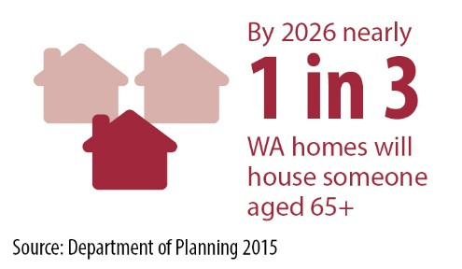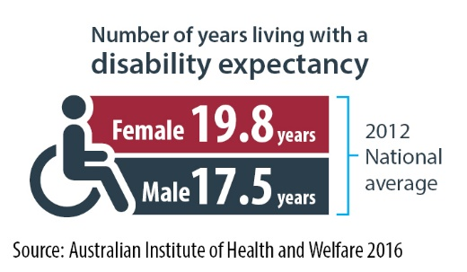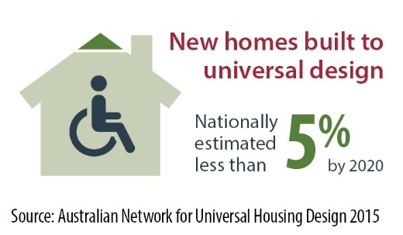

Priority 3: Affordable housing innovations and alternatives to home ownership

Direction
Expand innovative and affordable housing options for older people with limited assets

Current issue
- Home ownership for people aged 65 or over is expected to decline significantly in the future.
- More people are reaching retirement age with a significant mortgage. Many have insufficient superannuation and assets to meet their housing needs.
- Most older people’s borrowing capacity is restricted. For example, a single person receiving the full age pension can expect to borrow a maximum of $49,800. This barely covers the transaction costs of moving to a more suitable home.
- There is a critical gap for affordable housing options for older people with limited assets and who are ineligible for social housing (refer to Figure 1).
- While retirement villages were once considered an affordable option, many are now targeted at the premium end of the market.
- People who cannot afford retirement living options struggle to find alternative housing that creates a sense of community.

Why this matters
- Many people who enter retirement with a mortgage will struggle to maintain their home and meet their housing needs on a low fixed income. This places them at risk of falling out of home ownership.
- People who fall out of home ownership after 50 are more likely to require housing assistance.
- Shared, communal and intergenerational living arrangements can reduce social isolation, enhance safety and security and enable people to live independently for longer.

Response
Responding to this challenge requires:
- increasing access to shared equity, partial ownership and land lease models that provide long-term tenure and lower up-front housing costs
- working in partnership to develop innovative tenure models as alternatives to home ownership
- facilitating shared-living and intergenerational housing options
- investigating ways to incentivise affordable and appropriate housing supply and encourage older people, particularly with limited assets, to move to more suitable housing.
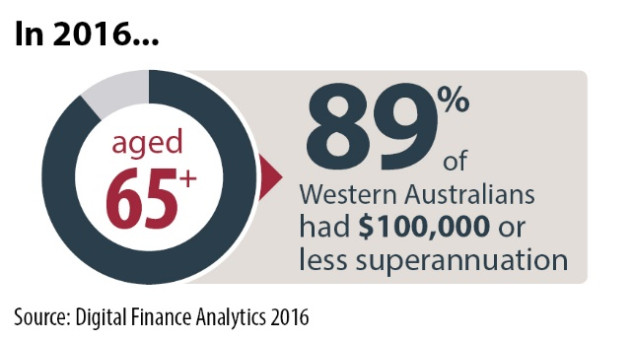
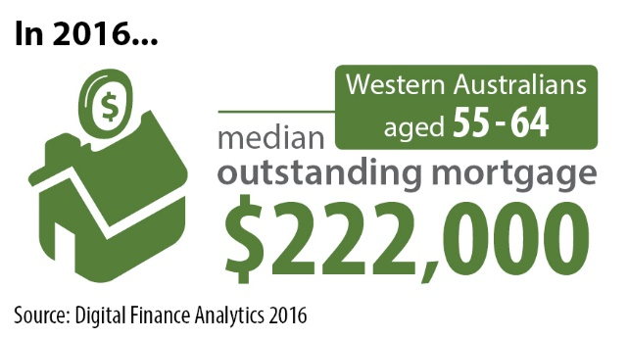

Figure 1: Critical market gap in WA
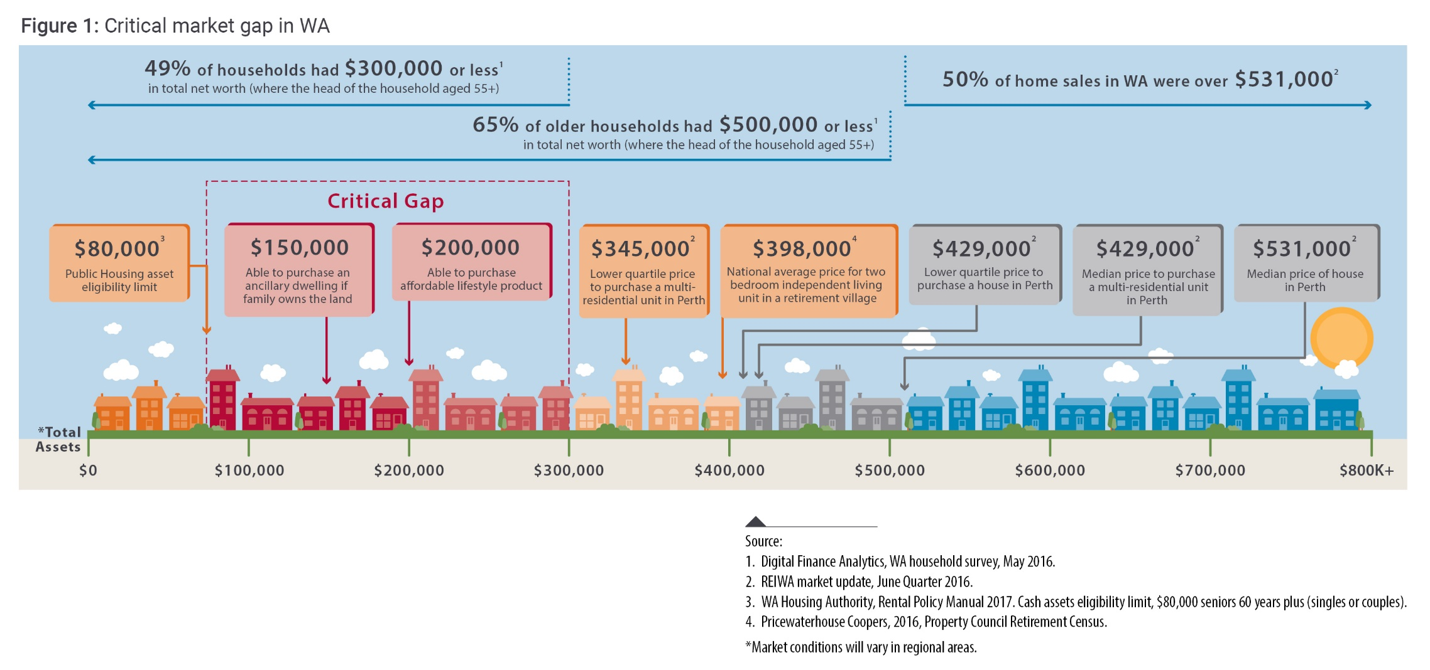
Figure 1 shows that in 2016, 50 per cent of home sales were more than $531,000, while 65 per cent of older households had less than $500,000 in total net worth (including superannuation and housing assets). This leaves them with limited housing options.
In addition, nearly 50 per cent of older households have a net worth of less than $300,000. This is less than the lower quartile (bottom 25 per cent) sales price for a home ($429,000) or for a unit ($345,000). This creates a critical gap for affordable housing options for older people. Without addressing this gap, more older people will struggle to afford private market rents.

Priority 4: Better options for renters

Direction
Encourage stable, affordable and appropriate rental options for older people

Current issue
- Renting in older age is rarely a choice. Many older renters previously owned property but fell out of home ownership due to health issues or relationship breakdown.
- More older people are living in private rentals, particularly women.
- The cost of renting is unaffordable for many older people on lower incomes.
- Older renters may avoid asking their landlord for maintenance in case their rent increases.
- Many landlords are reluctant to modify properties for older renters to age in place.
- Most leases are short-term which can cause older people anxiety.

Why this matters
- As most older renters are on low fixed incomes, they are highly vulnerable to rent increases, placing them at risk of housing stress and homelessness and increasing demand for social housing.
- High rents, insecurity of tenure and an inability to modify homes negatively impact older people’s wellbeing and quality of life and reduce their ability to participate in their community.
- Without an ability to modify their homes, older renters are at increased risk of injury, hospitalisation and early entry into residential aged care.

Response
Responding to this challenge requires:
- a wider pool of affordable rentals
- opportunities for older renters to access longer-term leases in the private market so they have greater housing stability
- a better understanding among landlords of the benefits (for themselves and their tenants) of accessible design and home modifications that support ageing
- promoting good examples of home modifications
- exploring strategies to harness private capital to increase the availability of affordable, long-term private rentals.
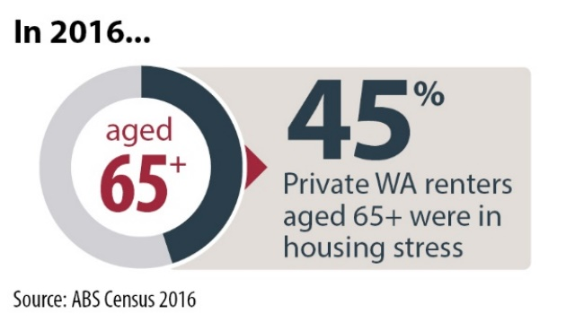
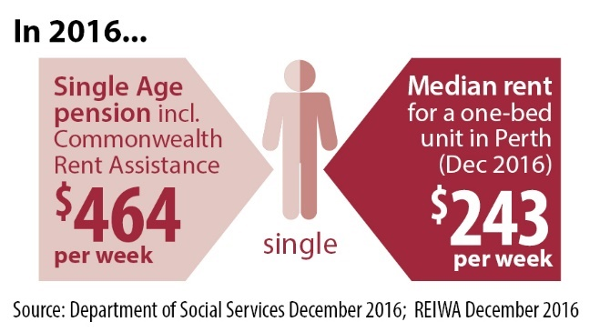
Housing is considered affordable when costs are no more than 30 per cent of gross household income.
A person on the basic age pension, for example, can afford $120 per week or up to $185 per week in rent if receiving Commonwealth Rent Assistance.

Priority 5: A more age-responsive social housing system

Direction
Enable the social housing system to sustainably respond to current and future needs of our ageing population

Current issue
- Many people rely on social housing in older age.
- Social housing requires a high level of capital investment from government.
- There is a mismatch between much of the current social housing stock and the needs of older people. Only a small proportion of public housing stock is liveable design.
- Older people are often in single households, however, many social homes are built for larger families.
- The capacity to reconfigure older social housing stock is limited.

Why this matters
- Despite significant investment, demand for social housing will continue to outstrip supply.
- The social housing system alone cannot sustainably respond to the projected demand.

Response
Responding to this challenge requires:
- viable alternatives to social housing for older people on low incomes that more effectively meet individual need and circumstance
- continuing to explore partnerships with community housing providers to deliver affordable housing and integrated aged care outcomes
- consideration of older people’s needs as part of future reforms to social housing, from both a client service and asset management perspective
- a higher proportion of smaller liveable design social housing stock
- housing options that connect older social housing tenants to formal and informal support networks
- strategies to reduce under-occupancy and support to assist older tenants to transition to homes that are better suited to their needs.
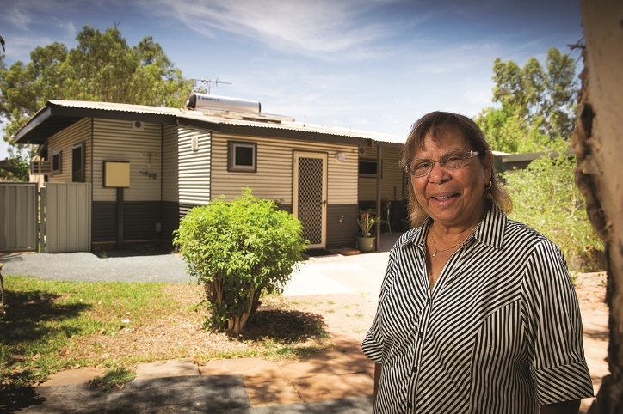

Priority 6: Assistance for those experiencing housing crisis

Direction
Improve assistance to older people in housing crisis so they can find stable housing more easily

Current issue
- Rent increases, termination of rental housing, health issues and family and relationship breakdown, including domestic violence, are leading causes of homelessness in older age.
- People experiencing homelessness for the first time in older age generally require different support than younger people.
- Many older people do not think of themselves as homeless and do not access traditional homelessness services.
- The perceived stigma of homelessness prevents many older people accessing services until they are in crisis.
- Concerns about waiting times for social housing prevent some older people from applying for assistance.
- There is no specialist housing assistance service that caters to the needs of older people.
- Referral services between agencies are disjointed.

Why this matters
- The health and social costs of homelessness to society are high.
- Fragmented information services and poor referral pathways create added pressure for people experiencing high stress and crisis.
- Leaving intervention until people are in crisis can lead to poor health outcomes and a downward spiral into homelessness.

Response
Responding to this challenge requires:
- a focus on early intervention rather than crisis responses, with targeted strategies for priority groups
- housing assistance services which are inviting for older people
- streamlined referral pathways for older people in housing crisis
- advocacy, practical support and brokerage to help older people maintain or access appropriate housing
- specialist accommodation and support services for those experiencing housing crisis
- home support workers and health professionals who can identify and refer older people in housing crisis
- better awareness among lawyers and financial advisors about housing needs in older age to reduce risk of housing crisis later in life
- better links between housing assistance services and financial counselling to reduce the risk of elder abuse
- cross-sector collaboration to deliver new and innovative housing options for older people at risk of homelessness.
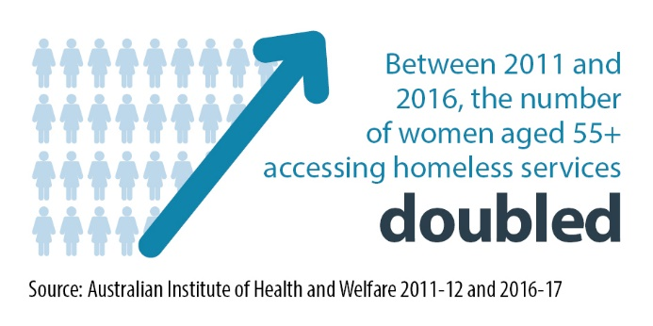.

Priority 7: Informed decision-making

Direction
Improve access to useful information and tools to enable earlier and informed housing decisions.

Current issue
- Many people avoid planning for their housing needs until crisis hits.
- Housing decisions become more difficult due to changes in health and support needs in older age.
- Understanding and comparing housing and living options can be complex because of the different contractual arrangements, and the intersection with the Commonwealth aged care system.
- Housing decisions can be further complicated where family is involved and may be a risk factor for elder abuse.
- Moving house becomes more stressful as functional ability declines.

Why this matters
- Delaying decision-making limits housing choice in older age when financial and borrowing capacity is reduced.

- Once a person signs a housing contract, it can be difficult and costly to terminate if their circumstances change.
- If people do not fully understand the contracts they are signing, or the costs involved, they may choose housing that does not meet their needs. This can create stress, lead to poor financial outcomes and negatively impact wellbeing.
- Housing decisions in older age also impact family members, emotionally, financially and in terms of providing care.
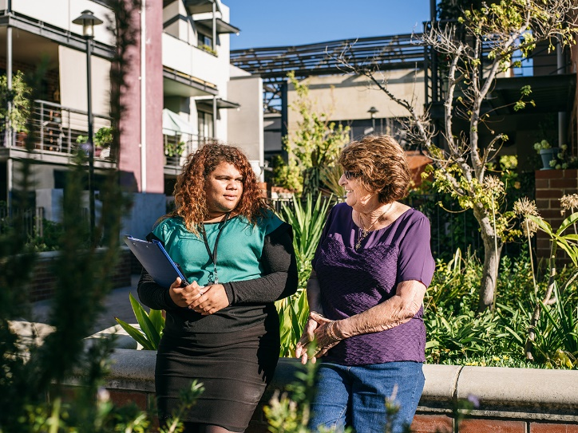

Response
Responding to this challenge requires:
- greater awareness of the importance of housing in later life so people plan for their future and access housing options that support ageing when they have greater personal and financial capacity
- consumer education so older people can take steps to protect their interests before entering into a contract or transferring assets
- good consumer information, clear contracts and appropriate disclosure for retirement and residential park options
- practical tools to help older people find and compare housing options.

Actions
Priority 1: Inclusive and connected communities
Direction: Design communities, infrastructure and services to enable ageing in place
Action | Lead Agency
- Pursue inclusive community engagement in the design and planning of diverse and affordable communities. | Communities / LandCorp
- Facilitate dialogue between consumers, industry and local government to better understand older people’s housing needs and preferences and unlock latent housing demand. | Communities
- Deliver and promote liveable design homes in developments close to public transport or high amenity locations | Communities / LandCorp
- Develop guidance for the design of accessible, safe and inclusive public spaces and places in urban precincts as part of the Design WA Stage 2 suite of policies. | Planning Lands and Heritage (DPLH)
- Investigate use of dementia-friendly design principles in Department of Communities’ developments. | Communities
- Leverage existing planning policies to support provision of adaptable and diverse housing. | Metropolitan Redevelopment Authority (MRA)
- Review model definitions and zoning permissibility for aged-related accommodation, including retirement villages, within Local Planning Schemes Regulations. | DPLH
- Deliver mixed-use developments that enable interaction between people of all generations. | Communities / LandCorp
- Use research to assess and improve multi-generational connections in existing developments. | LandCorp
- Investigate options under community titling to improve affordability for seniors. | Communities
- Investigate the use of technology to enable older people to age in place. | Western Australian Country Health Service
- Work with local governments, Regional Development Commissions and the Commonwealth Government to ensure suitable housing and care options for people living in regional areas. | Department of Primary Industry and Regional Development
- Engage with aged care providers to identify opportunities to integrate aged care within developments. | Communities / LandCorp
- Fast-track the establishment of aged care facilities through removing planning impediments and identifying Government land and buildings suitable for aged care facilities. | Aged care availability working group (Department of Health, DPLH, Department of Local Government Sport and Culture, Communities)

Priority 2: Homes that support ageing in place
Direction: Design liveable and manageable homes to meet changing needs in older age
Action | Lead Agency
- Build a minimum of 20 per cent of new housing that is for sale to market in Department of Communities’ developments to National Liveable Design Standards. | Communities / Housing Advisory Unit (HAU)
- Pursue whole of government liveable design standards and targets. | HAU (with Communities, DPLH, LandCorp, MRA)
- Support the Australian Building Codes Board’s investigation into the benefits of introducing minimum accessibility standards for residential dwellings in the National Construction Code. | Department of Mines Industry Regulation and Safety (DMIRS)
- Investigate planning options to facilitate and encourage the housing industry’s uptake of smaller and more affordable liveable design dwellings suitable for aged and dependent persons. | DPLH / HAU
- Develop design guidance for medium and high-density residential dwellings, as part of the Design WA Stage 2 suite of policies to ensure that good design is at the centre of all developments. | DPLH / Communities
- Encourage a diverse range of housing options in land developments. | Communities / LandCorp
- Trial innovative and affordable housing types including intergenerational, dual-key and ancillary dwellings and more affordable housing options. | Communities / LandCorp
- Deliver projects that encourage affordable living, including initiatives that reduce transport and utility costs. | Communities / LandCorp

Priority 3: Affordable housing innovations and alternatives to home ownership
Direction: Expand innovative and affordable housing options for older people with limited assets
Action | Lead Agency
- Progress affordable leasehold models on government land targeted to older people. | Communities
- Trial the uptake of shared and other co-ownership models targeted to older people with limited income and assets in State Government developments. | Communities
- Develop and investigate innovative housing options for older women, including co-housing. | Communities
- Investigate other models of clustered, shared and supported housing for targeted groups of older people, including Aboriginal people and those from culturally and linguistically diverse backgrounds. | Communities
- Investigate affordable ownership models for use with inclusionary zoning, including restricted resale housing. | Communities / MRA
- Investigate targeted opportunities to incentivise the development and supply of affordable homes that are designed to enable ageing in place, including possible rebates for liveable design homes in Department of Communities’ developments to encourage older people to rightsize to more suitable homes. | Communities

Priority 4: Better options for renters
Direction: Encourage stable, affordable and appropriate rental options for older people
Action | Lead Agency
- Review the Residential Tenancies Act 1987, including issues related to security of tenure, notice periods and home modifications. | DMIRS
- Investigate optional standard long-term lease agreements for landlords and tenants wishing to enter into longer arrangements. | Communities / DMIRS
- Work with the Commonwealth Government to leverage the National Housing Finance and Investment Corporation mechanisms to enable the community housing sector to grow affordable rental stock. | Communities / Treasury
- Investigate the viability of build-to-rent models targeted to older people and other mechanisms for engaging and incentivising private landlords and the retirement sector to provide affordable rentals for older people. | Communities

Priority 5: A more age-responsive social housing system
Direction: Enable the social housing system to sustainably respond to current and future needs of our ageing population
Action | Lead Agency
- Develop a housing needs register to prioritise social housing assistance to those in greatest need, assist others to access alternatives and better understand housing need to inform the design of social housing responses. | Communities
- Build 100 per cent of new social housing developments to National Liveable Design Standards where practical. | Communities
- Trial the use of ancillary dwellings and moveable units for social housing eligible tenants to connect older people on very low incomes to family and support networks. | Communities
- Repurpose larger social houses to create smaller and more manageable homes for older, single person households. | Communities
- Better enable social housing tenants to access live-in care, including investigating rent settings for live-in carers. | Communities

Priority 6: Assistance for those experiencing housing crisis
Direction: Improve assistance to older people in housing crisis so they can find stable housing more easily
Action | Lead Agency
- Deliver a 10-year Strategy on Homelessness that will set direction and tailored responses. | Communities
- Work with older people and the community sector to redesign housing assistance services so they are better suited to the needs of older people. | Communities
- Produce practical, easy-to-understand information for older people and professionals about how to access assistance and housing options. | Communities
Priority 7: Informed decision-making
Direction: Improve access to useful information and tools to enable earlier and informed housing decisions
Action | Lead Agency
- Work across State, Commonwealth and Local Government to make it easier for older people to access information about housing and aged care and services to support ageing in place. | Communities
- Develop tools to help people compare housing options and understand their legal and financial implications. | DMIRS
- Redevelop the Affordable Housing Online Portal so older people and their families can find affordable housing options that can support ageing in place more easily. | Communities
- Raise awareness of housing needs in older age, including the importance of liveable design and rightsizing earlier in life. | DMIRS
- Continue to implement the recommendations of the Retirements Villages Act 1992 review to improve early understanding of the retirement village product and comparison with housing and other alternative housing options. | DMIRS
- Amend the Residential Parks (Long-stay Tenants) Act 2006 to improve protections for older residents while balancing the needs of operators, focusing on creating more certainty and fairness for residents. | DMIRS

Glossary
Accessible homes and communities: Refers to the design of homes, environments and communities to accommodate people of all ages and abilities.
Ageing in place: When a person lives independently in a home of their choice, for as long as they are able or choose to do so. This includes being able to access any care or services they might need over time as their needs change.
Commonwealth Rent Assistance: A non-taxable income supplement payable by the Commonwealth Government to eligible people who rent in the private rental market or community housing.
Continuum of care: Refers to the increasing intensity of services that a person may need as they age.
Downpricing: Refers to the ability to release equity from the sale of a home by purchasing a home of lower value.
High-density housing: Refers to attached dwellings on micro lots that are often compact, three storey terraces or townhouses or apartments.
Housing stress: Is defined by the 30/40 rule whereby a household is in housing stress if they spend more than 30 per cent of their gross income on housing and they fall in the bottom 40 per cent of the income distribution for WA.
Infill development: Refers to development within existing developed areas, including inner or middle ring suburbs.
Liveable design: Liveable homes are designed in accordance with the national Livable Housing Australian Guidelines with the aim of making them easier to access, navigate and live in, as well as more cost effective to adapt when life circumstances change.
Medium-density housing: Refers to detached and attached two to three-storey homes, such as terraces, townhouses and small-scale apartments.
Public housing: Is subsidised housing that is owned and operated by the Department of Communities. It is only available to low income households.
Social housing: Refers to rentals for low income households managed by the State Government (public housing) and the not-for-profit and local government sectors (community housing).
Retirement housing: For the purposes of this document, retirement housing refers to age-specific housing options targeted to older people, including retirement village and lifestyle village communities.
Rightsizing: Consultation indicates many older people prefer the term rightsizing to the traditionally used term downsizing. Rightsizing refers to purchasing a home that is better suited to their specific wants and needs, rather than just a smaller home.

References

Department of Planning, 2015, WA Tomorrow, age by sex SA4, series B
Australian Institute of Health and Welfare, 2018, Older Australians at a glance, web report, September 2018, <https://www.aihw.gov.au/reports/older-people/older-australia-at-a-glance/contents/healthy-ageing>.
Customised table, 2006 and 2016, Census of Population and Housing.
Customised table, 2006 and 2016, Census of Population and Housing.
Digital Finance Analytics, 2016, Western Australian Household Survey, May 2016.
REIWA market update, June quarter 2016 (Greater Perth).
Wood, G., Colic-Peisker, V., Berry, M., and Ong. R. 2010, Asset poverty and older Australians' transitions onto housing assistance programs, Melbourne: Australian Housing and Urban Research Institute.
Customised table, 2006 and 2016, Census of Population and Housing.
REIWA market update, December quarter 2016 (Greater Perth).
Department of Social Services, Social Security Guide, calculation based on the maximum single Age Pension rate of $399 per week and Commonwealth Rent Assistance of $65 per week for December 2016, <http://guides.dss.gov.au/guide-social-security-law/5/2/8>.
Customised table, 2016, Census of Population and Housing.
Customised table, 2011 and 2016, Census of Population and Housing.
Australian Bureau of Statistics, 2017, Selected living costs indexes, Australia, December 2017, cat no. 6467.0.
Internal Department of Communities data, 2018.
Dockery AM, Duncan A, Nguyen H and Ong R (2015), Securing Our Future: Meeting the Challenges of WA’s Ageing Population, Bankwest Curtin Economics Centre, Focus on Western Australia Series, Issue #6, November 2015.
Australian Bureau of Statistics, 2016, Household Income and Wealth, Australia, 2013-14. cat.no. 6523.0 Accessed 17 February 2017.
Customised table, 2016, Census of Population and Housing.
WA Regional Development Council, 2016, Ageing in the Bush: An ageing in place strategy for Regional Western Australia
Australian Bureau of Statistics, 2016, Census of Population and Housing.
Hugo, G. 2014, The Demographic Facts of Ageing in Australia, Appendix Q for Aged Care Financing Authority Second Annual Report 2014, Adelaide: Australian Population and Migration Research Centre.
Commissioner for Senior Victorians, 2016, Ageing is everyone's business: a report on isolation and loneliness among senior Victorians, Melbourne: Victoria State Government, Department of Health and Human Services.
Australian Institute of Health and Welfare, 2016, Australia’s health 2016, Australia’s health series no.15. Cat. No. AUS 199.
National dialogue on universal housing design 2010, strategic plan, July 2010, <https://www.dss.gov.au/sites/default/files/documents/05_2012/national_dialogue_strategic_plan.pdf>.
Customised table, 2016, Census of the Population and Housing.
WA Department of Health, 2015, Injury Prevention in Western Australia: A Review of Statewide Activity for Selected Injury Areas, Perth: Chronic Disease Prevention Directorate.
Ballestas T, Xiao J, McEvoy S and Somerford P. 2011, The Epidemiology of Injury in Western Australia, 2000-2008, Perth: Department of Health WA.
Grattan Institute 2018, Money in Retirement: More than Enough, November 2018, <https://grattan.edu.au/wp-content/uploads/2018/11/912-Money-in-retirement.pdf>.
Internal Department of Communities modelling, 2018.
Wood, G., Colic-Peisker, V., Berry, M., and Ong. R. 2010, Asset poverty and older Australians' transitions onto housing assistance programs, Melbourne: Australian Housing and Urban Research Institute.
REIWA market update, December quarter 2016 (Greater Perth).
Digital Finance Analytics, 2016, Western Australian Household Survey, May 2016.
Digital Finance Analytics, 2016, Western Australian Household Survey, May 2016.
REIWA market update, December quarter 2016 (Greater Perth).
Hodgson H, James A, Webb E (2018), Older renters in the Western Australian private rental sector: Strategies to enhance housing security for WA’s older renters, Research Report No. 19/18. Bankwest Curtin Economics Centre.
Customised table, 2011 and 2016, Census of Population and Housing.
Hodgson H, James A, Webb E (2018), Older renters in the Western Australian private rental sector: Strategies to enhance housing security for WA’s older renters, Research Report No. 19/18. Bankwest Curtin Economics Centre.
Morris, A. 2009, Living on the Margins: Comparing Older Private Renters and Older Public Housing Tenants in Sydney, Australia, Housing Studies 24 (5): 693-707.
Department of Social Services, Social Security Guide, calculation based on the maximum single Age Pension rate of $399 per week and Commonwealth Rent Assistance of $65 per week for December 2016, <http://guides.dss.gov.au/guide-social-security-law/5/2/8>.

