June 2019
Western Australian Public Sector Quarterly Workforce Report

Enquiries:
UPDATE 18 JANUARY 2021
Please note that in order to correct a discrepancy in reported data, representation rates for the following groups (see Western Australian Public Sector Overview) have been updated:
- Culturally and linguistically diverse people
- Employees aged 34 and under
- Employees aged 55 and over
- People with disability.
No other data in this report is affected by this update.
Data Analytics and Reporting
Public Sector Commission
Hale House, 1 Parliament Place, WEST PERTH WA 6005
Locked Bag 3002, WEST PERTH WA 6872
Telephone: (08) 6552 8500
Fax: (08) 6552 8710
Email: stateadministrator@psc.wa.gov.au
Website: www.publicsector.wa.gov.au

© State of Western Australia 2019
There is no objection to this publication being copied in whole or part, provided there is due acknowledgement of any material quoted or reproduced.
Published by the Public Sector Commission, December 2019.
This publication is available on the Public Sector Commission website at www.publicsector.wa.gov.au
Disclaimer
The Western Australian Government is committed to quality service to its customers and makes every attempt to ensure accuracy, currency and reliability of the information contained in this publication. However, changes in circumstances over time may impact on the veracity of this information.
Accessibility
Copies of this publication are available in alternative formats upon request.

Western Australian Public Sector overview
June 2019
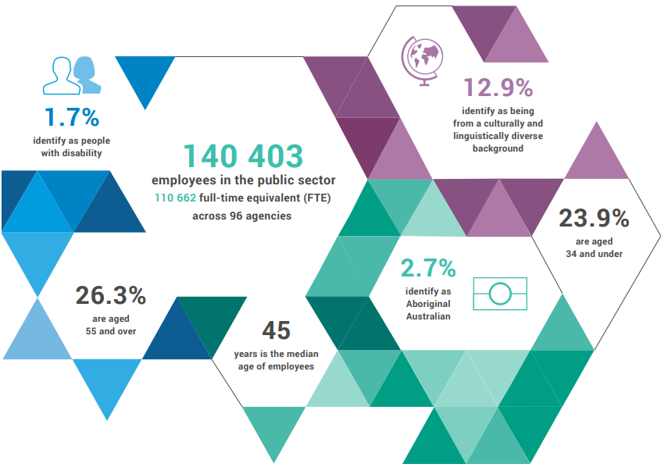
13.5%
identify as being from a culturally and linguistically diverse background

1.6%
identify as people with disability

142 735 people
111 932
full-time equivalent (FTE) across
69 agencies

23.7%
aged 34 and under

2.7%
identify as
Aboriginal Australian

26.6%
aged 55
and over

46
median age

Top 3 occupation groups
383
members of the SES

$3172M salaries
$5034M other expenses

240 men
143 women

19.7% teachers
16.2% clerical workers
10.8% nurses and midwives
53.3% others

Sector profile
This report provides a snapshot of the public sector as at the end of June 2019. Observations from the changes in staffing levels and employment trends over the last quarter (April-June) and salaries expenditure over the 2018-19 financial year are summarised below. More detail on the sector profile can be found in the State of the Western Australian Government Sector Workforce report.

Staffing levels
In June 2019, the WA public sector employed 142 735 people (headcount), an increase of 457 employees since March 2019. While the headcount has increased, the number of full-time equivalent (FTE) staff has decreased by 167 FTE over the same period, down to 111 932 FTE.
The June quarter shows:
- a decrease in WA Health staff numbers (-865 FTE) likely due to a change to data entry processes
- a decrease in the number of staff across the TAFE entities (-181 FTE) which is consistent with an annually occurring reduction in June
- additional staff for the education sector (+480 FTE) reflecting the growth in public school student enrolments in recent years
- an increase in prison officers and trainee prison officers (+153 FTE).
The Commission is working with WA Health to determine the effect of changes to data entry processes on the calculation of headcount and FTE for this quarter. Based on preliminary September quarter data, the Commission infers that this decrease is likely a data anomaly.

Employment trends
This quarter has seen the number of women in leadership positions increase. The representation of women in the Senior Executive Service has reached 37.3 per cent, up 1.3 per cent since March 2019.

Salaries expenditure
General government salaries expenditure was $3172 million for the quarter ending June 2019. This equates to a total of $12 269 million for the 2018-19 financial year, compared to $12 193 million for the 2017-18 financial year. In headline terms, growth in salaries expenditure in 2018-19 was just 0.6 per cent. Adjusting for the impact of Voluntary Targeted Separation Scheme payments in 2017-18 ($280 million) and 2018-19 ($33 million for Western Australia Police Force and Education), underlying salaries growth was 2.7 per cent in 2018-19, less than half the average growth of 5.8 per cent per annum over the last decade.
Figure 1 Salaries growth for 2018-19 (general government)

Source: Department of Treasury, Annual Report on State Finances 2018-19

Headcount, FTE and salaries expenditure
September 2014 – June 2019
Quarter | Headcount | FTE | Salaries expenditure ($M)
September 2014 | 138 353 | 109 379 | 2 707
December 2014 | 137 607 | 109 160 | 2 811
March 2015 | 138 307 | 108 979 | 2 722
June 2015 | 138 440 | 109 019 | 2 849
September 2015 | 139 277 | 109 919 | 2 837
December 2015 | 137 520 | 108 325 | 2 888
March 2016 | 137 371 | 108 722 | 2 801
June 2016 | 135 770 | 107 809 | 2 857
September 2016 | 137 746 | 109 295 | 2 887
December 2016 | 135 936 | 106 830 | 2 931
March 2017 | 139 144 | 109 895 | 2 880
June 2017 | 140 403 | 110 662 | 2 912
September 2017 | 141 609 | 111 472 | 2 980
December 2017 | 137 878 | 108 371 | 3 029
March 2018 | 140 799 | 110 404 | 3 049
June 2018 | 139 812 | 110 373 | 3 135
September 2018 | 141 744 | 111 255 | 3 023
December 2018 | 138 678 | 108 569 | 3 091
March 2019 | 142 278 | 112 099 | 2 982
June 2019 | 142 735 | 111 932 | 3 172

WA public sector entities staffing levels
Agency | Jun-19 Headcount ¹ | Jun-19  FTE ² | FTE change from Mar-19 | FTE change from Jun-18
Department of Education | 54 050 | 40 113 | ▲ 480 | ▲ 795
WA Health  (North Metropolitan Health Service) | 11 711 | 8 733 | ▼ 315 | ▼1 764
WA Health  (WA Country Health Service) | 9 443 | 7 203 | ▼ 297 | ▼ 235
WA Health  (South Metropolitan Health Service) | 8 895 | 6 673 | ▼ 182 | ▼ 104
WA Health  (East Metropolitan Health Service) | 7 865 | 6 072 | ▼ 198 | ▼ 9
Department of Justice | 6 489 | 6 035 | ▲ 151 | ▲ 239
Department of Communities | 6 387 | 5 523 | ▲ 136 | ▲ 224
WA Health  (Child and Adolescent Health Service) | 4 564 | 3 204 | ▲ 58 | ▲ 47
Western Australia Police | 2 818 | 2 089 | ▲ 12 | ▲ 70
Department of Biodiversity, Conservation and Attractions | 2 153 | 1 787 | ▼ 69 | ▲ 70
Public Transport Authority | 2 019 | 1 950 | ▲ 18 | ▲ 108
WA Health (PathWest)⁴ | 1 991 | 1 616 | ▲ 28 | N/A
WA Health (Health Support Services) | 1 988 | 1 374 | ▲ 9 | ▼ 4
Department of Primary Industries and Regional Development | 1 738 | 1 580 | ▲ 10 | ▲ 1
Department of Fire and Emergency Services | 1 726 | 1 623 | no change | ▲ 36
Department of Mines, Industry Regulation and Safety | 1 506 | 1 408 | ▲ 4 | ▲ 37
North Metropolitan TAFE | 1 477 | 1 191 | ▼ 38 | ▲ 12
Department of Transport | 1 451 | 1 342 | ▲ 12 | ▲ 55
South Metropolitan TAFE | 1 336 | 1 078 | ▼ 80 | ▲ 26
Department of Local Government, Sport and Cultural Industries | 1 108 | 886 | ▲ 24 | ▼ 25
Main Roads Western Australia | 1 081 | 1 025 | ▲ 2 | ▲ 5
Department of Finance | 971 | 906 | ▼ 15 | ▼ 39
Department of Water and Environmental Regulation | 923 | 812 | ▲ 16 | ▲ 72
Department of Health | 866 | 747 | ▲ 33 | ▲ 99
Department of Planning, Lands and Heritage | 852 | 756 | ▲ 79 | ▲ 63
Department of the Premier and Cabinet | 580 | 494 | ▲ 1 | ▲ 43
South Regional TAFE | 530 | 370 | ▼ 52 | ▲ 15
Landgate | 513 | 470 | ▲ 4 | ▲ 9
Department of Training and Workforce Development | 454 | 404 | ▲ 2 | ▼ 36
VenuesWest | 449 | 228 | ▼ 42 | ▼ 10
Central Regional TAFE | 422 | 333 | ▼ 17 | ▲ 16
Insurance Commission of Western Australia | 402 | 372 | ▲ 15 | ▲ 35
Mental Health Commission | 348 | 280 | ▼ 9 | ▼ 3
Legal Aid Commission of Western Australia | 336 | 289 | ▼ 9 | ▲ 3
North Regional TAFE | 324 | 290 | ▲ 6 | ▲ 12
Department of Treasury | 309 | 285 | ▲ 2 | ▲ 28
Office of the Director of Public Prosecutions | 288 | 256 | ▲ 8 | ▲ 8
Department of Jobs, Tourism, Science and Innovation | 288 | 263 | ▲ 8 | ▲ 19
Lotterywest | 249 | 237 | ▲ 2 | ▲ 23
Forest Products Commission | 226 | 192 | ▲ 22 | ▲ 8
Office of the Auditor General | 169 | 158 | ▲ 1 | ▲ 16
Metropolitan Cemeteries Board | 168 | 149 | ▲ 3 | ▼ 2
ChemCentre | 144 | 133 | ▼ 2 | ▼ 3
WorkCover Western Australia | 133 | 123 | ▲ 3 | ▼ 1
Corruption and Crime Commission | 125 | 119 | ▼ 1 | ▼ 1
Public Sector Commission | 113 | 99 | ▼ 2 | ▼ 3
Metropolitan Redevelopment Authority | 107 | 99 | no change | ▼ 10
Ombudsman Western Australia | 70 | 61 | ▲ 3 | ▼ 2
Animal Resources Centre | 65 | 59 | no change | ▼ 1
Economic Regulation Authority | 62 | 59 | ▲ 1 | ▲ 2
Small Business Development Corporation | 58 | 51 | ▲ 2 | ▲ 3
GESB | 52 | 46 | no change | ▲ 3
Legal Practice Board | 45 | 41 | ▼ 1 | ▼ 1
Western Australian Electoral Commission | 44 | 41 | no change | 1
National Trust of Australia (W.A.) | 40 | 29 | ▲ 1 | ▲ 1
Department of the Registrar, Western Australian Industrial Relations Commission | 37 | 34 | no change | ▲ 2
Western Australian Meat Industry Authority | 34 | 18 | ▲ 2 | ▼ 3
Construction Training Fund | 23 | 22 | ▲ 1 | no change
Equal Opportunity Commission | 21 | 18 | ▼ 1 | ▼ 1
Office of the Inspector of Custodial Services | 20 | 19 | no change | ▲ 1
Commissioner for Children and Young People | 19 | 15 | no change | ▲ 2
Health and Disability Services Complaints Office | 18 | 17 | ▲ 2 | ▲ 2
Office of the Information Commissioner | 13 | 11 | no change | ▲ 1
Keep Australia Beautiful WA | 9 | 8 | no change | no change
Burswood Park Board | 6 | 5 | ▲ 1 | ▲ 1
Veterinary Surgeons' Board | 6 | 4 | no change | no change
Salaries and Allowances Tribunal | 3 | 3 | no change | no change
Minerals Research Institute of Western Australia (MRIWA) | 3 | 3 | ▼ 1 | no change
Architects Board of Western Australia | 2 | 2 | no change | no change
Western Australian public sector | 142 735 | 111 932 | ▼ 167 | ▲ 1 559

Headcount’ is a snapshot of employees as at the last pay period of the quarter, and includes all permanent, fixed term and paid casual employees during that pay period.
‘FTE’ is a snapshot of employees who were paid in the last pay period of the quarter. This methodology may differ from those used by public sector agencies in their own operational workforce management process. As the quality of agency data is regularly reviewed, some adjustments in FTE figures may occur.
‘Salaries expenditure’ covers the ‘general government sector’ as defined by the Department of Treasury which differs slightly from the ‘public sector’ as defined by the Public Sector Commission.
Effective 1 July 2018, PathWest Laboratory Medicine WA (PathWest) was established as an independent Chief Executive Governed Health Service Provider under Section 32 of the Health Service Act 2016. PathWest was previously under the North Metropolitan Health Service. In the first report post-separation (September 2018) PathWest reported a headcount of 1937 and 1559 FTE.
The Department of Communities supports the Disability Services Commission (Headcount: 1375; FTE: 1158) and Housing Authority (Headcount: 1839; FTE: 1689) which remain statutory authorities.
Sworn officers are employed by the Police Force (a non-public sector entity as defined in the Public Sector Management Act 1994), separated from the Police Service.
The Department of Biodiversity, Conservation and Attractions includes the Botanic Gardens and Parks Authority (Headcount: 142; FTE: 98), Rottnest Island Authority (Headcount: 131; FTE: 109), and Zoological Parks Authority (Headcount: 189; FTE: 141) as part of administrative arrangements. However, these statutory authorities remain as separate entities and continue to employ their own staff.
While staff of regional development commissions are part of the Department of Primary Industries and Regional Development, regional development commissions and their respective chief executives and boards remain as separate entities under legislation. For the purposes of this report, the nine regional development commissions are included in the Department of Primary Industries and Regional Development.
In January 2019, employees of Healthway were transferred to LotteryWest as part of the amalgamation of the two organisations.

