Setting up Two-Factor Authentication for Government Procurement Business Intelligence (BI) reports.

For cyber security reasons, users are required to comply with 2-factor authentication in order to access WA Department of Finance Government Procurement Business Intelligence (BI) reports.

What is 2-Factor Authentication?
Two-factor authentication (2FA) requires you to provide a second form of authentication in addition to your password, when logging in. You will need to enrol a mobile device or be able to receive a phone call on either a landline or a mobile phone in order to comply with this second form of authentication.

How do I setup 2FA?
The first time you log into these report you will be prompted to provide more information. The following instructions illustrate the process of setting up 2FA for the first time:

- You will receive an email from no-reply-powerbi@microsoft.com inviting you to enter an app a staff member of Department of Finance has shared with you.  - Make sure you check the sender and in doubt reply to the staff who invited you on his or her email address.  - Click on View App and your browser will take you to the login page. | 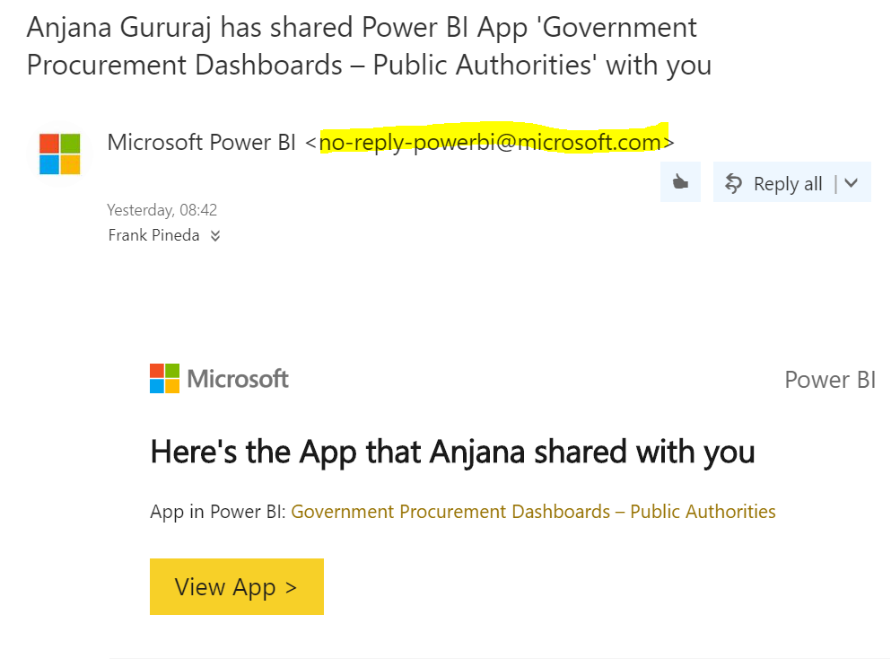
- The first time you log into the application you will be required to provide your second form of authentication. Click on Next button. | 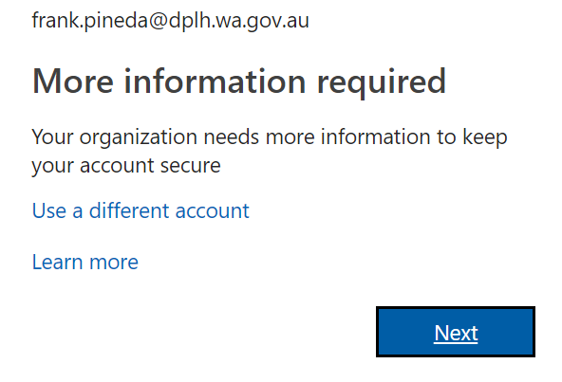
- Please select the way you want to provide this second method of authentication:
- Under Authentication Phone you can select whether you want to receive a text message (Send me a code by text message) or a phone call (Call me).
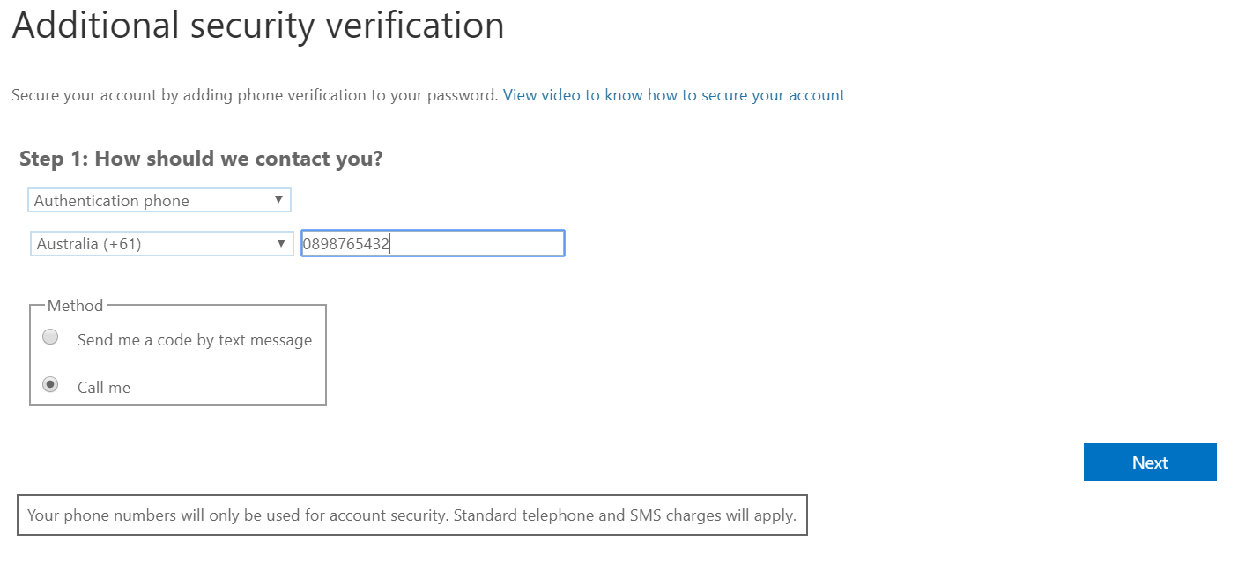
- Select Australia in Select your country or region drop down list.
- If you are using a landline enter your phone in the form of 2-digit area code + 8-digit phone number. E.G.: 0891239877. See the image above for reference.
- If you are using a mobile phone enter your 9-digit mobile phone number phone E.G.: 0412345670
- Click Next and check your phone for a call or a text message. Once you are authenticated the message below will be displayed. Click Done afterwards.
- You will be redirected to the application:
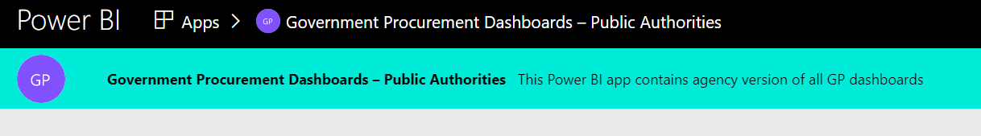

How do I log into the reports?
Once you have set-up 2FA you can log to the reports following the link provided in the original email.  You can either click the View App button in the email although we recommend adding the website to your browser’s favourites or bookmarks. | 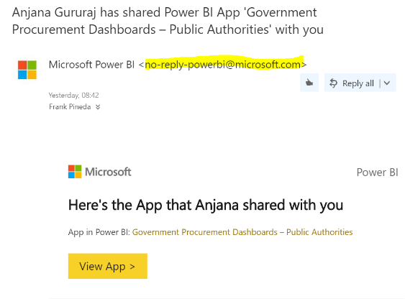
Click sign-in when prompted. Enter your email address and then your password. | 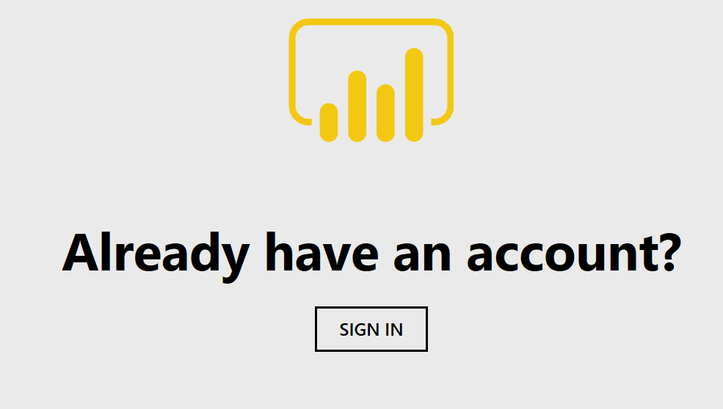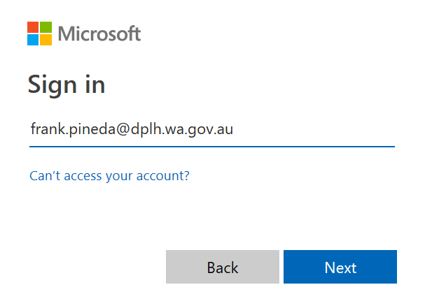
Enter your 2FA requirements according to the option you have selected on the first time setup screen. (In the sample image user is receiving a phone call) | 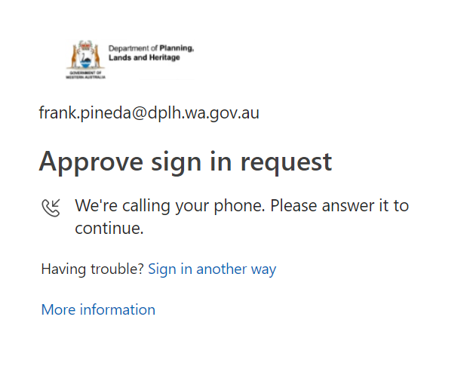
Finally, you can avoid 2FA challenges for up to 30 days providing you access from the same computer and internet browser. Bear in mind changes made to your computer by your ICT department may require you to authenticate via 2FA again. | 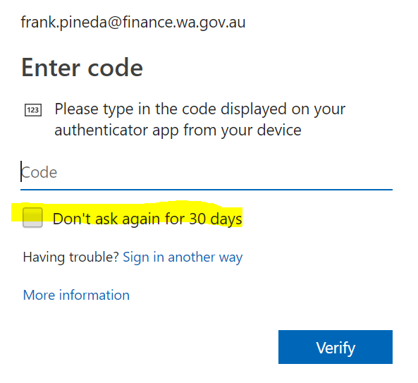

How to Change your 2FA options?
Should you wish to change your authentication options, this can be done at https://aka.ms/mfasetup (You will be prompted to meet the current 2FA option you have selected) You will be redirected to the first time setup page where you can set up an additional way to authenticate:

Additional Resources:
- Comprehensive guide to set up 2FA:
https://docs.microsoft.com/en-us/azure/active-directory/user-help/multi-factor-authentication-end-user-first-time
- Walkthrough video:
https://youtu.be/VzZFKS8AfQU
- Contact Department of Finance – Government Procurement for additional info.

Frequently Asked Questions:
- Is my phone number shared or disclosed with any third party?
No, phone numbers are not used for any other contact purpose.
- What if I do not carry my mobile phone with me at all times?
You can enrol another method such a phone call to your office phone in addition to a text message to your phone.
- What if I am overseas with no phone coverage?
As long as you have an internet connection and a mobile phone you can download an app and enrol it as 2FA to receive confirmation code to any internet connected phone of your choice.
- If I lost my phone, will be my access compromised?
No, that’s why 2FA is important. Anyone with your phone will still have to know your password. Likewise, if your password is compromised your 2FA method will still be required.
- What if I lost access to all my 2FA methods?
Email Department of Finance – Government Procurement at GPBusinessAnalysis@finance.wa.gov.au and request us to remove your 2FA methods. Once you receive confirmation that your 2FA methods are removed, browse to https://aka.ms/mfasetup where you will be prompted to run 2FA first time setup.

