**The South West**

**Native Title**

**Settlement**

An Agreement reached between the Noongar People and the Western Australian Government

**Noongar Recognition Act: Factsheet**

The South West Native Title Settlement (the Settlement) is the largest and most comprehensive agreement to settle Aboriginal interests over land in Australia. The Settlement, involving six Noongar Native Title Agreement Groups, and covering 200,000 square kilometres of land, represents significant social and economic investment in the Noongar community and the shared future of Western Australia.

On 8 June 2015, after extensive negotiations, and authorisation by the Noongar people, the Western Australian Government signed (executed) the six South West Native Title Settlement Agreements with the Ballardong, Gnaala Karla Booja, South West Boojarah, Wagyl Kaip & Southern Noongar, Whadjuk and Yued groups.

The Settlement as a whole will only become fully effective after all of the six Agreements have been conclusively registered in accordance with the Native Title Act 1993 (Cth), and any related court proceedings have been resolved.

For the latest information see the ‘status of the Settlement’ section of the Department of the Premier

and Cabinet website ([http:/www.dpc.wa.gov.au/lantu](http://www.dpc.wa.gov.au/lantu)).

Noongar Traditional Owner Recognition through an Act of Parliament

***The Noongar (Koorah, Nitja, Boordahwan) (Past, Present, Future) Recognition***

***Act 2016 (the Act) formally recognises the Noongar people as the Traditional***

***Owners of the south-west of Western Australia. The Act, proclaimed on 6 June***

***2016 to coincide with WA Day 2016, recognises the important relationship that the Noongar people have with their traditional lands, and the significant and unique contribution of Noongar people to the heritage, cultural identity, community and economy of Western Australia.***

What does the Act recognise?

Through the Act, the Noongar people are now formally recognised as the Traditional Owners of Noongar Lands in the south-west region of Western Australia. A Map of the South West Native Title Settlement Area (the Settlement Area) showing the six Agreement Areas is provided below.

Map. South West Native Title Settlement Area.

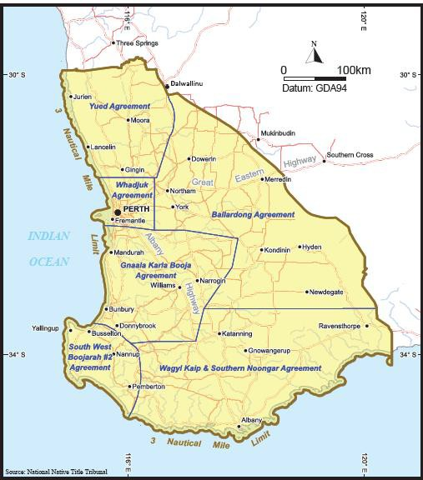

The Western Australian Parliament acknowledges and honours the Noongar people as Traditional Owners of the land and recognises:

• the living cultural, spiritual, familial and social relationship that the Noongar people have with the Noongar lands; and

• the significant and unique contribution that the Noongar people have made, are making, and will continue to make, to the heritage, cultural identity, community and economy of the State.

Will similar legislation need to be passed for every other native title claim in Western Australia?

No, the Act is one of a number of outcomes negotiated between the Noongar People and the WA Government. The successful passage of the Act through Parliament fulfilled a central pre-condition to the future commencement of the South West Native Title Settlement (the Settlement).

Aboriginal people make native title claims in order to be recognised as the traditional owners of the areas they claim. In the South West, as a condition of the Settlement, the six Settlement Agreements (or Indigenous Land Use Agreements (ILUAs)) provide for a single comprehensive package of benefits to be provided to the Noongar people in return for the surrender of any native title rights and interests in an area of land referred to as the Noongar lands. The Noongar Recognition Act is in exchange for the Noongars not seeking native title recognition and does not carry with it any of the statutory rights that flow with native title recognition.

Will the Noongar Recognition Act place new obligations on the WA Government?

The purpose of the Noongar Recognition Act is to recognise the Noongar people as Traditional Owners of the South West. The Act can have no effect upon any civil claim, action or proceeding, or any right of review of an administrative decision, and cannot conflict with any other State or Commonwealth law.

Where can I find copies of the Noongar Recognition Act, the historic second reading speech and further information?

The DPC website ([www.dpc.wa.gov.au/lantu](http://www.dpc.wa.gov.au/lantu)) provides an Information Pack with links to the:

* *Noongar (Koorah, Nitja, Boordahwan) (Past, Present, Future) Recognition Act 2016*
* *Explanatory Memorandum – an aid to Parliament’s consideration of the legislation*
* *Second Reading Speech to Parliament – Extract from Hansard: Assembly – 14 Oct 15*
* *Noongar Recognition Act 2016 flyer*

*Noongar (Koorah, Nitja, Boordahwan) (Past, Present, Future) Recognition Bill 2015*

Further information

Further information about the Settlement, including the six Settlement Agreements (or Indigenous Land Use Agreements – (ILUAs)) made in compliance with the Commonwealth *Native Title Act 1993*, can be found on the website of the Department of Premier and Cabinet (<https://www.dpc.wa.gov.au/lantu>).