The South West Native Title Settlement

An Agreement reached between the Noongar People and the WA Government

Noongar Corporations: Factsheet

The South West Native Title Settlement (the Settlement) is the largest and most comprehensive agreement to settle Aboriginal interests over land in Australia. The Settlement, involving six Noongar Native Title Agreement Groups, and covering 200,000 square kilometres of land, represents significant social and economic investment in the Noongar community and the shared future of Western Australia.

On 8 June 2015, after extensive negotiations, and authorisation by the Noongar people, the Western Australian Government signed (executed) the six South West Native Title Settlement Agreements with the Ballardong, Gnaala Karla Booja, South West Boojarah, Wagyl Kaip & Southern Noongar, Whadjuk and Yued groups.

The Settlement as a whole will only become fully effective after all of the six Agreements have been conclusively registered in accordance with the *Native Title Act 1993 (Cth)*, and any related court proceedings have been resolved.

For the latest information see the ‘status of the Settlement’ section of the Department of the Premier and Cabinet website ([http:/www.dpc.wa.gov.au/lantu](http://www.dpc.wa.gov.au/lantu)).

# The Noongar Corporations

***As a part of the South West Native Title Settlement (Settlement), six Noongar Regional Corporations will be formed to represent the rights and interests of the six Noongar Native Title Agreement Groups. A seventh Noongar corporation, the Central Services Corporation, will also be formed to provide support and services to all six of the Noongar Regional Corporations. The establishment of the Noongar Corporations will be guided by the Transition Principles. [1]***

Diagram. Governance Structure of the Noongar Corporations.

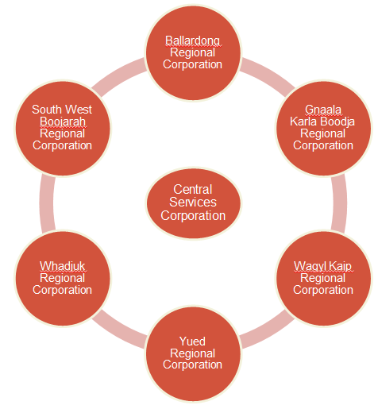

## What are the functions of the Noongar Regional Corporations?

The Regional Corporations are the major beneficiaries of the Noongar Boodja Trust. Once established the Noongar Regional Corporations will:

* benefit, advance and promote the Agreement Groups;
* manage and care for Cultural Land;
* develop a strategic plan based on regional priorities;
* develop key policies, for example, a cultural advice policy;
* engage with government and relevant stakeholders to further Noongar community interests and priorities;
* maintain, protect, promote and support their culture, customs, language and traditions;
* manage and use the land and waters within the region to which they have a traditional connection; and
* manage the benefits and meet the obligations under the Settlement.

## What are the functions of the Central Services Corporation?

The Central Services Corporation will be funded by the Noongar Boodja Trust to provide assistance and core services to the Noongar Regional Corporations. The proposed purpose of the CSC is to:

* support the Regional Corporations to manage the benefits and meet the obligations under the Settlement;
* centralise systems, professional experience and expertise.
* protect, promote and support the culture, customs, languages and traditions of the Noongar People; and
* provide cultural, social, economic and environmental benefits to or for the Noongar People.

It is possible that the South West Aboriginal Land and Sea Council (SWALSC) may transition to become the Central Services Corporation. For SWALSC to be successful as the CSC would require the majority endorsement by the 6 Noongar Agreement Groups.

## When will the Noongar Regional Corporations be established?

The establishment of the Regional Corporations and the commencement of the Settlement are aligned to ensure that the Regional Corporations are established at the same time that the Settlement will commence.

It is anticipated that that Settlement will commence in the second half of 2018 after the conclusive registration of all the 6 ILUAs.

The Settlement Effective Date Notice will trigger the formal incorporation of the Regional Corporations. The Trustee, once established, will then consider the Regional Corporations eligibility in line with the terms of the Trust Deed.

## What steps are involved in becoming a Regional Corporation?

The seven key steps for a Regional Corporation to be eligible and endorsed are:

* Establishing a Regional Corporation;
* Agreement Group endorsement;
* Endorsement as an eligible charity;
* WA Government endorsement;
* Nomination of Regional Corporation;
* Appointment of Regional Corporations; and
* Application made to the Trustee for funding.

Read the ‘Transition Program: Establishment of the Regional Corporations 2016’, on the SWALSC website for details about the various steps and how to get involved (www.noongar.org.au)

## What is SWALSC’s role in assisting to establish the Corporations?

SWALSC is supporting the Noongar Agreement Groups to establish the Noongar Regional Corporations and will maximise Noongar participation in the development of the Regional Corporations.

In doing so, SWALSC must ensure that Noongar people are fully informed and have the opportunity to be involved in the process.

## How do Noongar people become a member of the Noongar Regional Corporations?

All Noongar people are encouraged to lodge an Expression of Interest form to become Members of their Regional Corporation/s.

Members can only be people that are included in the Native Title Agreement Group (Agreement Group) definition as per Schedule 2 of the relevant ILUA[2], and who meet requirements set out in the relevant Regional Corporation Rule Book.

Applicants will become members once the Initial Directors have confirmed that the Applicant meets the eligibility requirements, the most significant requirement being connection with the apical ancestor lists. Member eligibility will be determined using a genealogical database containing information relevant to the apical ancestor lists, as per Schedule 2 of the relevant ILUA.

Copies of the draft Rule Books and Expression of Interest Forms for membership to the Corporations can be found on the SWALSC website ([www.noongar.org.au](http://www.noongar.org.au/))

## How can Agreement Group Members become Regional Corporation Members?

Agreement Group members need to submit ‘Expressions of Interest for membership forms’ (EOIs) via the [SWALSC website](http://www.noongar.org.au/) ([www.noongar.org.au](http://www.noongar.org.au)) to become Regional Corporation Members. EOIs were also accepted during the 2016 Town Information Sessions held by the SWALSC

*Membership will not be finalised until the Regional Corporation has been incorporated*.

## How will the directors of the Noongar Regional Corporations be elected?

Each Noongar Regional Corporation will have two to four Member Directors, who will be elected by the members of that Regional Corporation by postal vote, and appointed at the First Regional Corporation General Meeting.

Each Regional Corporation will also have two Expert Directors who will be appointed by the Member Directors based on their expertise (e.g. legal or financial experience).

An Interim Pre-qualification Committee has been established by SWALSC and the WA Government to pre-qualify the Member and Expert Director candidates as eligible for appointment before the postal vote commences. This will assist the Regional Corporations to comply with the requirements of the ILUAs.

## Will the Noongar Regional Corporations replace the services of the Government and non-Government organisations?

No, the Noongar Regional Corporations should not seek to duplicate or compete with the existing services of Government agencies, non-government organisations and established Noongar service organisations. It is intended that the Noongar Regional Corporations will develop partnerships with other organisations aimed at improved outcomes for the Noongar community.

## Further information

Further information about the Settlement, including the six Settlement Agreements (or Indigenous Land Use Agreements – ILUAs) made in compliance with the Commonwealth *Native Title Act 1993*, can be found on the website of the Department of Premier and Cabinet (<https://www.dpc.wa.gov.au/lantu>) .

1. The Transition Principles are located in Annexure Y of the ILUAs. The Transition Principles were negotiated and agreed to by the WA Government and the South West Aboriginal Land and Sea Council who represent the Noongar Native Title Agreement Groups.
2. Schedule 2 of each ILUA includes an Agreement Group description which outlines that the Agreement Group is made up of Noongar People who are the descendants of one or more persons listed (the apical ancestors).