The South West Native Title Settlement

An Agreement reached between the Noongar People and

the Western Australian Government

Community Development Framework: Factsheet

The South West Native Title Settlement (the Settlement) is the largest and most comprehensive agreement to settle Aboriginal interests over land in Australia. The Settlement, involving six Noongar Native Title Agreement Groups, and covering 200,000 square kilometres of land, represents significant social and economic investment in the Noongar community and the shared future of Western Australia.

On 8 June 2015, after extensive negotiations, and authorisation by the Noongar people, the Western Australian Government signed (executed) the six South West Native Title Settlement Agreements with the Ballardong, Gnaala Karla Booja, South West Boojarah, Wagyl Kaip & Southern Noongar, Whadjuk and Yued groups.

The Settlement as a whole will only become fully effective after all of the six Agreements have been conclusively registered in accordance with the *Native Title Act 1993 (Cth)*, and any related court proceedings have been resolved.

For the latest information see the ‘status of the Settlement’ section of the Department of the Premier and Cabinet website ([http:/www.dpc.wa.gov.au/lantu](http://www.dpc.wa.gov.au/lantu)).

# Community Development Framework

***The Community Development Framework (the Framework) contained in the South West Native Title Settlement Agreement is a commitment between the WA Government and the Noongar people to a set of principles and priorities aimed at improving Noongar community development.[1] The Framework provides the WA Government with greater scope for direct communication and collaboration with the Noongar community, which will be represented through the six Noongar Regional Corporations.***

## What are the key objectives of the Community Development Framework?

The key objectives of the Framework are:

* improved and sustainable social and economic outcomes for the Noongar community;
* Strengthening of Noongar culture, language, traditional knowledge, values and identity in continuation with a greater understanding and celebration of Noongar culture and society throughout Western Australia;
* increased capacity for Government and other service providers to work more effectively, and partner with Noongar people in the design and delivery of human and community services; and
* improvements in economic independence, leadership and governance, and self-esteem across the Noongar community.

## What are the priorities for the first 5 years of the Framework?

The Framework will provide WA Government Human Service Agencies with greater scope for direct communication and collaboration with the Noongar people to deliver shared community development priorities including a focus on:

* safeguarding, developing and transmitting Noongar Culture;
* capacity building and leadership;
* housing;
* youth;
* health; and
* education.

These priorities will be reviewed after the first 5 years of the Settlement. Additional region specific priorities may also be agreed.

## How will the Framework be implemented?

Implementation of the Framework will be overseen by the Community Development Reference Group (the Reference Group), which will comprise:

* Members of the Aboriginal Affairs Coordinating Committee (AACC);
* Representatives from the six Noongar Regional Corporations and the Central Services Corporation; and
* Representatives from non-government organisations delivering services to the Noongar community.

The Reference Group will meet bi-annually, and will be co-chaired by a nominated representative from the AACC, and from the Noongar Central or Regional Corporations.

At the regional level, the key implementation mechanism will be the Regional Human Services Management Groups. These Groups will comprise a range of WA Government service agencies and other local and regional representatives, and will meet regularly with the six Noongar Regional Corporations to oversee the implementation of the Framework.

## When will the Framework commence?

The Framework will commence following the conclusive registration of the six Settlement Agreements (or Indigenous Land Use Agreements (ILUAs)) by the Registrar of the National Native Title Tribunal, and the subsequent establishment of the Central Services Corporation and the Noongar Regional Corporations (collectively the ‘Noongar Corporations’) by the Noongar Boodja Trust (NBT). Once established, the Noongar Corporations can nominate their representatives for the Reference Group and commence planning for engagement between the Noongar Regional Corporations and the Regional Human Service Managers Groups.

Diagram: The Noongar Corporations being established as part of the Settlement.



## What is happening in the lead up to the commencement of the Community Development Framework?

Prior to the formal commencement of the South West Native Title Settlement and the Community Development Framework, the South West Settlement Implementation Unit will be liaising with relevant WA Government agency heads and Regional Human Service Managers Groups regarding their roles under the Framework. Input will be sought from these groups and other key stakeholders to assist in shaping how the WA Government will most effectively engage with the Regional Noongar Corporations to implement the Framework.

## Further information

Further information about the Settlement, including the six Settlement Agreements (or Indigenous Land Use Agreements – ILUAs) made in compliance with the Commonwealth *Native Title Act 1993*, can be found on the website of the Department of Premier and Cabinet (<https://www.dpc.wa.gov.au/lantu>).

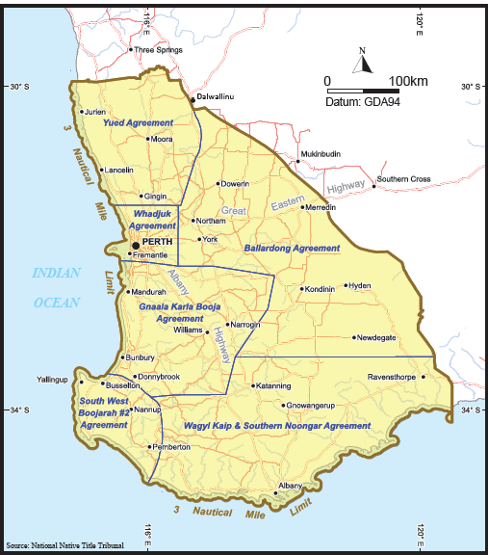Map. The South West Native Title Settlement Agreement Area

1. The *Community Development Framework* is set out in [Annexure T](https://www.dpc.wa.gov.au/lantu/south-west-native-title-settlement/Pages/Settlement-Publications.aspx#H7) of the six South West Native Title Settlement Agreements that were executed between the WA Government and the respective Noongar Agreement Groups on 8 June 2015.