Code of Conduct SuperCrew – Intranet articles

**Integrity - Carson**

Meet Carson.

Carson seems to be a happy-go-lucky public officer but to his team he’s a superhero.

Not only does Carson always act honestly and seek out the truth but he also possesses a strong moral compass. This force is so powerful he’s known as Captain Compass.

It’s his Code of Conduct superpower.

He never takes shortcuts when it comes to providing accurate and considered advice. As he navigates his wayyou’ll hear him call out a well travelled catch cry:

“Forget maps, integrity guides the way!”

Carson keeps public interest at the helm of his workday adventures.

“It sure is a super feeling to know I've earned the respect of my team. They can depend on me to make ethical decisions, provide honest advice and keep us travelling in the right direction.”

Sounds like things will never go south with you around, Carson!

Check out the Integrity section in our Code of Conduct [link] and discover how to get your moral compass pointing in the right direction – just like Captain Compass.

**Impartiality – Xavia**

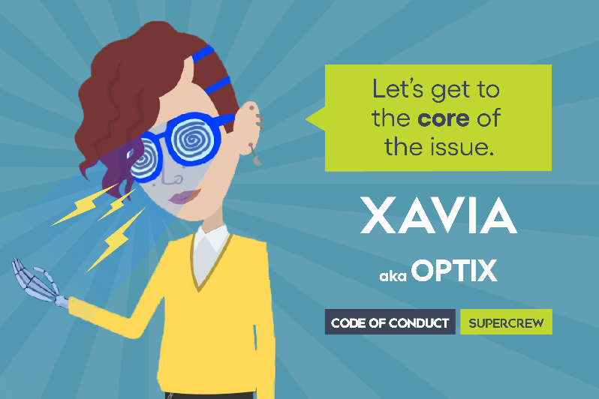

Meet Xavia.

Xavia appears to be a friendly, hardworking public officer but they have gained superhero status amongst their colleagues.

You see, Xavia can see straight through potential risks and tangled webs of conflict with amazing clarity – it’s as if they have x-ray vision!

It’s their Code of Conduct superpower.

With a laser focus on working in the public interest, Xavia is known to many as Optix: someone who upholds the integrity, trustworthiness and accountability of the public sector. Listen and you’ll hear their catch cry around the office:

“Vision with precision – it’s all about the optics!”

Zap! Xavia spots an ill-considered decision and sends it back for more evidence! Buzz! – there’s a potential conflict of interest, let’s get it declared!

“It sure is a super feeling when I can help my peers focus, see the full picture and make the fair decision. Make no bones about it, I always see straight through!”

Thanks Xavia, you’re a bone-a-fide superhero!

Take a look at the Impartiality section in our Code of Conduct [link] and learn how to see the full picture every time, like Optix.

**Respect for others - Erandathi**

Meet Erandathi.

Erandathi seems like an ordinary, unassuming public officer from the outside but at work her team knows she’s a superhero.

You see Erandathi is the most inclusive person they have ever met. She is so good at reaching out and making people feel welcome that she’s known around the office as Lady Elastica.

It’s her Code of Conduct superpower.

She's the first to extend a helping hand at workplace diversity celebrations and initiatives, where you'll hear her well known catchcry*:*

“Simple respect, it's all we expect!"

Erandathi goes above and beyond to make everyone feel welcome which helps create a safer and more respectful work environment.

“It sure is a super feeling to walk into the office and feel the vibe of the supportive and dynamic team that I have helped to create – I want to reach out even further!” she says.

Just how far can those arms stretch, Erandathi?

Discover how to turn inclusivity into your superpower by checking out Demonstrating Respect for Others in our Code of Conduct. [link]

**Trust and accountability - Ralph**

Meet Ralph.

Ralph may seem like your normal, capable public officer, but around the office he’s earned the status of a superhero.

This is because his workmates know Ralph is super meticulous in his record keeping. He simply couldn’t be more transparent – so he’s known as Mr Invisible.

It’s his Code of Conduct superpower. Like all superheroes, he has a catchcry regularly heard as he wields his powers.

“In TRIM we trust!”

Ralph says it’s about being completely accountable for all his processes and decisions, especially in busy times like the end of the calendar or financial year.

“It sure is a super feeling when I am asked about a decision that was made one or 2 years ago because I can find the answer in TRIM, quick as the Flash.”

Steady on Ralph … one super power is enough, buddy.

Check out our Code of Conduct's [link] Demonstrating Trust and Accountability section or our [Record Keeping Plan](https://dpcwagov.sharepoint.com/:w:/r/sites/CorporateLibrary/_layouts/15/Doc.aspx?sourcedoc=%7bB46C226D-79AC-4DEC-BF86-DC39D4ACE3C9%7d&file=Record%20keeping%20plan.docx&action=default&mobileredirect=true&DefaultItemOpen=1) [link] to become more like this conscientious crusader, Mr Invisible.