Western Australian (WA) Government Response to the Royal Commission into Violence, Abuse, Neglect and Exploitation of People with Disability

  - Easy Read - July 2024

Contents
How to Use this Book 3
What is the Disability Royal Commission? 3
Western Australia’s Plan. 6
Parts 1 – 3: Bad Things That Happened 10
Part 4: Rights for People with Disability 12
Part 5: Making Good Plans 14
Part 6: Choices and Easy Access 15
Part 7: School, Work and Home 17
Part 8: The Law 19
Part 9: Help for First Nations People With Disability 21
Part 10: Safe Help For people with Disability 23
Part 11: Telling Someone About Problems. 24
Part 12: What Happens Next? 25
Do you need help? 27
Here are some places to help you: 27
Word List 29

How to Use this Book

This is a short of a bigger .

The bigger is called the Western Australian Government's Answer to the Disability Royal Commission.

It tells you what we think about the ideas from the Disability Royal Commission.

Since this is a smaller .
It does not include everything from the bigger .

What was the Disability Royal Commission?

The Disability Royal Commission wanted to make Australia a safer place for people with disability.

It took over 4 1/2 years to happen.
Lots of things happened.

These things were:
- 32 public meetings.

- 2 special meetings.

- Answering 17,824 .

- 7,944 from .

The Western Australian Government has helped the Disability Royal Commission by sharing information.

The Disability Royal Commission started in 2019. It finished in 2023.
In September 2023, the Disability Royal Commission shared a with important ideas.

These ideas were about the things that needs to change.

These ideas are called recommendations.

The report is divided into parts which are called volumes.

The report makes 222 ideas for change.

They are in 12 parts.

132 of these ideas are for Western Australia.

The Western Australian Government will work on how best to make these ideas happen.

They will work with:
- People with disability,
- Families,
- Carers,
- The government,
- Disability services,
- People of Western Australia.

We will make Western Australia a better place for people with disability.

Western Australia’s Plan

We are working together to make a difference.
This includes:
- The Australian Government,

- State governments,

- Territory governments.

The Disability Royal Commission Final has 222 ideas for us to work on.

These are:
- 84 ideas for the Australian Government to be in charge of,

- 85 ideas for all governments to work on together,

- 44 ideas for each state and territory government to do,

- 6 ideas for some states and territories. There are 3 for Western Australia,

- 3 ideas for non-government places and the Australian Government.

Western Australia has 132 ideas to think about.

The Western Australian Government is replying to these ideas.
In the table below, the replies are:
The Words | What they Mean
Accept | Western Australia says Yes.  “Governments say yes to these ideas.”
Accept in Principle | Western Australia says Yes.  “But have different ideas on the best way to make the change.”
Accept in Part | Agree with some parts but not other parts.  “Governments have different ideas on how to make things better. They cannot always agree on the best way.”
Further consideration | We need to think about it more.  “We need more time to think about these ideas. We cannot decide on what to do right now.”
Note | This is not for Western Australia to decide.  “These ideas are outside of Western Australia. They are for somebody else to decide.”
Not accept | Western Australia does not agree.  “The Western Australian Government says no to this.
Figure 1: A pie graph of the 132 ideas for the Western Australian Government.
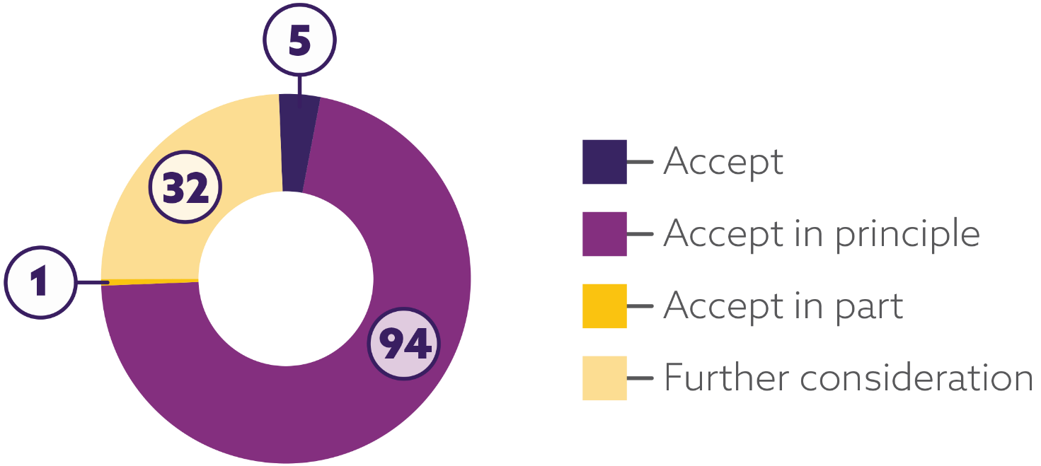

The Western Australian Government most of the ideas.

They like 100 out of 132 ideas.

They are thinking more about the other 32 ideas.

WA people are very with these ideas too!

Parts 1 – 3: Bad Things That Happened
This part talks about how people with disability are often hurt or abused.

It shows why there is a strong need for change.

Parts 1-3 of the report do not have any recommendations.

Part 1 is called ‘Voices of people with disability’.

This part has over 1,500 stories from people with disability.

These stories were shared with the Royal Commission.

The names and details of the people were kept private.

This is to protect the people.

Part 2 is called ‘About the Royal Commission’.

This part talks about how the Disability Royal Commission was made.

Part 3 is called ‘Nature and extent of violence, abuse, neglect and exploitation’.
This part gives facts about the bad things that happen to people with disability in Australia.
It includes the different stories of:
- Women and girls with disability,

- people with disability,

- people with disability,

- People with disability from different countries,

- People with disability who speak different languages.
Thank you for sharing your stories.

Part 4: Rights for People with Disability
Australia has promised to follow international rules to protect the rights of people with disability.

These rules are called the Convention on the Rights of Persons with Disabilities.
The Disability Royal Commission found some big problems:
- Australian laws do not fully protect the rights of people with disability,

- When rights are ignored, there is no way to fix it,

- Australia's Laws need to be the same as International Disability Rules. This does not happen right now.
This means people with disability do not have the safety they deserve.

Changes are needed to fix this.

The Disability Royal Commission says:

- Australia needs a new law called the Australian Disability Rights Act,

- This law would help protect people with disability,

- It would also protect people with disability.

This new law would help make sure people with disability are treated fairly. It would also make sure their rights are the same as everyone else.

The Western Australian Government:
- Accepts in principle 1 of the 2 important ideas,

- Agrees that Australia needs to do more to protect the rights of people with disability.

This means the Western Australian Government thinks it is a good idea and wants to work towards making it happen.

Part 5: Making Good Plans
The Western Australian Government wants to keep people with disability safe.

The Western Australian Government:
- Accepts or Accepts in Principle all 5 ideas to make sure hurt and abuse do not happen.

They agree that:
- Stronger national rules are needed to protect people with disability.

They will work with other governments to make things better for people with disability.

This means the Western Australian Government wants to keep people with disability safe and included.

Part 6: Choices and Easy Access

This part is about why it is important to make your own choices.

It also talks about how people with disability sometimes have problems.

People with disability sometimes have problems doing things on their own.

Part 6 talks about these ideas:

- Make My Own Choices: Helping people with disability make their own choices. They might need some help, but it is their choice.

- Information for Me: Making sure people with disability get the information they need to make choices. It should be easy to find out what things mean.

- Stay Healthy: People with disability should get the help they need to stay healthy.
and should know how to help them.

- Speak Up: Helping people with disability talk about what they need and want. Make sure others listen to them.

- Be Free: Do not stop people with disability from moving around or doing what they want. Do not lock them in a room or hold them back.

Part 6 has 31 ideas to make things better.
19 of these ideas are:
- Accepted, and
- Accepted in Principle.

Part 7: School, Work and Home
We want to make life better for people with disability.
We talked about 3 important areas:

- We want to welcome and include children with disability.

- Jobs: We want people with disability to have the same chances to work. We want them also to be a part of where they live.

We want more houses for people with disability. We want them to have more choices in the help they get.

We want everyone to be where they live.

The Western Australian Government agrees with most of the ideas in Part 7.
They:
- Accepts 25 ideas completely or mostly,

- Need to think more about seven ideas.

Part 8: The Law
People with disability can be treated unfairly under the law.
People with disability are more likely to:

- Have mental health problems,

- Be treated unfairly,

- Be lonely and ,

- Go back to jail again and again.

The Disability Royal Commission said we need to:

- Do a better job of finding out the needs of people with disability in jail,
- Make it easier for people with disability to crimes and trust .

The Western Australian Government agrees with most of these ideas.

They Accept or Accept in Principle 16 out of 20 of the ideas.

They want to make it better for people with disability.

They have already started working on some of these changes.

Part 9: Help for First Nations People with Disability
The Disability Royal Commission wants to make sure that people with disability get the right help.

To do this, we need to:

- Listen to their needs and hopes,
- Make plans and rules that have what they need and want.

This will help make a big difference in important areas like:
- Early childhood development

- Jobs

- Judges.

The Western Australian Government agrees with the Commission's ideas and wants to:

- Make things safe,

- Make sure people with disability feel good about keeping children safe,

- Make sure people with disability feel good about .

The Western Australian Government Accepts in Principle all 6 ideas in Part 9.

Part 10: Safe Help for People with Disability
This part is about helping people with disability get the help they need.

It is also about keeping them safe.

The Disability Royal Commission has some ideas to make things better:
- Make sure there are enough workers to help people with disability,

- Stop people from being hurt or treated badly in disability services.

The Disability Royal Commission thinks the National Disability Insurance Scheme Quality and Safeguards Commission is important.

They keep people safe. They make sure bad things don't happen.

The Western Australian Government Accepts in Principle all 14 ideas in Part 10.

Part 11: Telling Someone About Problems.
The Western Australian Government wants to make sure people with disability are safe.

To do this, they are going to make things better.

This includes:

- Laws to protect adults with disability from being hurt,

- Places to get help on telling someone about abuse,

- People to check on people with disability,

- More talking about abuse that happens.

The Western Australian Government Accepts in Principle 7 of the 15 ideas to make people with disability safer.

They want to work together to make sure people are safe around Australia.

Part 12: What Happens Next?
The Western Australian Government agrees with the main ideas from the Disability Royal Commission.

Here is what they plan to do:

- Write a to the Commission's ,

- Work with other governments to make the ideas happen,

- Share information to make things better.

The Western Australian Government Accepts in Principle all 7 ideas in Part 12.

Some ideas need more thought.

The Western Australian Government will talk about what they have decided.

They will tell us in the middle of 2025.

They will also:

- Talk to people with disability about big changes,

- Talk to the community,

- Work with other governments,

- Make sure everyone knows what is going on.

Do you need help?

Here are some places to help you:

- Beyond Blue Support Service

1300 224 636 any time.

online any time.

Website: Beyond Blue Support Service

Lifeline Crisis Support

13 11 14 any time.

online any time.

Website: Lifeline Crisis Support

- 1800RESPECT

1800 737 732 any time.

online any time.

If you have been hurt or abused at home, they can help.

Website: 1800RESPECT

- 13YARN

13 92 76 any time.

Yarn with us.
For First Nations people. And Torres Strait Islander people.
Website: 13 Yarn.

Word List
- Australian Government
– the big team that helps our country.

- Community
– the people around us who are our friends.

- Disability Services
– a place that helps people with disability.

- Government
– the team that makes big decisions for us.

- International
– other countries.

- Laws
– rules we follow to be safe and kind.

- Mental Health
– struggles with how people think and feel.

- National
– our whole country, all together.

- Non-government
– teams that help us but are not the government.

- Recommendations
– good ideas to make things better.

- Disability Royal Commission
– a special team that listens and helps people with disability.

- State
– a smaller part of our country, where people live.

- State Government
– the team that helps our State.

- Territories
– a special area in our country, like a State.

- Territory
– a special area in our country, like a State.

- Territory Government
– the team that helps our territory.

- Western Australian Government
– the team that helps Western Australia.

