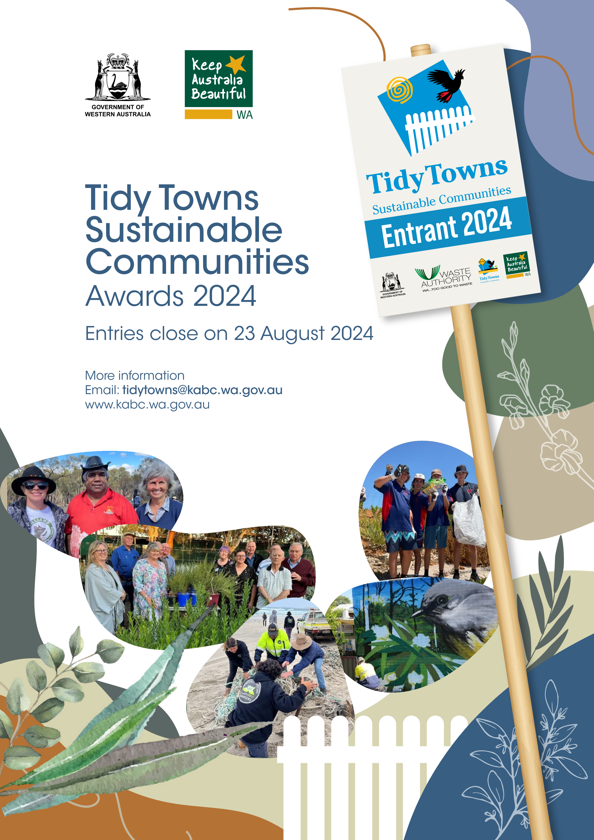

Tidy Towns Sustainable Communities Awards 2024
Submission form
The Keep Australia Beautiful Council's annual Tidy Towns Sustainable Communities Awards recognise regional and remote communities that demonstrate effective litter prevention activities, positive environmental action and social outcomes.
State title | To be eligible for the overall state title, a community must enter projects in at least six of the nine categories (does not include the Leadership award).  The overall state winner will represent Western Australia in the national Tidy Towns Sustainability Awards.
Categories | General appearance  Community action and wellbeing  Heritage and culture  Waste management  Litter action | Community containers for change  Young legends  Environmental sustainability  Environmental education  Leadership award (judges’ discretion)
Prize money | The overall state award winner will receive $2000. Category winners will receive $500–$1,000. Recipients of the Young Legends and Leadership (judges’ discretion) awards will receive $1,000. There are additional sponsor prizes.
Key dates | 17 May  Awards and online registration open  23 August  Entries close (submissions are due by 12 noon)  2‒20 September  Judges visit communities to assess projects  (entrants will be contacted in advance to arrange a visit)  October  Finalists are announced  22 November  State Awards event at Optus Stadium
Eligibility | Projects in regional and remote communities that have been initiated, completed or maintained between July 2023 and June 2024.  Any local individual, group, shire, business, organisation or school can enter their regional or remote community in the awards.
More info | Email: tidytowns@kabc.wa.gov.au  Website: www.kabc.wa.gov.au

Community name | Click to enter text.
Local government authority | Click to enter text.
Postal address | Click to enter text.
Postcode | Click to enter text.
Primary contact | Contact name
 | Phone number |  | Email address
Secondary contact | Contact name
 | Phone number |  | Email address
Community population | Click to enter text.
How many volunteers (if any) are engaged across all projects? | Click to enter text. |  |  | Number of hours volunteers worked on project/s | Click to enter text.
Photograph use authorisation
You can include pictures in this submission form or provide them as attachments (jpg format) when you email your submission to tidytowns@kabc.wa.gov.au.
I, Click to enter text., give permission to Keep Australia Beautiful Council to use any images presented as part of the submission. I understand that they may be used to promote the program. If any children appear in the photographs, their permission or parent/guardian permission has been granted.
Signed: Click to enter text or insert an image.
Please indicate the category/categories you are entering.
☐ General appearance  ☐ Community action and wellbeing  ☐ Environmental sustainability  ☐ Litter action  ☐ Waste management |  | ☐ Community containers for change  ☐ Heritage and culture  ☐ Environmental education  ☐ Young legends
Judging criteria
You can learn more about the judging criteria for each category on our categories and judging criteria webpage.
Preparing your submission
Please provide as much detail as you like ‒ the content fields will expand as you add text and images.
You can delete any categories you are not entering.
The submission instructions can be found on the back page of this form.
General appearance
Recognises achievements in improving the visual appearance of communities
Project title
Provide a description of the project
List the proponents (who was involved)
Outline the project outcomes
Community action and wellbeing
Recognises achievements in creating a healthy, vibrant community that actively engages groups across sectors.
Project title
Provide a description of the project
List the proponents (who was involved)
Outline the project outcomes
Environmental sustainability
Recognises outstanding community achievements in adaptation to environmental change
Note: this category includes initiatives focusing on the preservation of natural environment, water conservation and energy efficiency
Project title
Provide a description of the project
List the proponents (who was involved)
Outline the project outcomes
Litter action
Recognises innovation and achievements in reducing and managing litter
Project title
Provide a description of the project
List the proponents (who was involved)
Outline the project outcomes
Waste management
Recognises innovation and achievements in reducing and managing waste
Project title
Provide a description of the project
List the proponents (who was involved)
Outline the project outcomes
Community containers for change
Recognises container refund initiatives that have positively impacted the community
Project title
Provide a description of the project
List the proponents (who was involved)
Outline the project outcomes
Heritage and culture
Recognises outstanding commitment to the conservation and celebration of a community’s Indigenous and non-Indigenous heritage and culture
Project title
Provide a description of the project
List the proponents (who was involved)
Outline the project outcomes
Environmental education
Recognises an outstanding initiative or organisation for its innovative environmental advocacy or awareness program
Project title
Provide a description of the project
List the proponents (who was involved)
Outline the project outcomes
Young legends
Recognises achievements by an individual or group(s) of young people (under 25) who have contributed to the sustainability of their community
Note: the activity does not need a litter or environmental focus
Project title
Provide a description of the project
List the proponents (who was involved)
Outline the project outcomes

Submitting your form
Submissions are due by 12pm on Friday 23 August.
Email your submission to tidytowns@kabc.wa.gov.au.
Please provide all your supporting documents, images and videos with your submission by either:
- attaching copies of the files
- providing a link to a shared folder (Dropbox, OneDrive, etc.).
Submissions can also be printed and mailed to:
Tidy Towns Sustainable Communities Awards
Keep Australia Beautiful Council
Locked Bag 10
JOONDALUP DC 6027
If you require assistance, please email tidytowns@kabc.wa.gov.au or phone 6363 7210.

