COPP 9.4 Change of Prisoner Name
Prison
Principles
As referenced in the Guiding Principles for Corrections in Australia, 2018:

1.3.1 Effective systems provide prisoners / offenders with opportunities to make requests or complaints and access appropriate information.

1.5.1 Comprehensive and contemporary information is recorded to support appropriate assessment and continued management of prisoners / offenders.

Contents
1 Scope 3
2 Policy 3
3 Change Primary Name in TOMS 3
3.1 Eligibility and prerequisites 3
3.2 Supporting documentation 3
3.3 Procedure 3
4 Annexures 6
4.1 Definitions and acronyms 6
4.2 Related legislation 6
5 Assurance 6
6 Document Version History 7
Appendix A – Approval to Apply to Register Change of Name 8

Scope
This Commissioner’s Operating Policy and Procedure (COPP) applies to all prisons administered by or on behalf of the Department of Justice (the Department).

Policy
A prisoner’s name may be changed at any time if the Superintendent considers the change necessary.
Prisoner name changes shall be approved by the Commissioner, in accordance with the Registry of Births, Death and Marriages (RBDM) under the Births, Deaths and Marriages Registration Act 2020.

Change Primary Name in TOMS

Eligibility and prerequisites

The eligibility criteria to register for a name change is detailed on the ‘Application to register a change of name’ form BDM400 (BDM400).

The Superintendent shall consider the application subject to section 3.3.3 and forward the completed TOMS form ‘Approval to Apply to Register Change of Name’ to the Commissioner for approval (refer BDM400).

An application fee of $190 is required (refer BDM400). Note: the prisoner should be advised that the application fee is retained regardless of the outcome of the application.

Supporting documentation

At least three forms of identification are required for the application including one with a photo (refer BDM400).

Procedure

Where a prisoner requests a change of their name, the following procedure is followed:
- staff shall ensure the prisoner meets the eligibility criteria listed in BDM400.
- staff shall print out the ‘Approval to Apply to Register Change of Name’ from TOMS (see Appendix A – Approval to Apply to Register Change of Name) and where required, assist the prisoner in completing the hard copy application.
- once the ‘Approval to Apply to Register Change of Name’ form is completed, staff will forward the hardcopy application to the assigned staff member (eg Transitional Manager, Case Coordinator) who shall enter the details provided onto the TOMS ‘Approval to Apply to Register Change of Name’.
- the assigned staff member shall then print out the application and have the prisoner complete and sign part 6. The assigned staff member shall complete and sign part 7 and part 8.
- the assigned staff member shall then forward the printed and signed ‘Approval to Apply to Register Change of Name’ form along with any relevant history/charges of the prisoner and confirmation that the prisoners Victim Notification Register (VNR)/Victim-offender Mediation Unit(VMU) has been checked to the Superintendent/Officer in Charge (OIC) for endorsement (Part B section 9).
- the Superintendent shall consider the application and if supported, state that the application is supported in Part B section 9.
- the approved printed and scanned ‘Approval to Apply to Register Change of Name’ form shall be emailed to the Office of the Commissioner for the Commissioner’s approval (Part B section 10).
- the Superintendent shall not support the application, if the name change is considered reasonably likely to:
- have an adverse effect on the safety or security and the good order of the prison
- be considered offensive by a victim of the prisoner’s crime or a significant sector of the community. Where the prisoner has a TOMS Victim Notification Register (VNR) Alert, the Superintendent shall ensure to consult with and obtain comment/advice from the victim(s) through the VNR
- if the prisoner is registered against the Australian National Child Offender Register (ANCOR), the provisions of section 80C of the Community Protection (Offender Reporting) Act 2004 apply.
- any other reasons outlined in Part B section 10.

Once considered and approved by the Commissioner, the completed Approval to Apply to Register Change of Name’ form shall be emailed back to the sending prison.

If not approved by the Commissioner the application will not progress to RBDM, refer to section 3.3.11.

If approved by the Commissioner, the Superintendent shall ensure that the BDM400 is printed out and completed by the prisoner. The prisoner shall be given assistance to complete the form if required.

Once completed, compile the:

signed hardcopy of the ‘BDM400,

signed copy of the ‘Approval to Apply to Register Change of Name’ form

required proof of identity

application fee and all other application requirements (refer to the BDM400).

The compiled documents at section 3.3.5 shall be sent to:

Registry of Births Deaths & Marriages
PO Box 7720, Cloisters Square
Perth, Western Australia 6850

Any supporting documents which are originals shall be copied and the originals returned to the prisoner or the prisoner's property. Only copies of the supporting documentation will be forwarded to Operational Information Management.

The RBDM will register the name in their system and notify the relevant Supervisory Authority via datamanagementgroup@justice.wa.gov.au who will change the name on TOMS.

Following the changing of a prisoner’s TOMS Master Name, the Data Management Branch, Data Integrity Team shall notify the:
- Superintendent Administration
- Superintendent of the prison at which the prisoner is located
- Director, Health Services
- VNR (where applicable).

Upon notification, the Superintendent shall notify the prisoner of the approval and relevant business areas within the prison to amend all hard copy records held (eg Prisoner ID Card, Unit Files, Count Boards etc.) of the name change.

If not approved, the prisoner shall be notified in writing, as soon as practicable, as to the reason why the application was not approved.

Annexures

Definitions and acronyms
Term | Definition
Commissioner’s Operating Policy and Procedures (COPP) | COPPs are Operational Instruments that provide instructions to staff how the relevant legislative requirements are implemented.
Guiding Principles for Corrections in Australia, 2018 | The guidelines and the accompanying principles constitute outcomes or goals to be achieved, rather than a set of absolute standards or laws to be enforced. They represent a statement of intent that each Australian State and Territory can use to develop their own range of relevant legislative policy and performance standards to reflect best practice and community demands.
Superintendent | The Superintendent as defined in s. 36 Prisons Act 1981 and includes any reference to the position responsible for the management of a private prison under Part IIIA Prisons Act 1981. Does not extend to the Officer in Charge of a prison.
Total Offender Management Solution (TOMS) | An electronic database used by the Department of Justice to record and manage comprehensive information relating to prisoners.

Related legislation
- Births, Deaths and Marriages Registration Act 2020
- Community Protection (Offender Reporting) Act 2004
- Prisons Act 1981
- Prisons Regulations 1982

Assurance
It is expected that:
- Prisons will undertake local compliance in accordance with the Compliance Manual.
- The relevant Deputy Commissioner will undertake management oversight as required.
- Operational Compliance will undertake checks in accordance with the Operational Compliance Framework.
- Independent oversight will be undertaken as required.

Document Version History

Version no | Primary author(s) | Description of version | Date completed | Effective date
1.0 | Operational Policy | Approved by the Director Operational Projects, Policy, Compliance and Contracts | 24 June 2021 | 19 July 2021
2.0 | Operational Policy | Approved by the Commissioner | 16 December 2022 | 19 December 2022
3.0 | Operational Policy | Scheduled Review, Approved by the Director Operational Projects, Policy, Compliance and Contracts | 11 August 2023 | 11 August 2023
4.0 | Operational Policy | Approved by the Deputy Commissioner Operational Support  CM: S24/31824 | 28 June 2024 | 10 July 2024

Appendix A – Approval to Apply to Register Change of Name
Process:
- In TOMS choose Assessment – ACM Checklists – Perform.
- Once user clicks on it opens ACM Checklists – Perform Wizard.
- Navigate down to Assessments – Initial and Review
- The Approval to Apply to Register Change of Name is 2nd from the top
- Once selected, users will need to select Perform Checklist to start the process

Image 1.
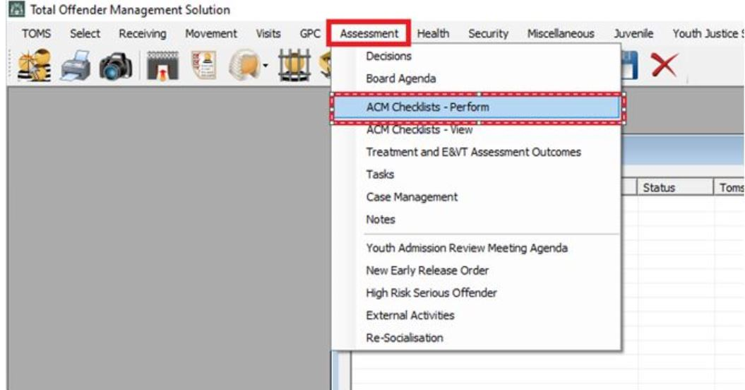

Image 2.
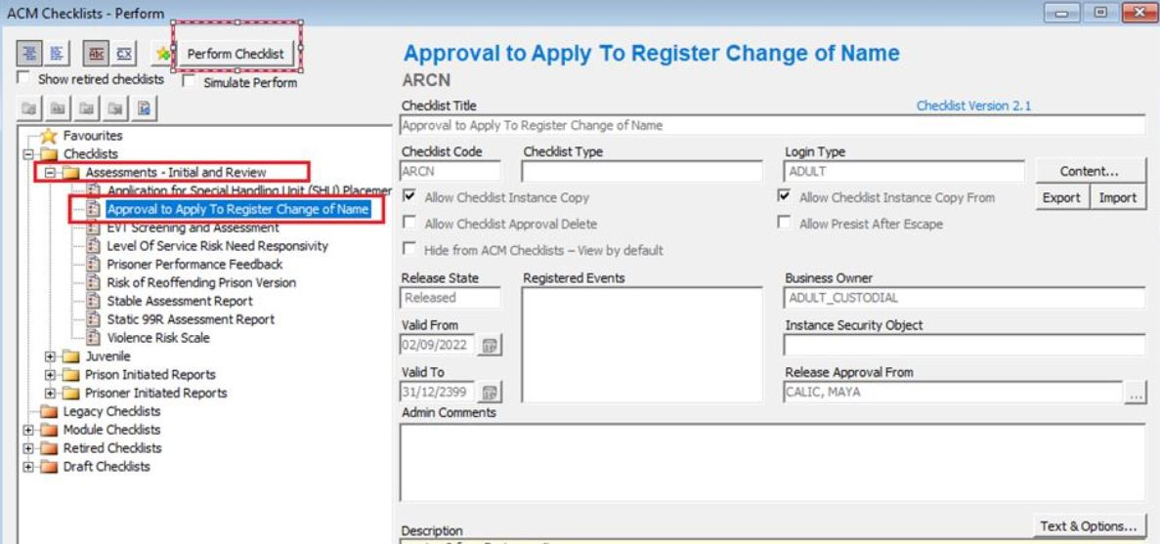

r.38(1b) Prisons Regulations 1982

